DT
Year 3
Autumn Term
How can I make a structure suitable for a bridge?
Knowledge to be taught:  To understand the function of a bridge.  To be able to identify different ways to strengthen a structure.  To learn about a famous architect. | POP Tasks  How did they make a structure in Year 1? What did they use?  What is a bridge? Show pictures – bridge or not. Decide on a definition.  Can they remember the different types of bridges? Match the names to the bridges.  What is an architect? Can you name an architect?  Why is a bridge important?  What if a real bridge was made of straws and card?  Odd one out - Use different pictures of bridges. Which one is the odd one out and why?
What do we already know?
Joining materials in Y1
Making a structure sturdy using tape

Where we will go next.
Making structures that stand up on their own, using wood in Y4.
Making a wooden structure in Y6
Lesson Guide |  | Key Vocabulary
1.  POP Task  Explore  How did they make a structure in Year 1? What did they use?  What is a bridge? Ask the children for their ideas. Show pictures – bridge or not  Think of a definition for the word “bridge.”  Respond - let the children explore and then learn afterwards  Practical session  Ask them to work in pairs/small groups and make a bridge out of lego. Share designs – what made them create those particular designs? Describe their structure without using the word “bridge.”  What do you think that an ideal bridge should be like? Use the ideas to generate a design criteria.  Why does a bridge need to be strong and rigid?  Watch video about what makes bridges strong: https://www.youtube.com/watch?v=oVOnRPefcno  Then discuss that variety and originality is always good in designs. https://www.youtube.com/watch?v=5C3VG0RdNPo This video discusses the different types of bridges that we are going to research : Beam Bridge, Arch Bridge, Suspension bridge, Cable stay bridge.  Learn  What do you think that an ideal bridge should be like? Use the ideas to generate a design criteria.  Why does a bridge need to be strong and rigid?  Watch video about what makes bridges strong: https://www.youtube.com/watch?v=oVOnRPefcno  Then discuss that variety and originality is always good in designs. https://www.youtube.com/watch?v=5C3VG0RdNPo This video discusses the different types of bridges that we are going to research : Beam Bridge, Arch Bridge, Suspension bridge, Cable stay bridge.  Explain that they are going to making their own bridges. It will need to span 40cm and hold 100g.  Make out of various material such as card, art straws  Reflect  Think back to the learning that they did in Year One, when they made structures. How can their learning be extended? Thinking of a variety of ways to strengthen their models, rather than just adding more tape.  Christian Values – Friendship and Respect  British Value - Tolerance and Respect |  | Bridge  Rigid  Structure  Properties  Architect  Beams  Columns  Balanced  Truss (triangular components)  Prototype  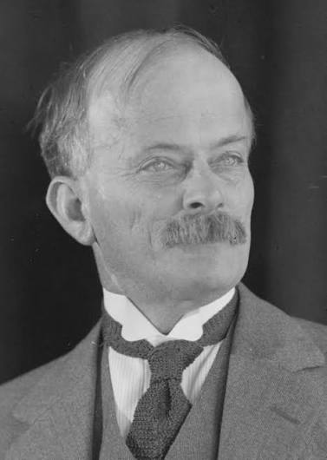  John Bradfield  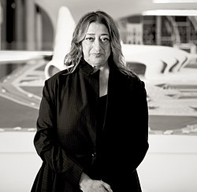  Zaha Hadid  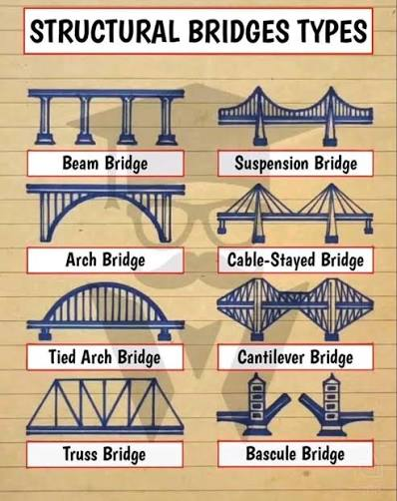
2.
POP Task
Explore
Can they remember the different types of bridges? Match the names to the bridges.

Learn
**To explore different designs.
Show the DT processes poster
Show the children some pictures of bridges. Can they remember the different names? How are the designs different? What features can they see on the bridges?

Respond

Use ipads to research different bridges.
Make notes in DT books about 3 different bridges. Give pictures if required.
What type of bridge is it? What is the location? How long is the bridge? What’s the purpose of the bridge? Which materials have been used? What design features can you see?

Reflect
Tell their friend facts that they have learnt about bridges.
Feedback as a class
3.
POP Task
Explore
What is an architect? Can they name an architect?

Learn

**To learn about famous architects
Show a picture of Sydney Harbour Bridge.
Watch the video clip - https://www.youtube.com/watch?v=Jy5cZ-IO0Eg
What do you notice about the style? What type of bridge is it?
What do you like/dislike about the bridge?
Show a picture of the architect – John Bradfield.

Respond

As a class, read a piece of text about John Bradfield and the bridge. Echo and Choral read.
Make a comparison with Zaha Hadid, who is a female architect. She designed the Sheikh Zayed Bridge in Dubai.
How are the designs similar/different? Which design do you prefer and why?
**To generate ideas for a design.
Show the DT processes poster
Thinking about the design criteria – in pairs, think of 2/3 designs for making their own bridge. Draw their designs in their books and annotate. What type of bridge is it? Can they explain their choices? Which materials could they use? Why would they choose those materials? What part of the structure will strengthen it? Beams? Columns? Trusses? Is the structure balanced?
Think about layering card to strengthen.

Watch the clip about making structures sturdier.
https://www.youtube.com/watch?v=sPhuwXB1ZLM

Reflect
Why are John Bradfield and Zaha Hadid great architects?
4. This may all need to be covered over 2 sessions
POP Task
Explore
Why are bridges important?

Learn
**To choose a final design.
Show the DT processes poster

In pairs, the children should look through their designs. Which design would be the most suitable bridge and also follow the design criteria – 40cm span and hold 100g weight?
Why have they made this choice? Which design is the most innovative? Can they link the design to the architect covered?

Respond

Children to draw their final design. Add annotations describing the equipment required, measurements, ways to strengthen the bridge, how the designers have influenced their designs.

British Value – Individual Liberty

To make a prototype
Ask the children to make a prototype bridge. Whilst doing this, modify their designs where appropriate. Were the materials suitable? Will the bridge be strong enough? What do they need to change? Give reasons
Can they add layers of materials to strengthen?

To plan
Children to use diagrams and captions to plan out the process of making the bridge. What order will they use, what equipment and materials will they use? Include measurements.

Reflect

Reflect on their designs. What will they change when they make their actual bridge? Discuss with a partner.
Challenge – What if they had no tape to fasten the materials together?

5.
POP Task
Explore

Odd one out - Use different pictures of bridges. Which one is the odd one out and why?

Learn
**To make a structure.

Discuss designs made.
Model techniques that the children will need to use.
Discuss how to evaluate as their go along. Is this working? What could I do to improve this design?

Respond
Children are to use ideas from their designs and their prototype, in order to make their structure. Think about any modifications that were needed.
What materials and tools do they need?
Which techniques are required?
Work with a pair to create their bridge.
Have the design criteria on show.
Refine techniques as work progresses.

Reflect
Test out their bridges with the weights. Are the bridges sturdy enough/strong enough?
If not, what could they have changed?

Christian Value – Perseverance, Friendship and Respect.
6.
POP Task
Explore
What if a real bridge was made of straws and card?

Learn
**To evaluate a product against a design brief.
Look at the DT poster. Which stages have they completed? Which stage should they move onto? Explain that they have been evaluating through the process as well.
Pupils to be reminded of the initial design brief.
Explain that part of any design project is the evaluation stage where the success is considered, and possible improvements identified.
Show the questions / headings that will form their evaluation: Discuss the questions and possible answers.
Description of the product I designed and made.
- Who this product would be useful for.
- Why I chose these specific materials.
- Ways in which my product is successful.
- How the product could be developed or improved.
- Problems or difficulties I had to solve.
- What I have learnt from doing this activity.
- Other places I could use these new skills.
Respond
Pupils to write their evaluations in their books, focusing on answering the questions. Think carefully about their bridge.

Christian Value – Truthfulness

Reflect
How did your work link with the architect’s designs?

Feedback:
.

Year 3
Spring Term
Can I make a healthy granola/cereal bar?

Knowledge to be taught:  To understand food groups.  To recognise healthy food choices.  To measure ingredients in grams.  To combine ingredients in the correct sequence.  To recognise the effect of cooling ingredients. | Ideas for POP tasks  What are the different food groups? Highlight cereal/grains group  What is granola? Based on oats, nuts and honey, variations include dried fruits, seeds and other whole grains, all gently baked together until crisp.  Why do the granola bars have honey in them?  What units can we use to measure ingredients? Model how much a small amount of something weighs in grams, so that they can confirm their choices in their final design.  Where do we get grains from?  What is the effect of cooking ingredients, as opposed to just chilling them?  What do we already know?  Looking at fruit as a healthy food choice. Selecting fruit to make a healthy smoothie in Y2.  Where are we going next?  Measuring ingredients more accurately in grams when making pizzas in Y4. Looking at the effect of heat on ingredients.  Y6 – looking at the use of micro-organisms in food – yeast in bread. Kneading, proving and baking bread.
Lesson Guide |  | Key Vocabulary
1.  **To explore different products.  Explore  What are the different food groups? Highlight cereal/grains group. What is granola?  Based on oats, nuts and honey, variations include dried fruits, seeds and other whole grains, all gently baked together until crisp.  Learn  Explain that they are going to make a healthy granola/cereal bar. Granola is rich in protein and fibre.  What do we mean by a granola bar? Show examples of different bars. What are the main ingredients? How can you ensure that it is healthy?  Share DT poster and discuss the different phases.  Model the respond part of the lesson.  Respond  Mind map – choose a cereal bar and discuss appearance, smell, size. What ingredients can they see?  Taste test – (check allergies) Describe the taste.  Record ideas in books using diagrams and annotations.  Reflect  What have you learnt about cereal bars/granola bars?  Learn about an innovative female chef – Andi Oliver. Look at her life and work. |  | Ingredients  Granola,  Oats  Raisins  Sultanas  Cranberries  Honey  Healthy  Prototype  Chilled  Grams  Non cook granola bars  https://thebakermama.com/recipes/5-ingredient-granola-bars/#tasty-recipes-14585-jump-target  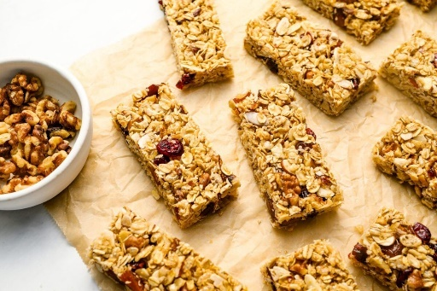
2.
**To create designs

Explore
Why do the granola bars have honey in them? To bind the other ingredients together, as a natural sweetener.

Learn
Show the DT design processes poster.
Share a simple recipe for granola bars. (see resource) These don’t need baking, just chilling in the fridge to solidify.
What granola bar would they like to design? They would need to have granola/oats as a base and an ingredient to bind the mixture together (honey) What other healthy ingredients can they think of that would make their granola bar healthy and tasty?
Model drawing and annotating. Think about the size of the granola bars that they explored. Would they like theirs to be a similar size?
Respond
Children should think about 2/3 designs for their own granola bars. Draw and annotate their diagrams. Describe the ingredients that they would like to incorporate into their granola bar. How thick would the bars be and length in cm?

Reflect
Share their designs with a partner. Which design would their partner recommend? This will advise them on a final design.
3
**To choose a final design.

Explore
What units can we use to measure ingredients? Model how much a small amount of something weighs in grams, so that they can confirm their choices in their final design.

Learn
Look at a couple of designs and discuss which could be a final design. Model how to give reasons.
Look at the simple recipe again
On the board, draw their final design and annotate, then use a simple diagram to record the making process.
First, …….Then ….. Next. Adapt the recipe as required.

Respond
Look at their different designs – which design would be the best for their own granola bar? Explain choice
Draw final design and use annotations describing the ingredients and measurements (length in cm and weight in g)
Use a simple diagram to describe the sequence of how they will make their granola bar. Use terms from the recipe to help.

Reflect
Would it make a difference if they followed the steps in a different order?

British Value – Individual Liberty

4
**To make a product.
Show the DT poster
Practical session – photos on Seesaw

Explore
Where do we get grains from? Grains are harvested from dead, or dry, grasses.

Learn
Look at a chosen final design of a granola bar. Discuss the steps on how to make that bar, thinking about the correct processes and the ingredients that need to be added. Model how to follow the recipe/process and make the bars.
Discuss food safety and hygiene.

Respond
Children to read through their diagram that describes the making process. Follow the instructions to make their granola bars. Put in the fridge to chill for 30 minutes, or longer if necessary.
Taste test their granola bars and take some home.

Reflect
What is the effect of chilling the granola bars. Discuss their end products with a partner.
Christian Value – Perseverance.

5
**To evaluate a product.
Explore
What is the effect of cooking ingredients as opposed to chilling them?

Learn
Show the DT design processes poster. Which stages have they completed? Explain that they have evaluating through the process.
Children to think about their final product.
Refer back to the initial questions when they were planning their designs.
Give an overview of their designs.
What went well through the process? What would they do differently?
Can they discuss a problem that they overcame?
Model how to answer questions.

Respond

Write evaluations in books, using prompt questions. Answer as fully as possible.

Reflect
What would they like to make at home next time, maybe using some of the skills practised?
Christian Value - Truthfulness

Feedback:

Year 3
Summer Term
Can I make a mechanism to lift a pot of water?
Knowledge to be taught:  To understand what a mechanism is.  To know what a pulley is.  To know the history of pulleys.  To understand how a pulley works, | POP Tasks  What is a lever? When did they use levers? Show a real pulley. Talk to a partner. What is it? Does anyone know what this might do?  Which lever / pulley system could be the odd one out? Explain your ideas.  Where would you see lever /pulley systems in everyday life?  Have a pulley design on the board, that has something wrong. Ask the children to spot the problem. How would this affect the pulley system?  What are the different stages on the DT poster?  What have they been learning about in this unit? Which skills have they covered?  What do we already know?  Mechanisms inY1 - using a simple lever in a moving picture.  Wheels and axles in Y2, when making a car.  Where are we going to next?  Cam toys in Y5
Lesson Guide |  | Key Vocabulary
1.  Explore  What is a lever? When did they use levers?  Show a real pulley.Talk to a partner. What is it? Does anyone know what this might do?  Learn  To understand the history of pulleys and levers.  What is a mechanism?  Look at the work of the Ancient Egyptians, who built the early pulley and lever systems. Talk about the word Shaduf, which describes the early lever mechanism.  Share with the class a piece of age appropriate text about these mechanisms.  Explain that the children are going to make their own mechanism, that will need to be able to lift a small pot of water.  Look at pictures of different levers / pulleys or examples in school. Have a quick chat about how they make work before letting the children explore. Set some prompt questions. How do you think this would work? What would this part do?  Respond  **To explore products.  Have pictures of levers / pulleys on show.  Use the simple pulleys in school. Wheels and string over hooks on a piece of wood.  Look at examples of levers and how they lifted heavy loads.  Complete mind maps for two of the designs and answer questions:  What do they like about the designs? What would they like to know more about? Which features are they not so keen on?  Reflect  Feedback ideas about the different designs. Do your opinions match others, or are they different? |  | Pulley  Grooved wheel  Circumference  Rope, belt or chain  Change direction  Force  Load  Lever  Gear  Pivot  Prototype  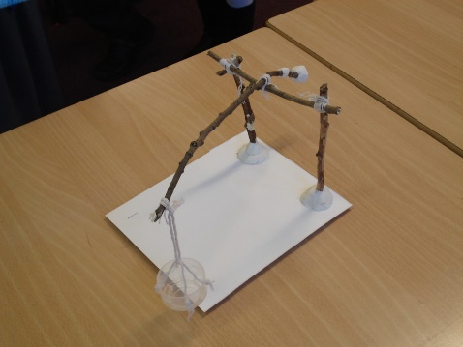  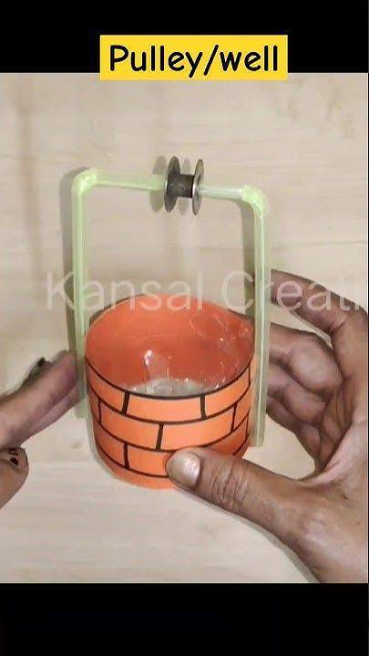
2.**To generate ideas to fit a brief.

Explore
Odd one out.
Which lever / pulley system could be the odd one out? Explain your ideas.

Learn
Show the DT design processes poster.
Explain that the children need to try and design a mechanism using the equipment.
How will it work? What tools/resources will you need? What would the pulley look like and how it works?
Children should draw 2 diagrams in their DT books and annotate.
Add labels and potential measurements, measuring to the nearest cm.

Reflect
Share their designs with a friend and explain them
Christian Values – Friendship and Respect
British Value- Democracy/ Tolerance and Respect

3. To explore how to use the equipment and make a prototype.
Explore
Where would you see lever / pulley systems in everyday life?
Learn
Look at the DT poster
Practical session on Seesaw.
Explain that they are going to use equipment to make simple prototypes of their designs from the last session.
Use art straws, string and other equipment, create structures that could lift a small pot.
Use small pulleys and lift small objects in bags, as an example as well.

Respond
Children to work in pairs/small groups to make a simple prototype. During this process, the children can easily change materials/change parts of their ideas/design. Does their design work? Is it able to lift a small pot?
Could they make any adaptations?

Reflect
Think about how they had to adapt their design, ready for a final design.

Christian Value - Truthfulness

4.**To choose a final design
Look at the DT poster and discuss the processes.
Explore
Have a lever / pulley design on the board, that has something wrong. Ask the children to spot the problem. How would this affect the system?

Learn
Looking at the previous designs and the prototypes from the previous session, the children should select a final design. Look at photos on Seesaw of their prototypes.
Why have they chosen this design? How is it better than the other designs?
Can they add measurements? For the pulley, how long would the rope need to be? Look at the difficulties of measuring rope/string.
Measure to the nearest cm, but with more accuracy.
How long will the straws/pieces of dowling need to be, if they are going to become a structure for the pulley/ lever?
Model ideas for drawing a final design

Respond
Children look at photos of their prototypes on Seesaw. Talk about what went well and how they had to make adaptations.
Make a decision on a final decision for a final design.
Draw their design, adding equipment and measurements.
Write out the ordered method of how they will make their lever structure / pulley.

Reflect
Look at a method. What happens if you do something in a different order?

5
**To make a product.
Explore
What are the different stages on the DT poster?
Show the DT processes poster and discuss each stage. Why is each stage important?

Learn
Practical session - photos on Seesaw.
Using their final design and any amendments that have come up, through creating their prototype, the children will make their final product. Discuss the processes and model measuring accurately.
Highlight and address any issues or difficulties that the children have experienced.

Respond
Children are to make their own mechanism.
Look at their final design and their method.
Select the correct equipment and tools. Think carefully about the measurements that they have chosen.
Start measuring and attaching the materials.

Reflect
Test their pulleys. What has gone well and what could be improved?

Christian Value – Perseverance, Friendship and Respect
British Value – Respect/Tolerance

6 **To evaluate a product.
Look at the DT poster. Which stages have they covered? Explain that they have been evaluating through the process.

Explore
What have they been learning about in this unit? Which skills have they covered?

Learn
Look at the mechanisms made by the children. Model how to carry out an evaluation.
Refer back to the design brief. Does the product fit the criteria?
Look at prompt questions that would help the children with their evaluation.
Model how to answer the questions fully.

Respond
Children to move onto their evaluations. This should be written in books. Alternatively, record feedback on Seesaw.
What went well? How could the design have been improved?
What made them choose that design and mechanism?
What problems did they need to overcome?

Reflect
How would they use these skills in other projects?

Christian Value - Truthfulness

Feedback:

