Year 4
Autumn Term
How can I make a free -standing photo frame?
Knowledge to be taught:  To make a free standing structure.  To make a slot in the structure.  To saw wood at an angle.  To join pieces of wood. | POP Tasks  How have they joined materials in other year groups?  What does free standing mean?  Odd one out - Look at different photo frames – which one is the odd one out and why?  True or False, eg. you can stick the wood together with cellotape? The wood needs to be sawn at an angle.  What are the different DT processes?
What do we already know?
Wood skills in Y2 - approximate measuring and hammering
Joining materials - card and art straws, glue and tape.Y1 and Y3
Strengthening structures – Y1 using tape and flanges, Y3 layering card, using trusses.
Where we will go next.
Making a wooden structure in Y6, using wood skills – hammering, sawing and screwing.
Lesson Guide |  | Key Vocabulary
1.  POP Task  Explore  How have they joined materials in other year groups?  Learn  **To research free standing structures.  Show the DT processes poster.  Explain that they are going to make a free- standing photo frame for someone in their family.  Explain the term – free standing.  Explore other free- standing structures – mug tree, music stand, tripod. How are they standing up? Why is it important that they are strong and stable?  What would happen if the music stand had two legs instead of three? Highlight the fact that some products are made stable by having a wide base.  Respond  Show the children a variety of photograph frames and ask them to identify how they are able to stand up.  Ask the children to compare the frames in terms of different features eg. how it stands up, how it looks, how easy it is to put a photograph in, how well it displays the photograph. Who would use it? What kind of picture is it for? Where would it stand?  Provide opportunities for children to discuss the component parts of the frames and what each is for. Ask the children to draw one or two of the frames from different views and to label the component parts and their purposes.  Discuss the frames in terms of the children's favourites and who might like the style of different frames eg child, grandparent.  Complete a mind map in their books to analyse their findings using the prompts above.  Reflect  Compare children’s likes and dislikes. Are there any particular trends that are popular? |  | Free standing  Slot  Joining  Base  Balanced  Components  Joins  Dimension  Saw  Angle  Millimetre  Perimeter  Prototype  Modification  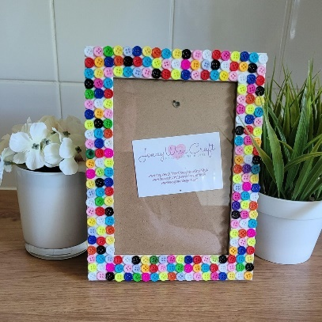  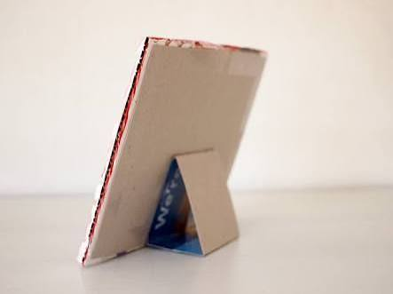  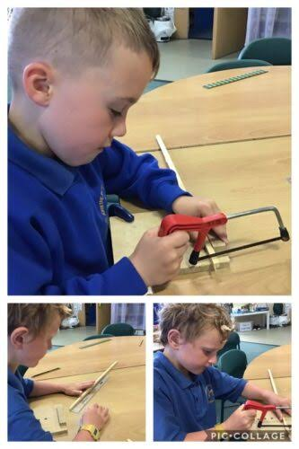
2.
POP Task
What does free standing mean?

Explore

Talk about the learning that the children did in Year 3, looking at strengthening structures.
They will have looked at using different layers and adding new components.

Learn

To explore different techniques
Practical lesson
In Y4, they will extend the learning by using wood and having a stronger, wider base.
Have different stations. Photos on Seesaw.
Demonstrate to the children ways of stiffening paper and card eg by rolling, folding and layering and encourage children to explore these along with different methods of joining.
Model the different techniques and activities to the children.
Respond
Ask the children to investigate ways of making free-standing structures from a limited number of pipe-cleaners.
Provide the children with a small piece of board and ask them to investigate ways of making it stand up using paper.
As the children will be using wood this time, have a station where they can practise sawing wood at an angle. Use the resources to cut wood at an angle.
This is an extension from Y2 where the children just saw a piece of dowling.
Reflect
Which learning will they take from this session and use in the making of their product?

3.
POP Task
Explore
Odd one out - Look at different photo frames – which one is the odd one out and why?

Learn

**To generate ideas for a design.
Show the DT processes poster.
Children to create designs for a free standing photo frame
Think about who their frame is being designed for eg the style of frame /a gift for a relative or friend. With the children, list some shared criteria. What will your frame need to do in order to be successful?
Encourage the children to consider how they are going to make their frame a stable structure and how the photograph will be fitted into the frame. How will you make it stable? How will it stand up? Where are the weak points? How could you reinforce them? Can they add suitable measurements?
Respond
Ask the children to draw and label how they would like their design to look considering the basic frame shape that they will be given and the user's preferences in colours and designs, as well as how it will stand up.
Annotate with equipment, skills, joining techniques, measurements.
Think about individual embellishments for their design.
British Value – Individual Liberty
Reflect
Share their designs with a friend and discuss how they think that it will be made.
4.
POP Task
True or False?
A smaller base is best to make structures more stable
To reinforce a join you must take materials away
Photo frames can have different stands

Explore
**To choose a final design
Show the DT processes poster. Talk about the processes covered so far.

Learn
Choose a design that one of the children has thought of. Explain how to draw a front, side and back view of the photo frame. Model how to annotate the diagram, focusing on the choice of design, equipment, measurements – to the nearest mm, techniques used, embellishments
Model how to plan the process. Use diagrams and captions to show the sequence of making the photo frame

Respond
Choose a design that they would like to make. Draw a diagram in their books. Annotate and add detail to the diagram, including measurements to the nearest millimetre. Explain choice of design and how the frame will stand up. Add techniques on how it will be made. How will the slot be added to the frame?
To make a prototype.
To check that their design is covering the design brief, make a prototype out of card.
Do the measurements work? Will the structure be stable and strong? Does the slot for the photo work?
Make modifications to their design, where necessary.
Stick their prototypes in books.
Plan
Draw diagrams and captions to plan out the process of making. Ensure the correct order of the process.
Add measurements and detail to their diagrams. Label the equipment required.

Reflect

Challenge – what if the photo frame won’t stand up on its own?
Show a different order to the processes – What if we cut the wood, before measuring? What is wrong with the order?
5.
POP Task
Explore
True or False statements, eg. you can stick the wood together with cellotape? The wood needs to be sawn at an angle.

Learn
**To make a product.
Show the DT processes poster.
Also use this session to plan the processes. The children can be planning, while small groups are sawing.
What would the sequence of the processes be? Model the order using a flow chart.

See the Respond criteria. Discuss processes already covered. Remind the children of the techniques investigated. Model again how to saw at an angle.

Respond

Children to plan their ideas in a flow chart. Think about how they are going to make their photo frame. What will they do first, next etc? Add measurements etc so that they can use for when they are making.
Children should look at their designs and the prototype. What modifications were needed? How would these help the final product?
Select the tools and materials. Think about the techniques that they will need to use.
Measure to the nearest mm accurately.
Use thin wood to cut at an angle and join using glue guns with an adult. Wear googles to saw wood.
Talk about the safety of using glue guns. Check Risk Assessment in the DT folder.
Add a slot onto the back of the photo frame – use joining techniques to attach card to the wood.
Make any modifications along the way.
Add individual decoration.
Refine techniques as work progresses.

British Value – Individual Liberty
Finally, put a photo into the frame.

Christian Value – Perseverance.

Reflect
Discuss their photo frame with a friend. What has gone well, what would they do differently next time?

6.
POP Task
Explore
What are the different DT processes? Explain each stage.

Learn
**To evaluate a product.
Study the DT processes poster. Explain that it is important to evaluate the product in order to think carefully about the skills used
Look at the designs in partners. Discuss
Model how to evaluate the designs. Look at the questions below and model possible answers to the questions.

Respond
Children to study their own products and evaluate using the following questions and prompts.
- Who this product would be useful for.
- Why I chose these specific materials.
- Ways in which my product is successful.
- How the product could be developed or improved.
- Problems or difficulties I had to solve.
- What I have learnt from doing this activity.
- Other times I could use these new skills.
Write evaluations in books.
.
Christian Value – Truthfulness

Reflect
What skills have they learnt in this unit? Share with a friend.

Feedback:

Year 4
Spring Term
Can I design and make my own pizza?
Knowledge to be taught:  To learn about a famous innovator in food  To understand where ingredients have originated from.  To prepare ingredients using different skills.  To understand the need for safety and hygiene when preparing food.  To recognise the effect of heat on food.  To measure food in grams.  To control the heat of the oven |  | Possible POP Tasks  What is a pizza? Where does it originate from?  What do you know about a balanced diet? Look at healthy foods.  Look at the origin of some foods.  What techniques are used for preparing food? Use picture prompts – cutting, slicing, peeling, chopping?  What are the safety measures when preparing food  What was the design brief for this unit? Have you fulfilled the Success Criteria?  What do we already know?  Healthy food from Key stage 1.  Chopping and mixing ingredients – Year 2  Where do we go next?  Year 6 - Measuring and combining ingredients, controlling heat to bake bread.  Looking at the effect of yeast as a micro organism.
Lesson Guide |  |  | Key Vocabulary
1  **To explore current products.  Explore  What is a pizza? Where does it originate from?  Learn  Show DT processes poster.  Explain that for this unit, the children are going to create their own pizza.  Remind the children about their learning in Y2. They will be carrying out similar preparation of ingredients, but adding in measuring to the nearest gram. Also, follow a recipe.  In this session, explore different pizzas. If possible, use actual pizzas, or pizza boxes. Could also use Domino menus, with pictures on.  Respond  Fill out a mind map in books – what is the appearance of the pizza? Which ingredients have been used? Which ingredients are on all pizzas? (Tomato sauce and cheese) Does it look appealing? Are all of the pizzas the same shape and depth?  If possible, try smelling and tasting the pizzas.  What effect does heat have on the ingredients?  Look at the cooking instructions on the box – how long will it take to cook?  To learn about a famous innovative chef.  Introduce the children to Heston Blumenthal – an extremely innovative chef, who has led the way in original cooking.  Look at an age appropriate piece of text about his life and work.  Reflect  Can the children see the benefits of originality in cooking? |  |  | Pizza  Ingredients  Cook  Cut  Chop  Slice  Grate  Dough  Seasonal  Base  Heat  Gram  Heston Blumenthal  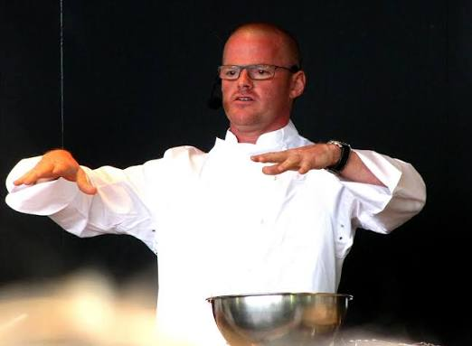
2  **To generate ideas to fit a design brief.  Explore  What do you know about a balanced diet? Look at healthy foods. Look at the origin of some foods.  Learn  Show the DT processes poster.  Children are moving onto the next stage of the process. Thinking about the pizzas that they have already explored, can they choose 3 pizzas that they would like to make? Think about the depth and shape of the dough, as well as the different toppings. How would they arrange the toppings to make it look appealing?  What would the success criteria be to make a good pizza?  Respond  In books, show these three designs. Draw and annotate with labels and descriptions. Label the type of base, the ingredients and the sauce to be used.  Make sure that their pizza fits the success criteria.  Reflect  Which pizza would be most appealing and why?  British Value – Individual Liberty |  |  | 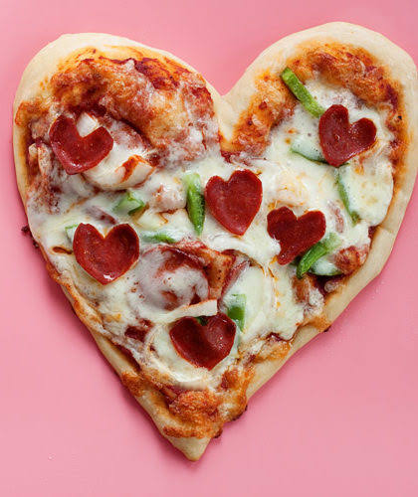
3. **To choose a final design.
To learn about the order of the process.

Explore
What techniques are used for preparing food? Use picture prompts – cutting, slicing, peeling, chopping

Learn
Looking at the designs, select a final design. Add more detail to the diagram. Explain why they have chosen that design over the others. Discuss the ingredients that they will use and the techniques that they will need to use to prepare them.
Think about the sequence of making the pizza. Look at pictures of the different process and sequence them in the correct order.
Respond
Draw the final design in their books. Annotate the base, sauce, ingredients and how they’ve been prepared, ie chopped peppers. Add some measurements, ie ___grams of cheese.
Draw a chart to show the order of making the pizza. Could be like a flow chart.

Reflect
What would happen if you did something in the wrong order? Would it affect the overall end product?
British Value – Individual Liberty

4
Explore
What are the safety aspects when preparing food?
**To use different techniques when preparing ingredients.
This session was added in this order to reduce the amount of ingredients purchased and used.
Practical sessions – photos on Seesaw
Learn
Look at the usual ingredients that are on pizza toppings. How can the ingredients be prepared? The cheese has been grated. Onions/ mushrooms have been sliced. Pineapple has been cut into chunks.
Model these skills. When chopping, use specific techniques.
Watch the video.
https://www.youtube.com/watch?v=mvJSPhAQNZ4
Respond
Children to have a go at their tables.
Ensure safety is observed.
Practise measuring quantities to the nearest gram. Can use any substance to practise.

Model to the children how to make the tomato sauce – explain the key ingredients and look at the instructions together.

To make a product.
Show the DT processes
Photos on Seesaw
Explain that the children will need to measure out some of their ingredients. Measure to the nearest gram. (grated cheese for example) Show a certain amount eg, 100g of cheese, so that the children can see that amount.
Children are to use their final designs and ideas from their prototypes. Create the shape and thickness of dough. Safely prepare the ingredients using skills from Session 2. Add the ingredients to the pizza, as the design shows.
Discuss what the pizza will look like when it comes out of the oven. Adult supervision
Control the heat of the oven. Check appropriate temperatures needed to cook a pizza. Check and alter temperature where required.
Reflect
Look at their products with a learning buddy. Does it fit the success criteria? Is it appealing? Did the process work? What could have gone better?

Christian Value – Perseverance and Thankfulness
5
**To evaluate a product.

Explore

What was the design brief for this unit? Have you fulfilled the Success Criteria?
Learn
Show the DT processes poster.
Children can ask each other, to help with their evaluations.
Can they tell each other how the pizza looks, once it has been cooked? How does it smell? How does it taste?

Respond
Write evaluations in books. Use opinions of class to help.
Also comment on what worked well with their designs and what do they wish that they had done differently. Different thickness of base as too doughy or crispy? Cut the ingredients more finely, as they didn’t cook through enough?

Reflect
What other dishes could they make using these skills?

Christian Value - Truthfulness

Feedback:

Year 4
Summer Term
How can I create an instrument using a circuit?
Knowledge to be taught:  To be able to use an electronic kit.  To understand which materials are conductive.  To be able to make a circuit  To understand the difference between series and parallel circuits  To learn about famous innovators. | POP Tasks  What do the children already know about circuits, from their Science Lessons? Discuss their ideas and knowledge.  Show Makey Makey kit – what could this be? What could it do?  What is a conductor? Gather ideas and discuss. Show prompts on the board.  Sort objects into conductive and non conductive.  True or False statements such as: Does the circuit need to be complete for it to work? A rubber is a conductor.  What are their steps to use Makey Makey in their instrument?  What skills have they learnt during this unit?  What we already know  Children have covered circuits in their Y4 Science lessons.  Where will we go next?  In Y5, the children will be using Tinkercad to design a 3D model of a key ring.  In Y6, the children will be using microbits to create a pedometer.
Lesson Guide |  | Key Vocabulary
1. **To explore the electronic kits  Explore  What do the children already know about circuits, from their Science Lessons? Discuss their ideas and knowledge.  Show Makey Makey kit – what could this be? What could it do?  Learn  Practical session – photos on Seesaw  .  Explain to children that we can use a makey makey to complete a circuit. Teach how the circuit is being used.  Watch a couple of minutes to show how to plug into computer https://makeymakey.com/blogs/how-to-instructions/lesson-two-hands-on-a-makey-makey  Go through instructions as children follow along.  Demonstrate how the makey makey works with musical instruments (piano / bongos)  Respond  Explore session  Put children into small groups and show them the makey makey kits.  Give children time to experiment with different scratch games and different ways to make a circuit.  Reflect  Feedback ideas to class. What did the children enjoy? What did they find out?  Can do in class or use for homework.  Learn  To learn about famous innovators  Linking to ICT and electronics, the children will find out about Charles Babbage, who invented the first computer and Adam Osborne, who created the first portable computer.  Respond  Use age appropriate text to read and find out about their lives and work. Refer back in the different electronic lessons. |  | Makey Makey  Electronic  Circuit  Series  Parallel  Programme  Instrument  Note  Conductive  Electricity  Innovator  Prototype  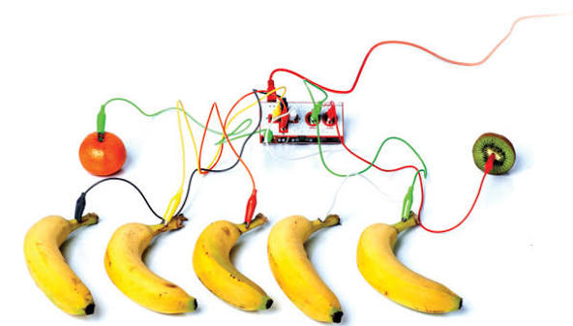  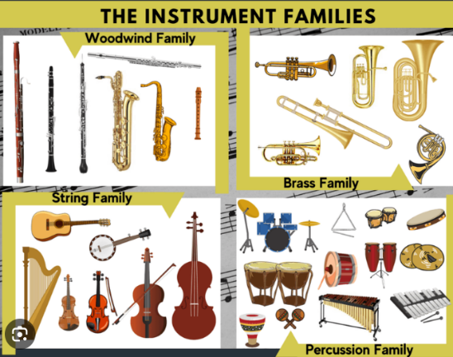
2. **To research different products.
Show the DT processes poster

Explore
What is a conductor? Gather ideas and discuss. Show prompts on the board.

Learn
Explain that they are going to make a musical instrument using an electronic kit.
Explore different musical instruments that can make notes. Try and have the actual instruments, if not use pictures.
What do the children like and prefer about the instruments? How are the notes made / changed?
What are the instruments made out of/which family of instruments do they belong to?

Respond.
Allow the children to have time to explore the instruments and study how sounds can be made.
Use the above questions to aid exploration.
Children to record ideas in their books – mind map. Add labels and ideas around their sketches.

Reflect
Children to share their experiences and ideas with others. Did they prefer the same instruments or different? Were they surprised at how notes could be changed?
3. To explore conductive materials.
Explore
How do they attach Makey Makey to the laptop? Recap time
Learn
Practical session – photos on Seesaw.
Explain to children that in this lesson, we will experiment with all sorts of objects to find out what is conductive so they can start designing their own game controller.
Explain what conductive means and link back to their prior learning on circuits.
Watch video to explain the experiment.
Respond
Children to set up the scratch game https://scratch.mit.edu/projects/199905945/ and have a variety of items to test to see if they are conductive. Make predictions before they check. Were they right?
Reflect
After testing items, discuss why some items are conductive and why some aren't.
Create a list as a class – how will this help them when they come to design their games controller? Explain that conductive items can be made into a key for their controller!
Show banana clip
Display on board items that would be good for their instrument and share ideas for how this could be used. Discuss that although some items may be conductive, does that mean they would make a good key for an instrument?

4.
**To generate ideas for a design
Show the DT processes poster.
Explore
Sort objects into conductive and non conductive.

Learn

Think about the design brief
Choose 2 designs for a musical instrument. Think about which materials they would use to make the instrument. Which conducive materials will you choose? What tools will you need? How can you use Makey Makey to change the notes on the instrument? What measurements would you use?

Respond
Draw and annotate diagrams in their DT books. Children should add materials that they are going to use and measurements. Highlight the conductive materials.

Reflect
Share designs with a friend. Do they think that the designs will work? Have they included a conductive material?

British Value – Individual Liberty
5.
To make a prototype and **choose a final design.
Explore
True or False statements such as: Does the circuit need to be complete for it to work? A rubber is a conductor.

Learn
Explain what the word prototype is? Can they remember from previous years?
The children are to look at their designs and make a prototype. Encourage the children to think critically and suggest any adaptations that they could make. Model how to make a prototype, discussing thinking as you go along.

Respond

In preparation for making their own musical instrument, the children can use materials to have a practise and decide what works well and if they need to make any modifications. Give reasons for any changes.
Decide on their final designs and create clear designs on books. Explain how they will make their final product.
Does it fit the Success Criteria.
Look at how to make their product aesthetically pleasing. Explain what this means, if necessary.

Reflect
What adaptations did they decide to make, through making a prototype? Explain why they were required.

Christian Value - Truthfulness

6.
**To make a product, to fit a design brief.
Explore
What are their steps to use Makey Makey in their instrument? Discuss as a class.

Learn
Refer back to the design brief and also the learning over this unit. Does their final design adhere to the key elements?
Use their prototype to decide upon any changes that need to be made. Model how to think through and record the steps required to make their product.

Respond
Create their steps in written form that will lead to the effective making of their product.
Independently select appropriate equipment and tools required for their product.
Make the final product – think about any changes that need to be made along the way.
Refine techniques as work progresses.

Reflect
Test their product. Does it work? Is there anything that can be improved?

Christian Value – Perseverance.

7.
**To evaluate a product.
Explore
What skills have they learnt during this unit?

Learn
Study the DT poster – which stages have we completed? Where do we go next? Explain that they have been evaluating through the process.
Model the following in full answers:

Study the effectiveness of their product and discuss key prompts.
Discuss why they chose that design – give an overview of their product.
What was successful about their product and what could have been improved?
Which features did they feel worked well?
Did they select the most appropriate materials? How do they know?
What problems did they have to overcome?

Respond
Children to think about their own designs. Can they answer the questions above, when evaluating?
Put out prompt questions/cards to help the children.
Ensure that they have answered fully and honestly.

Reflect
Could the children use these skills in another project?
Christian Value - Truthfulness

Feedback:

