Year 4
Autumn Term
Key Question Rivers
Knowledge to be taught:
By the end of Year 4, children should know:
- The key elements and features of a river.
- The key elements of the water cycle.
- The names of and key information on the world’s main rivers.
- Basic ideas about flood management.
By the end of Year 4, children should be able to:
- Interpret and explain key information on rivers.
- Evaluate a range of possible flood prevention measures.
- Use globes, atlases and maps to locate the world’s principal rivers.
- Use appropriate vocabulary when describing rivers and river features and place locations.
Christian value: Respect, Compassion, Thankfulness (being thankful for the people who work hard at preventing flooding and helping when places do flood. Showing compassion and respect when learning about the impact of flooding from rivers on communities).
Lesson Guide | Key Vocabulary
1.To describe the water cycle, explain what a river is and locate the world’s longest rivers on a map.  What is a river?  Explore:  Share the knowledge organiser. Using the Oddizzi powerpoint (slide 2 onwards), share information already known about the water cycle.  Learn:  Introduce more information about what the water cycle is and each stage (continue to use the powerpoint if needed).  Introduce what a river is and the vocabulary linked to a river e.g. ‘mouth’, ‘channel’ etc (slide 7 Oddizzi powerpoint). Continuing with the powerpoint (slide 8), locate the world’s longest rivers. This could be altogether with the children having atlases in pairs to locate the rivers at the same time using their prior atlas/map skills.  Respond:  Using a map (named), label the world’s rivers (template on page 6 of resource pack Oddizzi). Describe what the water cycle is, including what a river is (templates on page 4/5 of resource pack but this could just be used for the image and then writing completed below).  Reflect:  Match the vocabulary to definition (slide 9 Oddizzi powerpoint) – evaporation, precipitation, condensation, overland flow, water cycle, mouth, channel.  What if… one day, the water cycle stopped? | Place names: Amur River, Congo River, River Thames, Ob-Irtysh River, Paraná River, Yangtze River, Yellow River, Yenisei River, Thames Barrier  Geographical terms and processes: Water cycle, overland flow, mouth, channel, condensation, precipitation, evaporation, hydro-electric power, transporting, recreational, crops, source, meander, tributary, waterfall, ox-bow lake, v-shaped valley, dam, irrigation, floodplain, embankment, sandbag, drinking water, canal, flooding, flood management, flood prevention, river bank, river basin  Locational terms: Continent, country, world river, lower course, middle course, upper course, estuary  Christian values: Respect, Compassion, Thankfulness
2.To describe how rivers are used around the world.
How do people use rivers?

Explore:
Recap vocabulary from end of previous lesson - evaporation, precipitation, condensation, overland flow, water cycle, mouth, channel.

Learn:
Using Oddizzi powerpoint (slide 14) and online page - https://www.oddizzi.com/teachers/explore-the-world/physical-features/rivers/uses-of-a-river-2/ (use options at the side for more details e.g. survival, food), use the pictures/video (video of the River Zambezi will have been looked at in Year 2 during the focus on the Mugamareno village in Zambia) to discuss the uses of a river. Compare this to how we use rivers in the UK – locate the River Slea and discuss its uses.

Respond:
Consider how rivers are used for survival, food, energy and transport (template on page 10 Oddizzi resource pack and questions on page 8/9).

Reflect:
Match vocabulary to definition – hydro-electric power, crops, transporting, recreational.
What if… you couldn’t water the crops using the river?

Possible questions to consider:
-Why are settlements often near rivers?
-Why do people need rivers to survive?
-How do people use rivers for fun?
-Why is it important to protect rivers?

3.To identify the stages and features of a river and the way that land use changes.
What journeys do rivers make?

Explore:
Using maps/atlases, recap locations of the world’s rivers (as found out in lesson one).

Learn:
Using the Oddizzi powerpoint (slides 19 onwards) and online pages https://www.oddizzi.com/teachers/explore-the-world/physical-features/rivers/stages-features/, identify the stages of a river, how the land use changes travelling from the source to the mouth of the river and features of a river.

Respond:
Label the features of a river (template on page 14/15 of resource pack Oddizzi could be adapted)

Reflect:
Recap vocabulary by matching word to definition – source, mouth, meander, tributary, v-shaped valley, waterfall, ox-bow lake.

Possible questions to consider:
-Where do rivers run most quickly?
-What shapes does a river make as it travels?
-How does the land beside the river change during its journey?
-What sort of things can people do with a river at each stage of the journey?

4.To recognise and explain how human activity affects rivers.
How do people change rivers?

Explore:
Use the Follow me cards (Oddizzi resource pack pages 19-23) to recap vocabulary and knowledge learned so far.

Learn:
Use the Oddizzi powerpoint (slide 29), online pages https://www.oddizzi.com/teachers/explore-the-world/physical-features/rivers/rivers-human-features/ https://www.oddizzi.com/teachers/explore-the-world/physical-features/rivers/river-pollution/ to recognise how human activity can affect rivers in a positive or negative way.

Respond:
As an activity, children could write about advantages/disadvantages of the dam in the Three Gorges Dam case study (page 32 Oddizzi resource pack could be adapted) or the pros and cons of human activity impact on rivers.

Reflect:
Recap vocabulary by matching word to definition – dam and hydro-electric power, irrigation, litter and pollution, washing clothes.
What if… a dam in one country stopped enough water getting to another one?

Possible questions to consider:
-What harm can people do to rivers?
-What causes river pollution?
-Why do people build dams across rivers?
-How might people meet their needs while also caring for the rivers?

5.To recognise and explain how flooding affects communities.
How can flooding affect people?

Explore:
Use Oddizzi quiz on ‘Rivers’ – choose Level 1 or 2 depending on the needs of the class. This could be done on ipads in pairs or individually.

Learn:
Using the Oddizzi powerpoint (slides 33 onwards), and https://www.oddizzi.com/teachers/explore-the-world/physical-features/rivers/flooding-2/, recognise how flooding affects communities. Discuss how flooding can be prevented (slide 36).

Respond:
Using the pictures (page 35 Oddizzi resource pack), explain how flooding affects communities and living with the risk of flooding with possible preventative measures. This could be via Seesaw as a most important to least important activity with a verbal explanation of why they think this.

Reflect:
Recap vocabulary by matching words to definitions – floodplain, dam, Thames Barrier, hydro-electric power, embankment, sandbag.

What if… your home flooded tomorrow?

Possible questions to consider:
-What damage can floods do?
-Are floods always a problem?
-How can you stop a flood?
-How do some people find ways to live with floods?

6.To identify the key characteristics of one of the world’s longest rivers.
What can I find out about the world’s longest rivers?

Explore:
Use Oddizzi quiz on ‘Rivers’ – choose Level 1 or 2 depending on the needs of the class. This could be done on ipads in pairs or individually. Alternatively, have a matching activity on Seesaw for the children to match some of the vocabulary learned so far with the definition of the word.

Learn:
Use the Oddizzi powerpoint (slide 41) and an atlas, match the world’s longest rivers with the continents they flow through. This could be in pairs with some children focusing on some of the rivers and then sharing this altogether.

Respond:
Using the online pages - https://www.oddizzi.com/teachers/explore-the-world/physical-features/rivers/world-rivers/ (select river on left hand menu), children to create a factfile about one of the world’s longest rivers (please don’t choose The Amazon as this is focused on in more depth in Spring/Summer Term). The factfile could be created using ipads logged onto Oddizzi (or printed out (pages 38-44 of resource pack) including information such as the countries it flows through, the length, source, mouth, location and how people use the river.

Reflect:
Use the follow me cards (pages 25-29 on Oddizzi resource pack) to consolidate understanding from this learning.

Possible questions to consider:
-What would it be like to visit this river?
-What is the land near the river like?

Year 4
Spring Term
Key Question Rainforests
Knowledge to be taught:
By the end of Year 4, children should know:
- The key elements of a rainforest biome, how these contrast with other biomes and the main location of the world’s rainforests (including the Congo).
- How physical processes involving rainforests distinctively apply to the Amazon.
- How some human beings have adapted to life in the rainforest.
By the end of Year 4, children should be able to:
- Use globes, atlases and maps to locate the world’s rainforests (and other biomes).
- Use appropriate vocabulary when describing the rainforests and other biomes.
Christian value: Respect, Compassion, Truthfulness (showing respect when learning about rainforests. Discuss being compassionate when learning about the truth of the impact of deforestation on the rainforests within the world).
Lesson Guide | Key Vocabulary
1.To recognise what a rainforest is and locate the world’s rainforests on a map.  Explore:  Ask the children to share what they already know about rainforests, this could be done as a KWL or by sharing the knowledge organiser with the children.  Learn:  Introduce what a rainforest is and then using the Oddizzi powerpoint (slide 3 onwards), read the statements about rainforests and discuss as true/false. Use the slides to discuss the location of rainforests using the map and prior knowledge about the Equator / Tropic of Cancer / Tropic of Capricorn.  Using the map (or using maps in atlases), introduce four rainforests – Amazon, Congo, Gunung Leuser and St Lucia. Use the Oddizzi powerpoint (or as a template) to locate them and discuss which continents they are in. The Oddizzi explore page could be used to learn more about each of the four rainforests - https://www.oddizzi.com/teachers/explore-the-world/physical-features/ecosystems/rainforests/world-rainforests/  Respond:  Label the world’s rainforests on a named map (template on Oddizzi resource pack page 5) and describe the pattern of the location of rainforests in the world.  Reflect:  Match vocabulary for rainforest, Equator, continent, Amazon and Congo to its definition.  Possible additional questions to consider:  -What makes a forest a rainforest?  -Are all rainforests near the Equator?  -Why are rainforests located where they are?  -Why are rainforests important? | Place names: Amazon, Congo Forest, Congo River, Democratic Republic of the Congo  Geographical terms and processes: Biodiversity, biome, canopy, deforestation, emergent layer, forest floor, environment, ecosystem, drainage, humidity, indigenous, logging, pollution, source, tributary, understory, vegetation, watershed  Locational terms: Equatorial, altitude  Christian values: Respect, Compassion, Truthfulness
2. To know and describe the different layers of life in a rainforest.
Explore:
Recap vocabulary learned in the last lesson. Display the map and label the four rainforests together (or using atlases to locate each continent).
Learn:
Use the information on the Oddizzi powerpoint (slide 11-16) to learn about the four layers of vegetation in the rainforest. Discuss the features of each layer and the animals that live in each layer.
Respond:
Write about each rainforest layer (using real life pictures) – the emergent, canopy, understory layer and forest floor. This could be completed as a ‘fact finding’ activity using the Oddizzi online pages (https://www.oddizzi.com/teachers/explore-the-world/physical-features/ecosystems/rainforests/rainforest-layers/) . Information could include height, amount of sunlight, plants and animals that are found there.

Reflect:
Match vocabulary for forest floor, understory, emergent and canopy.
What if… you could take a walk across the rainforest canopy?
Possible additional questions to consider:
-What are the different layers of life in a rainforest?
-What sort of plants grow in each layer?
-What sort of animals live in each layer?
-What is it like in the different parts of a rainforest?
3. To recognise the features that make up a rainforest.
Explore:
Recap vocabulary learned so far. This could be with a verbal quiz with the knowledge organiser, telling their partner the answer and then sharing this as a class. This could also be completed on Seesaw by matching the layers of the rainforest to real life pictures to consolidate learning from the previous lesson.
Learn:
Explore about food, animals and people within the rainforest to gain an understanding of the features that make up a rainforest. This could be in pairs/groups, using the Oddizzi online pages (https://www.oddizzi.com/teachers/explore-the-world/physical-features/ecosystems/rainforests/animals/) and sharing information found on food, animals and people (templates in Oddizzi resource pack page 7/8).
Respond:
Create an information page for food/medicine, animals or people, using the online pages/books. This could be to inform people of these elements of the rainforest or completed as a piece of writing to explain.

Reflect:
Match vocabulary for tribe, logging, okapi, piranha and avocado.
What if… you grew up in a remote community in the Amazon Rainforest?
Possible additional questions to consider:
-What do we mean by a ‘rainforest biome’?
-What sorts of food come from the rainforest?
-What would it be like to live in a rainforest?
-Do all rainforests have the same features?
4.To describe the key characteristics of the Congo.

Explore:
Recap vocabulary learned so far by using the ‘follow me cards’ (page 10/11) on Oddizzi resource pack.

Learn:
Using a map (on Oddizzi powerpoint slide 27) or in atlases/using a globe, ask the children to locate the second-largest area of rainforest in the world – the Congo Rainforest in Africa. Use slide 28 onwards to learn more about the Congo (or use https://www.oddizzi.com/teachers/explore-the-world/physical-features/ecosystems/rainforests/world-rainforests/congo-rainforest/) or use the factfile on page 25 of the resource pack.

Respond:
Complete a fact-file based on information found – this could be written (example of a template in resource pack 22/23 – could use the template as an idea for content) or on Seesaw, including things that live in the Congo rainforest, people and key facts.

Reflect:
The children could share 3 things that they have learned about the Congo.

Possible additional questions to consider:
-Where is the Congo Rainforest?
-What else shares a name with the Congo?
-What plants/animals/people live in the Congo Rainforest?
-How is the Congo changing?
5.To understand and describe the impact of deforestation of rainforests.

Explore:
Match vocabulary learned so far to the definition – aka people, nomadic, hunter-gatherer.

Learn:
Ask the children what they know about deforestation and discuss together. Use pictures on Oddizzi powerpoint (slide 37) to describe each picture.
Explain what deforestation means and sort reasons ‘for’ and ‘against’ (slide 38). Continue slides to discuss ways to reduce deforestation by thinking of solutions to reasons why it happens.

Respond:
Complete writing on deforestation and the impact it has on rainforests. This could be by having a picture prompt to write about or as a piece of writing containing solutions. Alternatively, it could be as a debate of ‘for’ and ‘against’ deforestation. More information is on the Oddizzi online pages - https://www.oddizzi.com/teachers/explore-the-world/physical-features/ecosystems/rainforests/deforestation/

Reflect:
Add to vocabulary by matching definitions to deforestation, indigenous, fell, ecosystem and farming.
What if… the world grew more rainforest than it lost?

Possible additional questions to consider:
-What is deforestation?
-Why does deforestation matter to rainforests?
-How is deforestation affecting the planet?
-What can be done about deforestation?
6.To explain the importance of the Amazon Rainforest.

Explore:
Recap the location of the four rainforests learned about. Focusing on the location of the Amazon using a map (on Oddizzi powerpoint slide 43) or in atlases/using a globe, ask the children to locate the largest area of rainforest in the world – the Amazon rainforest in South America.

Learn:
Use the information on the powerpoint (slide 44 onwards) or the online page - https://www.oddizzi.com/teachers/explore-the-world/physical-features/ecosystems/rainforests/world-rainforests/amazon-rainforest/ to learn about the animals, River Amazon (recap on facts learned in Autumn Term), the trees and people in the Amazon.

Respond:
Complete writing about how valuable and important the Amazon Rainforest is. This could be writing to the president of a logging company working in the Amazon about why the rainforest is so important, or writing to someone in the form of a diary entry about what life is like in the Amazon.

Reflect:
Use the follow me cards (page 18-21 Oddizzi resource pack) to consolidate understanding and knowledge learned about rainforests.

What if… Manaus was still covered by tall trees?

Possible additional questions to consider:
-How big is the Amazon Rainforest?
-What plants/animals would you find in the Amazon?
-Why is the Amazon sometimes called ‘the lungs of the world’?
-What is it like to live in the Amazon Rainforest?

Year 4
Summer Term – Local Study
Key Question: What is my local area like?
Knowledge to be taught:
By the end of Year 4, children should be able to:

-Locate my local area on an aerial image in relation to other places around it.
-Use an aerial image to describe the key physical and human features of their local area.
-Use Geographical language to describe places at different scales.
-Describe physical and human features of my local area.
-Compare different perspectives on my local area.
-Use fieldwork to observe and record a range of data on the human and physical features in the local area.
-Find evidence of settlement and change in the local area.
-Use an ordnance survey map to identify local features and landmarks.
-Record the features of the local area using a sketch map.

Christian value: Respect, Compassion (being respectful when learning about and taking care of our local area)

Lesson Guide | Key Vocabulary
1.To locate Sleaford, and surrounding towns on a map.  Can I locate Sleaford?  Explore: Recap, continents, countries of the UK and capital cities.  Learn/Respond: Begin by having a conversation about our local area. Can anybody name any towns or villages that are around Sleaford? Where do you visit on a weekend? Recap vocab of human and physical features. Give the children a sheet split into 4 sections (or they could split a page into 4 sections in their Geography book. Using digi maps, center the map on the school area and then zoom out as far as you can and zoom in on the school in 4 stages: continent, country, region, local area.  At the first stage, children write down in one box what they can see at the continent stage: physical and human features, colours, bodies of water, shapes, colours, land.  Then in the next box, they repeat the process for the country, then the same with the third, region, and fourth , local area where they should be able to see several features of Sleaford. Explore with changing from aerial to map view – can you add in any of the place names?  Reflect: Show the children a map of Lincolnshire with the surrounding counties missing. Which counties surround Lincolnshire – could drag and drop them at this stage! | Christian values: Respect, Compassion
2.To know what is special about my local area.  What is special about my local area?  Explore: Recap the counties map from Session 1 reflect task. If children are confident, you could begin to add in some of the towns in Linconshire – e.g. Boston, Lincoln, Grantham, Sleaford and locate them on the map.  Learn: Recap learning from last week – let children look in the 4th box – what is in our local area? Which human and physical features are there (link back to previous Y2 unit). A child’s-eye view. Children discuss in pairs: as children living and/or going to school in Sleaford, what do we like and dislike about it? Share one like and one dislike from each group. Whole-class discussion: are similar points coming up from every group? Do some people like things that others dislike? What changes would we like to see in Sleaford? What has already changed during our own time here? Children close their eyes and imagine … What if you were a grown-up visitor coming here for the first time? What would you notice? What are the landmarks? What is special about its landscape? Where would you want to visit? Is it easy to get to? What is good about the place and what could be better?  Respond: Children are to produce a ‘Visit Sleaford’ post (could be a postcard/Instagram post/or just stuck in books with ideas underneath, or could use template in resources). Which three places do you think people should visit – what would you tell them about? E.g. The Hub – there are lots of arts and crafts for you to look at. Could use Sleaford - Visit Lincolnshire to support.  Reflect: If you were to meet someone who was 100 years old and had always lived in Sleaford, what would you ask them? | Christian values: Respect, Compassion
3. What can I find out from a walk in my local area?  Explore: Brief children on the route you will be using, noting hazards such as road-crossings (e.g. by simulating the journey on Google Streetview). Establish ground rules for safety and behaviour. Briefly outline the main activities that they will be carrying out.  Learn:  Give each child two copies of the chatterbox (see Oddizzi resources). Ask them to fold the corners into the middle, creating four triangles with the letters showing. They will need to bring these two ‘chatterboxes’ with them on the fieldwork, along with a pencil and if possible ipads. They will also need a clipboard with a ordnance survey map of the area they are walking on and four coloured crayons.  Carry out a walk with the children in the local area, observing what is around them and carrying out the following tasks. Near the start of the journey (while still on Rookery Av), stop in a suitable place. Using a compass or smartphone, identify North. Pointing the ‘N’ edge of their chatterbox northwards, children open up their ‘N’s and sketch what they can see in the diamond shape beneath the flap. They repeat this with West, South and East, until they have a simple sketch map orientated to the points of the compass. On the outward journey: working as pairs or small groups, children mark up an Ordnance Survey map, using different coloured pencils for the approximate ages of buildings and other features that they see (red pencil = 100+ years old; yellow = 50-100; green = under 50; blue = very recent). Children also note down any landmarks that they see, e.g. river, train line, castle, shops, church. About half-way through the walk, choose another place for a second set of chatterbox activities. The children could take photographs at points along the journey. They will need to keep all of the information they have recorded for their learning next session.  Reflect: Discuss what was seen on the journey – were there more physical or human features? Compare chatterboxes and photos on ipads with a different pair. Are they different? The Same? | Christian values: Respect, Compassion
4. LO: To create a sketch map of my local area.  How can I make a map to show what we have found out about our local area.  Explore: Show a map of Sleaford and some of the features found last week (human and physical). Drag and drop them onto the map. Why is it important to have this in our local area? E.g. school/transport links/post office etc.  Learn/Respond:  Children should be given a blank piece of paper (this could be scaffolded with roads etc drawn on). On this they will use the information that they gathered during the local area walk to create a ‘sketch map’ of the walk.  On their messy map, they should mark down:  • The route that they travelled  • The places where they stopped to create their chatterbox images  • The places where their photographs were taken  • Any other landmarks that they chose to note  They could also add the age of the buildings in particular places.  Beneath the map, they should create a simple key that would help somebody looking at the map to find these things on it, and know what they were. Each group decides on a title for its map and then presents its messy map to the other groups. As a whole class, children compare the maps: what did different groups choose to show? What did they leave out? Put together, what do they tell us about the local area?  Reflect: Where were the older buildings found? What about the newer buildings? Show a map of Sleaford – where might new buildings be found now? Why?  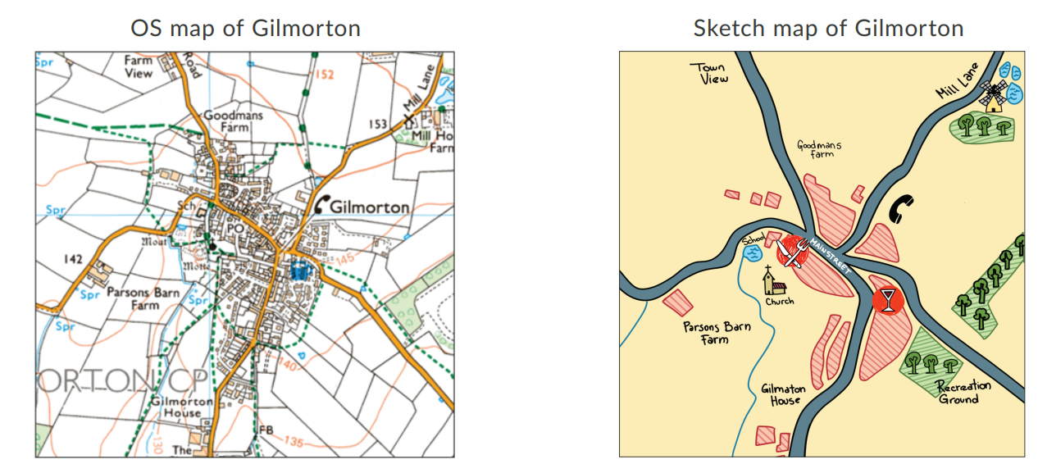 | Christian values: Respect, Compassion
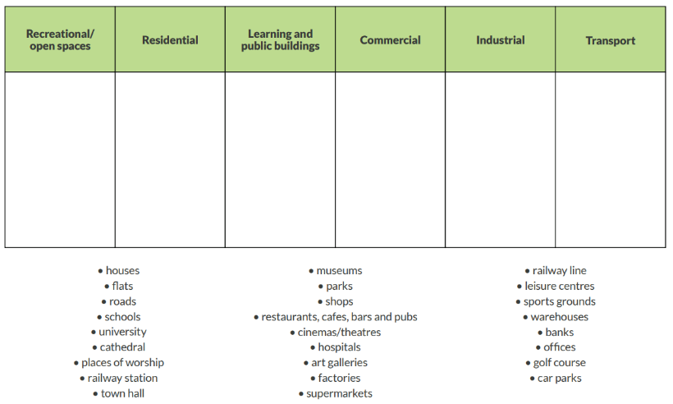  5. LO: To recognise and describe how Sleaford has changed over time.  How has Sleaford changed over time?  Explore: Discuss the different ways land can be used and sort the places by land use (see picture).  Learn:  The whole class recaps ideas from Lesson 2: what has changed in the area during their own time there; what they imagined the 100-year-old person would say about changes in their lifetime. Working in the pairs or small groups that created them, they look at the OS local area maps that they marked up in coloured pencil. What has been built in the area in the last few years, and why? What was there before? What about the 50 years before that (maybe their parents, teachers or grandparents know something about this)? The last century? Before that? How has this area changed? Has it grown or largely stayed the same? Why might that be?  Respond: Children use two maps of Sleaford (could snip from digimaps) one current and one historical. Explain the changes that have happened over time. Teacher could model this using a different location.  Reflect: What do you think the biggest change to our area has been? Justify your response. | Christian values: Respect, Compassion
6.To know that my local area will change.
How will Sleaford change in the future?
Explore: Recap learning about Sleaford by asking questions: Region? County? Nearby towns? Physical Features? Human Features?
Learn: As a class, children briefly revisit ideas they have discussed from Lesson 2 onwards about what could or should change in the local area. Share the ‘How are our neighbourhoods changing?’ reading text in the Oddizzi resources. Can you link this to our local area? (Discuss new Quarrington developments with plans for schools/shop/old peoples home etc).
Respond:
Children create a simple timeline stretching from 100+ years ago to the present day, and then 50 years into the future (when they too might have children or even grandchildren). They note down one or two key points from the past, and then, based on their knowledge of changes that have already happened, add four or five ideas about things that might change in the local area in future. There might be things in the local news that inform this, for example, a big new local development. Using fresh printouts of the local area Ordnance Survey map, each group draws on some of the main changes that they think could or should happen. Changes might not only be to the built environment, so they should also consider their sense points and how they might change in future.
Reflect: Today we have thought about how a town like Sleaford will change. How might this be different for a city like Lincoln? Show a map – what changes might happen over the next 100 years?

