RE
Year 3
Autumn Term 1 and 2
What does pilgrimage mean to individuals and communities?
Content overview
Places and journeys that people consider to be special.
How places become sacred.
What happens during a pilgrimage: the experience for individuals and communities and diversity in practice.
Local places of significance, religious and non-religious.
Previous Learning  Year 2  Sacred texts.  Religions and worldviews.  Reception  Idea of sacred and special.  Year 1  How people come together for celebrations and festivals.  Year 2  Sacred texts, key beliefs of Abrahamic and Dharmic traditions. | New Learning Objectives  - How going on a pilgrimage can strengthen the identity of individuals and communities.  - How pilgrimage reflects key beliefs e.g. Makkah and the 5 pillars of Islam.  - What actions and rituals people carry out during pilgrimages.  - What people experience during a pilgrimage and how this might be life changing.  - Why the experience of pilgrimage may have a different meaning for different people. |  | Unit Outcomes and Expectations  Pupils should be able to:  - Interpret the significance of a special journey and the way ‘journey’ can be used as a metaphor for life.  - Explain what meaning pilgrimage has for different individuals and communities.  - Make connections between pilgrimage and key beliefs.  - Interpret the actions and rituals that people carry out during pilgrimages.  - Ask relevant questions about peoples’ experiences during pilgrimages.
Disciplinary Knowledge:  How might pupils learn?  They could:  • interview people from different RWs who have been on a pilgrimage  • use TV programmes to compare aspects of pilgrimage (see under ‘Resources’)  • read accounts of pilgrimages and look for threads of commonality  • visit a local place of interest which has special meaning for some people  • explore the emotional and sensory aspects of pilgrimage  • analyse data and statistics, e.g. to show the numbers of people visiting various sites, how these fluctuate, etc.  Substantive Knowledge:  The meaning of pilgrimage  Pilgrimage is a significant journey carried out for a special reason. There are many examples of religious and non-religious pilgrimages (e.g. pilgrimage to a particular football ground or site of significance for a family, to war graves, to the place of birth of an important person, etc.) Many children’s books have the idea of journey as central to the narrative. ‘Journey’ is also used a metaphor for life.  Religious pilgrimages  Some places are regarded as sacred for all members of a religion, e.g. Makkah, where Muslims are expected to visit at least once in their life- time. Others are places visited predominantly by one denomination, e.g. Roman Catholics and Lourdes or sites associated with various saints. Some places have significance for more than one religion, e.g. Jerusalem, which is a place of pilgrimage for Jews, Christians and Muslims. It is worth discussing the impact of pilgrimage on the natural world and the way in which this challenges the value religious believers place on the environment and their duty to protect it. |  | 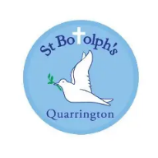  Link to our Christian Values  Friendship – Pilgrimages are important to make people feel part of something bigger than them. Being part of a religious community and giving a sense of belonging.  Perseverance – Sometime a pilgrimage can be challenging – saving up the money it will cost or actually completing the pilgrimage itself.
Vocabulary
journey, pilgrimage,
Christianity: Bethlehem, Gethsemane, Holy Island, Jerusalem, Lourdes, Rome, Walsingham.
Hinduism: Kumbh Mela, Lord Shiva, River Ganges, Varanasi.
Islam: Eid-ul-Adha, Hajj, Jerusalem, Makkah, Umrah.

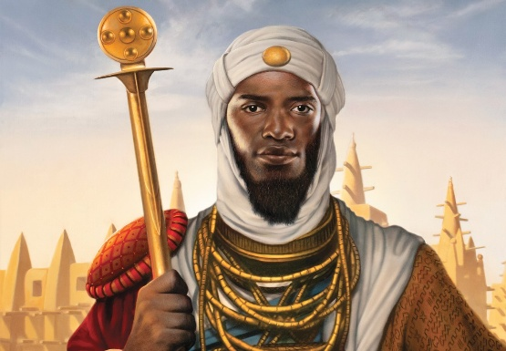  Case Study: Mansa Musa  ‘The Richest Man who ever Lived’  Who Was Mansa Musa?  Mansa Musa was the ruler of the Mali Empire in West Africa from around 1312 to 1337 CE. He is often described as one of the wealthiest people in history because the Mali Empire controlled major gold and salt trade routes across the Sahara Desert.  The empire covered parts of modern-day Mali, Senegal, Guinea, Niger, and neighbouring regions.  Why Is He Important for a Unit on Pilgrimage?  Mansa Musa’s famous pilgrimage to Mecca (Makkah) shows:  - Pilgrimage as an act of faith  - The scale and commitment involved in a special journey  - How a pilgrimage can transform individuals and communities  - How religious practice connects people across continents  - How one journey can have political, cultural, and economic effects  His story vividly demonstrates that pilgrimage is much more than travel—it can shape identity, strengthen belief, and influence the wider world.  Mansa Musa’s Pilgrimage (Hajj)  In 1324 CE, Mansa Musa set out on the Hajj. The journey likely took over a year and crossed thousands of miles of desert.  Historical accounts describe:  - Thousands of attendants  - Camels carrying gold  - Scholars, officials, and servants  - Stops in major cities such as Cairo  Mansa Musa gave generous gifts and donations during his travels. In Cairo, his spending and gifts were said to have affected local gold prices for years. This story illustrates both his wealth and the importance of generosity in Islamic practice.  Arrival in Makkah  In Makkah, he completed the Hajj rituals alongside Muslims from many different cultures and countries. This would have reinforced his sense of belonging to a global Muslim community (the Ummah | 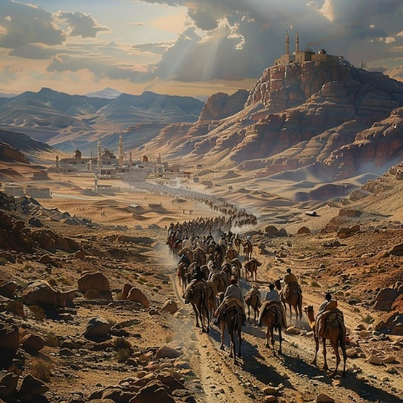  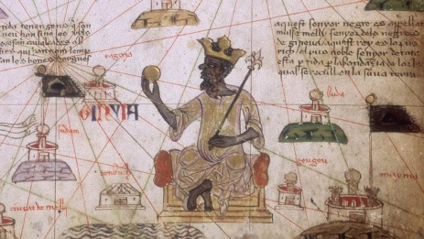
Links and Resources

Horrible Histories – Mansa Musa Bing Videos

Mansa Musa Facts for Kids

Musa - Students | Britannica Kids | Homework Help

Lesson Guide | Unit Questions
Lesson Guide | Theologians might ask... | Philosophers might ask... | Social Scientists might ask...
1.Why do people make special journeys?  Explore: Sort pictures into ordinary and special journeys.(e.g. trip to football stadium/sporting event/going to school/ going to the shop/going on holiday.  Learn: Begin with the pupils’ own experiences. Encourage them to share their thoughts about places that have a special meaning for them, whether religious or not. Ensure that pupils understand the concept of sacred space or place and that non-religious people might have similar experiences linked to, for example, sport or the birthplace of a famous person. You could also include extracts from books that involve journeys. Discuss the meaning of the word pilgrimage.  Engage pupils in thinking about the sensory and emotional aspects of special journeys as the spiritual experiences people claim to have.  Respond: Draw and label a special place. What makes it special? How do you get there? Who do you go there with? How does it make you feel?  Reflect: What makes a place special or sacred to people? (Theo)  What special journeys might a non-religious person make? (Sophie) | What make a place special or sacred to people?  How might the experience of pilgrimage deepen people’s religious faith?  How does being in a sacred place help believers to connect with God?  What is the meaning of rituals associated with pilgrimage?  What do people remember during pilgrimages?  How do pilgrims express their beliefs on pilgrimages?  Could anywhere be considered a pilgrimage site?  Do religious pilgrimages have deeper meaning than those associated with,  for example, famous people or sport?  What miraculous things do people believe happen during some pilgrimages?
2. Who was Mansa Musa?  Explore: Show a map of Africa. What do you know? Which places, rivers etc can you see? Which animals live there? Which religions might there be in Africa? Link to Y2 History.  Learn: Show the children 4 pictures: Gold, Crown, Camel, map of Africa. Who might these belong to? What sort of person might these represent? Use pictures, Horrible Histories Videos and notes to discuss who was Mansa Musa. Teach the children that Mansa Musa was one of the richest people in History. Look at the map of Mansa Musa’s pilgrimage to Hajj. Explain that Mansa Musa was a Muslim and he wanted to complete the special journey to Hajj (more links will be made to this later). Teach the children about Mansa Musa’s pilgrimage to Makkah and how he travelled with thousands of people (including camels loaded with gold!) and on the way gave many generous gifts, setting up hospitals, schools and colleges and using his wealth for good.  Respond: Children annotate a picture of Mansa Musa’s journey with facts about him and simple facts about his pilgrimage.  Reflect: What made Mansa Musa’s journey special? (Theo)  How did Mansa Musa’s pilgrimage bring people together? (Livi) | Philosophers might ask:  What makes a place sacred?  How are the senses involved in pilgrimage?  What special journeys might a non-religious  person make?  How is ‘journey’ a metaphor for life?  How does a place become a pilgrimage site?  Are visions real?  Is it possible to have a non-religious pilgrimage?
3. Why do Muslims go on Hajj?  Explore: Show the children 6 pictures or words – Mansa Musa, Camel, Gold, Africa, Mecca, Mosque. Who was Mansa Musa? Which religion did he follow? What was the special journey called? Why did he begin the journey?  Learn:  It is a duty for Muslims to go on pilgrimage to Makkah at least once in their lifetime, provided that they are physically able and can afford it. The pilgrimage is the fifth Pillar of Islam (see Year 2, summer term). Muslims try to go to Makkah during Dhu al-Hijjah, the twelfth month of the Islamic calendar. Millions of Muslims travel together. It reminds Muslims that everyone is equal before Allah. They must follow several important rituals whilst on Hajj including wearing special clothes and performing symbolic actions at different sites. (don’t go into these too much before next week)  Watch:  BBC Two - Belief File, Islam: The Hajj, Introduction to Hajj - the fifth pillar of Islam  Show some photographs of a modern Hajj, and return to Mansa Musa – how is this similar? Different? Was Mansa Musa treated differently because he was rich? (no everyone was treated the same, all wore the same white clothing, all completed the same pilgrimage.)  Respond: Underneath a modern day picture of Hajj, children write some of the reasons Muslims go on Hajj. Then they could answer the question, ‘How was Mansa Musa’s pilgrimage an act of faith?’  Reflect:  Why is Hajj an important act of worship for Muslims? (Theo)  Could somewhere become sacred even if you had never visited it? (Sophie)  How does Hajj help Muslims feel part of one worldwide community? (Livvy | Social Scientists might ask:  Why do pilgrimages matter to people?  How do they bring people together and  give them a sense of identity?  Why do people feel the need to make special  journeys, including into space?  What spiritual experiences do people share on pilgrimages?  Should people respect special and sacred  experiences, even if they do not mean anything to them?  How might the experiences of individuals differ?
4. What happens during Hajj?
Explore: Use the real objects or show a pilgrim’s bag - a map, a small water bottle, sandals, a white cloth (to represent ihram, explained respectfully), a passport. What can you remember about Hajj? Why do Muslims go on Hajj?
Learn:
Teach the children the different stages of Hajj (useful lesson on Oak which you could use parts of with an excellent narrative of each stage at the bottom in additional material): Hajj: a sacred duty for Muslims KS2 | Y4 Religious education | Lesson Resources | Oak National Academy)
Rather than children remembering all of the religious elements – the focus is on How might this stage make people feel?
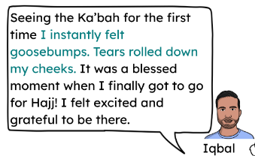
- Ihram
- Tawaf
- Sa'i
- Mount Arafat
- Mina
- Eid-ul-Adha
Respond:
Children could have a long picture strip in their book and as a class, you could move around the classroom using the Oak narrative to walk around each stage of Hajj, after each section they could write a sentence next to the corresponding picture to show what happens or how people would feel.
Reflect:
Watch Lesson Media: Hajj: the impact on believers | KS2 Religious education | Oak National Academy
Why do Muslims complete these rituals? (Theo)
Does completing a journey change a person? (Sophie)
Why do millions of people continue to complete Hajj today? (Livvy)
5. Eid-ul-Adha
Explore: True or False e.g.
Hajj is one of the Five Pillars. ✔️
Only children complete Hajj. ❌
Muslims wear special white clothing during Hajj. ✔️
Mansa Musa travelled to Jerusalem. ❌
Millions of Muslims travel to Makkah each year. ✔️
Hajj can strengthen someone's faith. ✔️
Learn:
Re-cap the pilgrimage of Hajj. What do you think happens when the pilgrimage ends? Eid ul-Adha is celebrated at the end of the pilgrimage (see Year 1, summer term). Muslims celebrate because they remember Ibrahim's faith and trust in Allah. Many Muslims celebrate Eid ul-Adha after completing Hajj, but Muslims all around the world celebrate it, even if they have not been on pilgrimage.
This festival reminds them of Ibrahim's obedience when he was told by Allah to sacrifice his son, Ismail. Muslims may sacrifice a sheep or a goat to symbolise the lamb provided by Allah for Ibrahim to sacrifice in place of Ismail.
Watch the video and information here to introduce Eid-ul-Adha:
When is Eid-ul-Adha 2025 and what is it? - BBC Bitesize
Could also use some of the information found here Eid al-Adha for Kids: Story & Meaning to explain more about what the day might look like.
Respond:
Read the 1st person account of Eid-ul-Adha ‘My Eid-Ul-Adha’. They could use highlighters to highlight themes, e.g. family, worship, generosity, celebration, community.
Then they could complete a spider diagram with Eid-Ul-Adha in the middle and around write the five themes each with a statement from Ayaans account. E.g. Community ‘Ayaan and his sister take food to the local food bank’.
Reflect: How do festivals and pilgrimages connect people?
Why is remembering Ibrahim important to Muslims? (Theo)
Why do people keep celebrating events that happened a long time ago? (Sophie)
How do celebrations help communities feel they belong? (Livvy)
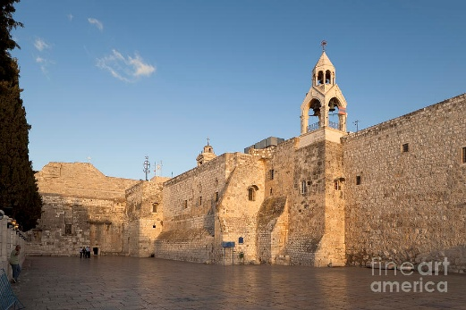
6.Why would Christians want to visit the place Jesus was born?
Explore: Show four pictures. Ask: Which picture doesn't belong?
🕋 Ka'bah
🐪 Mansa Musa
🎉 Eid-ul-Adha
⭐ Stable in Bethlehem
Learn: Imagine you could visit the very place where someone important was born. Who would you choose? (Harry Kane/Taylor Swift/King Charles). Christians believe that Jesus was born in Bethlehem. The most important site in Bethlehem is the Church of the Nativity in Manger Square. Inside is an area called the Grotto of the Nativity where there is a 14-pointed star, which marks the traditional site of the birthplace of Jesus Christ. Some pilgrims kiss the star to show their devotion. Near this spot is the ‘Chapel of the Manger’ where some Christians believe Mary placed Jesus after he was born. Display an image of the inside of the church and tell the children:
Imagine: Imagine...You have travelled for days.
You walk through the busy streets of Bethlehem. You arrive in a large stone church. People are praying quietly. Then...
A guide leads you down some narrow stone steps. Everyone becomes silent.
On the floor is a 14-point silver star. This star marks the place where Christians believe Jesus was born. Some people kneel. Some touch the star. Some pray. Some cry.
People have travelled from all over the world just to spend a few moments there
Ask: Why would some travel thousands of miles to visit this place?
The church has a very small entrance called the Door of Humility.
Everyone has to bend down to enter. It was made smaller centuries ago, but today many people also see it as a reminder to enter with humility and respect.
Respond:
Give children a photo of the grotto – children annotate – for instance - The silver star marks the birthplace, it is in Bethlehem, Pilgrims come from all over the world, this place reminds Christians that God came to Earth as Jesus.
Reflect:
How might the pilgrimage to The Church of the Nativity be different to Hajj?
Hajj was:
movement
millions of people
action
Church of the Nativity:
quiet
one special place
reflection
End the lesson with the stem sentence: Christians visit ________ because...
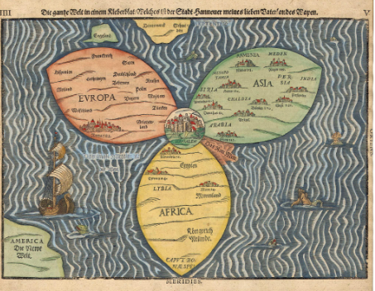
7. Why would Christians want to walk in Jesus’ footsteps?
Explore: Look at the map of the world drawn in 1581. What do you notice? How is it different to a map we would draw today? Show children that Jerusalem has been placed at the center of the world because for Christians at that time, Jerusalem was the most important place in the world.
Learn: Christians believe that Jesus visited Jerusalem at Passover time and was there during the week leading up to his death. Pilgrims remember key events in Jesus' final week, known as Holy Week. They might visit the Garden of Gethsemane, believed to be where Jesus prayed before he was
arrested by the Romans and put to death, the Via Dolorosa, the Church of the Holy Sepulchre and the Church of the Ascension. Many Christians believe that undertaking a pilgrimage to Jerusalem can bring them closer to what Jesus experienced as he approached his death.
Use some of the slides Jerusalem: a place of Christian pilgrimage KS2 | Y4 Religious education | Lesson Resources | Oak National Academy to show the children what happens on this pilgrimage and how people might feel.
Respond:
Over a page in their book, children make a journey map (this could be scaffolded by pictures/statements first) adding the different pilgrimage sites along it. They could also add thought bubbles to show how people might feel or speech bubbles to show what people might say along the journey. (see example in resources)
Reflect:
Why are these places sacred? (Theo)
Can walking where someone walked help you understand them? (Sophie)
Why do Christians continue making this journey today? (Livvy)

End the lesson with the stem sentence: Christians visit ________ because...
8. Can a holy place exist anywhere?
Explore: Guess where...display a picture of Walshingham with no clues and say that this is a site of pilgrimage. Can you guess where? Let children guess and then reveal Norfolk!
Learn:
Walsingham is where an important vision of Mary took place in 1601. It is claimed that Richeldis de Faverches, a Saxon noblewoman, who lived there had a vision in which she was taken by Mary to her home in Nazareth. This was the house where the Angel Gabriel promised Mary that she would give birth to Jesus. In this vision Mary asked Richeldis to build an exact copy of this house, which is why Walsingham is often called the Nazareth of England. Today, this copy of Mary's home is called the Holy House and is found in the Anglican National Shrine Church in Walsingham. The Catholic National Shrine is located at the Slipper Chapel, where pilgrims would remove their shoes to walk the last mile into the village.
Use the resources and videos found here to learn more:
Schools' Resources - The Shrine Of Our Lady Of Walsingham
Respond
Comparison table.
Bethlehem/Jerusalem/Walsingham or could just focus on Walsingham and HAPS could compare underneath.
Three rows:
Why do Christians visit?
What do they remember?
How might they feel?
Reflect
Why do Christians believe Walsingham is special? (Theo) Can somewhere become holy because of someone's experience? (Sophie) Why do some pilgrimage sites continue attracting visitors for hundreds of years? (Livvy)
End the lesson with the stem sentence: Christians visit ________ because...
9. Why is the River Ganges so important to Hindus?
Explore: Place six images on the board. Tap water, Swimming pool, Baptism, River Ganges, Hajj, Bethlehem
Which of these uses water for a special reason?
Learn: Introduce vocabulary renew and purify. We have been learning about Christian places of pilgrimage, linked to learning about the life of Jesus. Hindus believe that going on pilgrimage renews them.
Show a picture of the River Ganges. Ask ‘Can water ever be more than just water?’
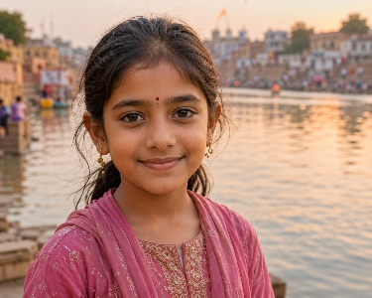
Read about Anaya’s journey to the River Ganges. What have we found out?
Teach the children:
- Hindus call it Mother Ganga.
- It is believed to have come from heaven.
- Many believe its water can purify them.
- Pilgrims often take holy water home for family.
- Millions of people visit every year.
If needed: Then children could read the Twinkl fact sheet about the River Ganges (in folder). Anaya

Respond: Annotate a picture of the River Ganges with key learning. Then add – why is this river important to Hindus?
Reflect:
Why is the River Ganges sacred to Hindus? (Theo)
Can water become holy? (Sophie)
Why do millions of people continue visiting the River Ganges today? (Livvy)
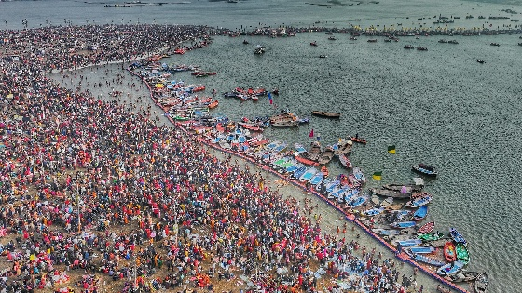
10. What happens at Kumbh Mela?
Explore: Show an aerial photo of Kumbh Mela. Don't tell them anything. What do you notice? How many people? Where are they? Why might they all be there?
Learn: Introduce Kumbh Mela. Tell children that these events take place by rotation at one of four different pilgrimage sites. Millions of people share in ritual bathing at the Kumbh Mela festival at four different riverside locations. Hindus take part in ritual bathing, believing that their sins will be washed away. This is followed by spiritual purification and a ceremony to ask for the blessings of the deity.
Use the videos and information below to teach the children more.
KS2 Religious Studies: A Hindu pilgrimage - BBC Teach
Kumbh Mela: What is the Hindu festival? - BBC Newsround
Respond: Remind children of Anaya from last week. Ask children to read her account of Kumbh Mela. Complete the table:

What did Anaya do? | Why was it important?
Bathed in the river
Prayed
Visited the temple
Travelled with family
Received a blessing
Then answer: How do you think Anaya felt at Kumbh Mela?
Reflect:
Why is ritual bathing important for many Hindus? (Theo)
Can one special journey change a person? (Sophie)
Why do millions of Hindus choose to gather together at Kumbh Mela? (Livvy)
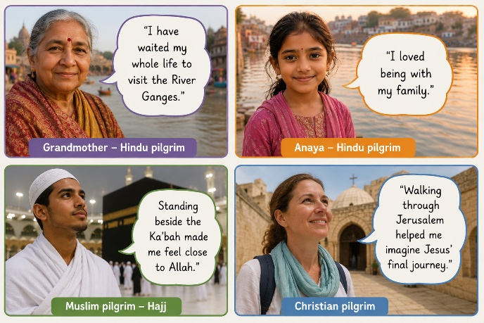
11. What makes a pilgrimage meaningful?
Explore: Vocab match or Q+A from across the unit.
Learn:
Give the children 4 quotes.
Allow children plenty of discussion time to talk about the question ‘Who enjoyed their pilgrimage the most?’
Hopefully the children will come to realise that this is a really difficult question to answer as they all got different meaning from their pilgrimage. Let’s think about what we have learned so far, right back from Mansa Musa up to Anaya and The River Ganges. Give children time to look through the learning in their books too.
Complete a diamond 9 activity ranking the most important to least: praying, family, remembering, visiting a holy place, feeling peaceful, community, following God, helping others, learning.
Allow time for discussion.
Respond: Give children small copies of each of the four pictures. For each one complete an ‘I think, I know, I wonder’. E.g. for the grandmother: I know she visited the river. I think she felt fulfilled. I wonder if she will take some water home with her?’
Reflect: As a class – draw a large heart on the board. Fill it with words linked to pilgrimages e.g. Hope
Prayer Family Peace Belonging Community Faith Love Remembering God Journey Reflection Blessing. Could ask which word do you think is most important to each pilgrim?

12. What does pilgrimage mean to individuals and communities?
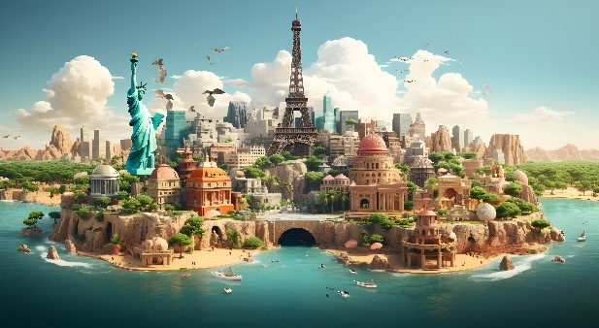
Explore: Around the room place 8 photographs from the unit. Children work in pairs.
For each one they answer:
- Who?
- Where?
- Why?
- Which religion?

Learn: Explain that Sophie the philosopher will be with us for the whole of this lesson as we are thinking like philosophers: Show the image:
If you could make ONE journey to anywhere in the world, where would it be? Gather some ideas verbally or on post-it notes. Why? (consider family, learning, peace, fun). Many people think of life as a journey. Draw a road with ‘birth’ at the start. What comes next? Build it together adding lots of life events.
Then teach them that different people have different beliefs about this journey:
Abrahamic traditions (Islam/Christianity in this unit)
Life happens once.
The choices people make matter.
Many believe they hope to be with God after death.
Dharmic traditions (Hinduism in this unit)
Life is one journey among many.
Some believe life continues through rebirth.
People try to live well to move closer to moksha.
Non-religious worldviews
Many people believe this life is the only one.
That makes this journey especially precious.
Respond: ‘My Life Journey’
Children draw: A winding road. Along it:
Things that have already happened.
Then...
Things they hope will happen.
Maybe:
- Learn to drive
- Go to university
- Become a vet
- Travel
- Get married
- Help people
- Have children
- Write a book
Then add one thought cloud with a question they have about life: e.g. Will I be happy? Will I travel the world? etc
Reflect:
How do different religions explain life's journey? (Theo)
What experiences shape the journey through life? (Livvy)
Is the destination or the journey more important? (Sophie)
Then link back to Mansa Musa, we started off by thinking about his journey and today you’ve started thinking about your own.
Feedback:

