Year 4
Autumn Term 1 and 2
How do people welcome new life into the world?
How do people show their commitment to a religion?
Content overview
Birth and commitment ceremonies
Symbols and clothing associated with these ceremonies.
Previous Learning  Year 3  What pilgrimage means to individuals and communities.  Which RW communities can be found in the neighbourhood.  Previous learning linked to this unit  Reception  Why babies are special.  Year 2  Sacred texts.  Beliefs.  Year 3  Communities and belonging. | New Learning Objectives  • how different ceremonies, clothing and symbols contribute to people’s sense of belonging and identity  • what promises tell us about what people believe and how they may be strengthened by the presence of the community  • which rituals and actions characterise ceremonies  • how ‘sacred and holy’ are key components of religious ceremonies, e.g. promises made to God  • how commitment ceremonies may have different meanings for different people |  | Unit Outcomes and Expectations  Pupils should be able to:  describe a) the ways in which people welcome new life into the world and b) what happens during commitment ceremonies  • explain how clothing and symbols contribute to people’s sense of identity  • compare promises and actions made during different ceremonies  • explain the difference between what people promise during religious and non-religious ceremonies  • consider how scriptures may be used in religious ceremonies
Disciplinary Knowledge:  How might pupils learn?  - talk to members of faith communities or families about different ceremony  • observe or act out a ceremony such as a baptism  • look at some symbolic artefacts (through objects or pictures) such as the 5 Ks, a cross, a candle and ask questions about them  • find out how many people in the class have had a birth ceremony (this needs to be handled with sensitivity)  Substantive Knowledge:  See LAS for full explanation of Substantive Knowledge. |  | 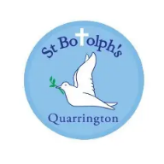  Link to our Christian Values  Thankfulness – the joy of new life.  Respect – appreciating religious and non-religious beliefs.  Truthfulness – how promises are made and kept.
Vocabulary
Christianity: baptism, baptistry, believers’ baptism, candles, confirmation, dedication, font, Godparents, Holy Communion, immersion, purity, oil, ring, sacrament, vows, water.
Judaism: Brit Milah, Bimah, Bar Mitzvah, Bat Mitzvah, kippah, mohel, phylacteries/tefillin, Shema, tallith, Torah.
Sikhi: amrit, Amrit Sanskar, Five Ks, Granthi, Kaur, Khalsa, Mool Mantra, Naam Karan, Singh.

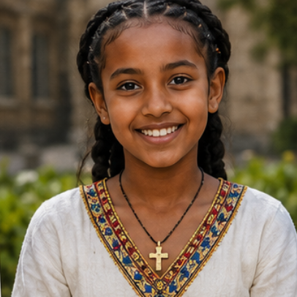  Case Study:  Meet Hana  Name: Hana Tesfaye  Age: 10  Lives: Addis Ababa, Ethiopia  Family: Mum, Dad, older brother and grandparents  Likes:  - Playing football with her friends  - Singing in church  - Helping her grandmother bake injera  - Listening to stories from the Bible  Something important to Hana:  Her Ethiopian Orthodox Christian faith.  Big Question:  "Why do Christians celebrate baptism?"  Hana's Story  Hana loves looking at family photographs.  One of her favourites shows her wrapped in a white shawl as a baby.  Her family often tell her about a special day when she was welcomed into the Ethiopian Orthodox Church.  The church was full of people dressed in white.  Family members travelled a long way to attend.  Prayers were said and candles were lit.  Everyone celebrated together afterwards.  Hana says:  "My family say this was the day I officially became part of God's family."  Now Hana wants to learn more about why baptism is so important to Christians around the world. | 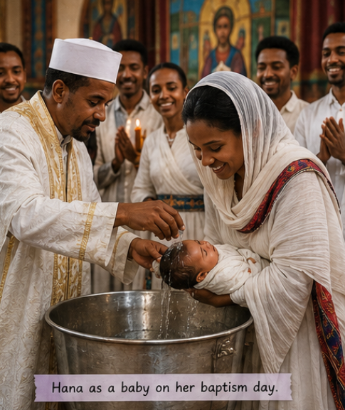
 | Links and Resources.

Lesson Guide | Unit Questions
Lesson Guide | Theologians might ask... | Philosophers might ask... | Social Scientists might ask...
Lesson 1: Why do people celebrate important moments?  Explore:  Show some pictures linked to pilgrimage (recap of Y3 Autumn) What can you remember. Reveal clues if needed:  - People travelled to Makkah.  - People travelled to Jerusalem.  - Pilgrims often travelled together.  - Journeys could change people.  - Mansa Musa travelled to Makkah.  - Pilgrims often visited special places.  Lead into:  "Last year we learnt that people make special journeys. This year we're going to discover that people also celebrate special moments in life."  Learn:  The Invitation Collection  Bring in a beautifully decorated box labelled: Invitation Collection  Inside are envelopes.  Children help you open them one by one.  Examples (see resources):  - Christening invitation  - Naming ceremony invitation  - Bar Mitzvah invitation  - Confirmation invitation  - Wedding invitation  - Birthday invitation  - Graduation invitation  - Baby shower invitation  Spread them across the carpet.  Ask:  - What do you notice?  - Which ones have you heard of?  - Why do people send invitations?  - What might all these celebrations have in common?  Then introduce the word: Ceremony  A ceremony is a special event that helps people celebrate an important moment.  Explain that over the next term they will become Ceremony Detectives, investigating why different people celebrate different moments.  Respond:  Why do people celebrate important moments?  Children draw a large circle in the middle of the page labelled:  Important Moments  Around it they create a spider diagram.  Ideas could include:  - being born  - starting school  - birthdays  - getting married  - winning an award  - moving house  - welcoming a baby  - leaving primary school  Then underneath:  I think people celebrate important moments because...  One or two sentences.  Reflect:  Theo  Why do people think some moments in life are special?  Livvy  How do ceremonies help people feel that they belong?  Sophie  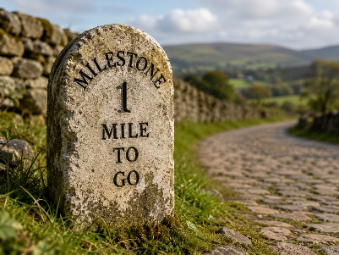  Do you think every important moment needs a ceremony?  Why?  Display a picture of a stone on an old road.  Explain:  "Hundreds of years ago, milestone stones told travellers how far they had travelled."  Then say:  "Today we also use the word milestone to mean an important moment in someone's life." | Theologians might ask:  Could these ceremonies take place anywhere or does it have to be a sacred space?  What beliefs are linked to special clothes or objects worn/used during commitment ceremonies?  How do certain actions and rituals show what people believe?  Why do many people believe that joining a religion must be marked by a special ceremony?  What do people mean when they say that a baby is a gift from God?  Can you believe something at one age then change your beliefs later?
Lesson 2: Why do people welcome new life?  Explore:  Return to the Invitation Collection.  Spread the invitations back out. Ask the children:  "Last lesson we discovered lots of reasons people celebrate. Which invitations do you think belong together?"  They'll probably sort them into groups:  - Baby celebrations  - Growing up  - Weddings  - Achievements  What do these invitations all have in common?  (Point to the Christening and Naming Ceremony.)  Hopefully:  "They're about babies."  Introduce today's enquiry:  "We're going to investigate why people think welcoming a new baby is worth celebrating."  Learn:  Hook: A New Baby Has Arrived!  Walk into class carrying (or show pictures of)  👶 a baby basket (or Moses basket!)  Inside:  - baby blanket  - tiny baby grow  - teddy  - baby socks  - congratulations card  - hospital wristband (toy one)  - photograph of tiny feet  - baby rattle  Then ask  Why are people excited? Collect vocabulary. Happy, love, family, celebrate, welcome, belong, new beginning, community  "Some families have big celebrations when a baby is born. Some have small celebrations. Some have religious ceremonies, some don't. Every family is different, and today we're exploring the many ways people choose to welcome a new life."  Now introduce a second picture.  One family is holding a new baby. Another family is gathered around them.  Who is celebrating? Hopefully they notice:  Grandparents.  Friends.  Family.  Community.  Discuss the word: Belonging  Belonging means feeling accepted, loved and part of a group.  Show photographs of:  - baby shower  - planting a tree  - family meal  - naming celebration  - welcoming party  - grandparents meeting the baby  Ask:  Why do people do these things?  Every culture celebrates differently...but nearly everyone celebrates somehow.  Only then say...  "Some people also have religious ceremonies to welcome babies.".  Respond:  Why do people welcome babies?  Children draw this simple diagram or something similar straight into books.  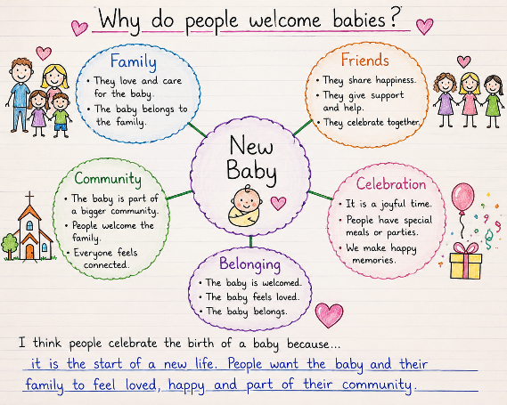  Then complete  I think people celebrate the birth of a baby because...  Extension  Which celebration do you think would make a new family feel most welcome?  Explain your answer.  Reflect  Bring back the milestone image from last week’s reflect task.  A milestone is also an important moment in someone's life.  Ask  What milestones have you already reached?  Children might say  - born  - first birthday  - started school  - learnt to ride a bike  - lost first tooth  - learnt to swim  Then ask  Why do you think being born might be everyone's very first milestone?  That's a lovely philosophical question.  follows. | Philosophers might ask:  Are some things special for everyone?  Are certain objects sacred just to the people who belong to specific religions? Should everyone show respect for them?  Is it right for someone to make promises on behalf of another person?  Can a baby believe something?  Does wearing special clothes or symbolic objects make you into a better person?  Do you remain the same person inside, no matter how old you get?  Can you belong to a religion without going through a ceremony?  Should promises always be kept?  Can you make a promise on behalf of someone else?
Lesson 3: Why do some Christians baptise babies?  Explore:  Make a simple washing line style display in the classroom or on the RE board. Name it the Celebration Timeline. Add the word birth. Recap Lesson 2.  Ask:  Why do people celebrate when a baby is born?  Hopefully:  - new life  - love  - family  - belonging  - welcoming  Then hold up two invitations from last lesson. Naming Ceremony/ Christening  Ask: Both welcome a baby...  So what's different about them?  Today we're investigate one of these ceremonies.  Introduce Key Vocab for the session:  New Vocabulary  Baptism  A ceremony welcoming someone into the Christian family.  Christening  Another word some Christians use for a baptism.  Godparent  An adult who promises to help a child grow up knowing about the Christian faith.  Learn:  Introduce Hana  "This is Hana."  "She lives in Ethiopia."  "When she was a baby, her family took her to church for a very special ceremony."  Show another photo.  Hana with her family outside church.  Ask  What do you notice?  How might everyone be feeling?  Hana’s Story  I'd tell it almost like a picture book.  When Hana was born, everyone in her family was excited.  Her grandparents travelled to meet her.  Neighbours came to visit.  People brought gifts.  But there was another celebration that was very important to Hana's family.  A few weeks later...  They all went to church which is a sacred space for Christians.  Today was Hana's Baptism.  Investigation Time (See resources for Photos)  Show photographs one at a time.  Rather than explaining first, let children notice.  Photograph 1  Outside the church.  Who has come?  Photograph 2  White clothing.  Why white?  Children infer: clean new special  Photograph 3  Water.  Why water?  Collect ideas.  Then explain simply:  Christians believe water is a sign of a new beginning and reminds them that God welcomes people into his family.  Photograph 4  Parents and godparents.  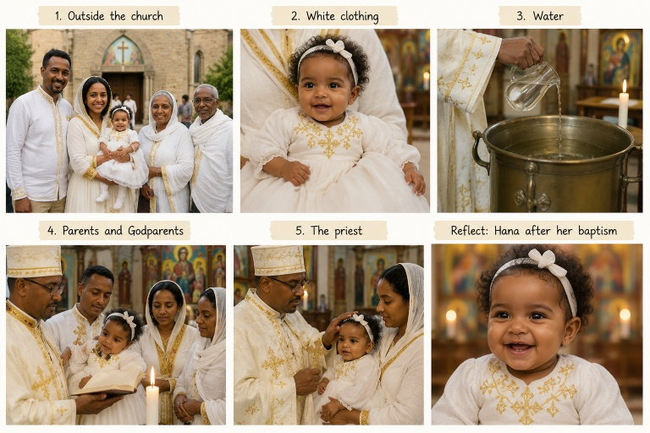  Who is making promises?  This is where your golden thread begins.  Adults.  Not Hana.  Photograph 5  Priest.  Why is everyone gathered together?  Community.  Church family.  Belonging.  Respond:  I think this deserves the beginning of your recurring resource.  Children complete their first ‘Ceremony Investigation Page’. This should be over one page in their book and each celebration could have the same format:  Every ceremony in Year 4 could have exactly the same page.  Ceremony Investigation:  Ceremony  Religion  What happens?  Special objects  Who makes the promises?  What does this ceremony show Christians believe?  Reflect  Show Hana smiling after the ceremony.  Ask  Imagine Hana is too little to remember today.  One day her parents show her these photographs.  How might she feel?  Loved?  Special?  Welcome?  Part of something?  Then ask  Sophie  Can someone belong to a community even if they are too young to choose?  Then add to the display washing line a photo (or the info mat in resources) of Hana at her baptism. | Scientists might ask:  Why do people associate special clothes or objects with special days, e.g. birthdays, weddings?  What are non-religious people celebrating at a birth ceremony?  Why does belonging to a community matter?  What kind of things are people expected to do to show that they belong to a community? How does a person show that they belong to a family or school?  How is one school community different to another?  Why might individuals or families belong to more than one RW?  Is belonging to a group always a good thing?
Lesson 4: Why do adults make promises for babies?
Explore: Bring back Hana's photographs. Rather than asking, "What happened?", ask:
Who can remember something that happened at Hana's baptism?
Build a retrieval mind map:
- water
- church
- white clothes
- priest
- family
- godparents
- celebration
Then ask one question:
Could Hana make the promises herself?
Learn:
Show three large envelopes. Each contains one promise.
Promise 1
I promise to love you and care for you.
Promise 2
I promise to help you learn about Jesus.
Promise 3
I promise to pray for you and help you grow in the Christian faith.
Ask:
Who do you think is saying these promises?

Look again at the photographs from last lesson.
Who was standing beside Hana?
Why do you think they were there?
Teach the children:
Some Christians believe babies are too young to choose for themselves.
Parents and godparents make promises.
Later, when the child grows older...
They can decide whether they want to make those promises themselves.
Don't mention Confirmation in detail yet (this comes later in the unit)
Look at each promise in more detail (a slide each)
Promise 1
"I promise to love and care for you."
Ask
What might that look like?
- reading stories
- comforting
- feeding
- helping
Promise 2
"I promise to help you learn about Jesus."
How might they do that?
- church
- Bible stories (Christians believe the Bible is a Sacred Text)
- praying
- Christmas
- Easter
Promise 3
"I promise to pray for you."
What is prayer?
Talking to God.

Respond:
Promises for Hana
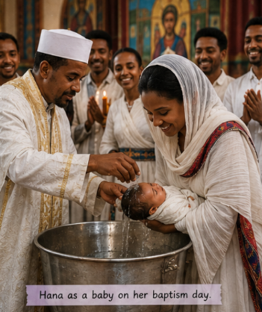
Children draw or stick a photo of Hana in the middle of the page.
Around her they create speech bubbles.
Each bubble contains one promise and an illustration.
For example
"I promise to love and care for you."
"I promise to help you learn about Jesus."
Then underneath
Christians make these promises because...
Extension
Which promise do you think is the most important? Explain why.

Reflect:
Using Sophie:
"Babies should choose their own religion when they are older."
Children stand somewhere along an opinion line.
Agree
Unsure
Disagree

Rules:
No right answer.
Listen respectfully.
Use evidence.

Then ask
Why might Christians answer this differently?
Some might say
Parents should guide children.
Others might say
Children should choose themselves.
Lesson 5: Can you celebrate a new baby without religion?
Explore:
Display two photographs side by side.
- Hana's baptism.
- The Naming Ceremony invitation from Lesson 1.
Ask the children:
- Which ceremony have we already investigated?
- What happened at Hana's baptism?
- Who made the promises?
- Why did Hana's family choose this ceremony?
"Do you think every family chooses a religious ceremony?"
Learn:
Introduce vocab:
Humanist
Someone who believes people can live good lives without following a religion.
Naming Ceremony
A celebration to welcome a baby and give them their name.
Guideparent
A trusted adult chosen to support and encourage the child as they grow up.
Introduce Mia, whose family are Humanists. Show a photograph of Mia with her parents outdoors in a beautiful park or garden.
"When Mia was born, her parents wanted to celebrate her arrival. They didn't belong to a religion, but they wanted all of their family and friends to come together to welcome Mia into the world."
"They decided to hold a Naming Ceremony."
Show a second photograph of family and friends gathered together.
Ask:
- What do you notice?
- How is this similar to Hana's celebration?
- What is different?
Explain simply that Humanists believe people should make kind and thoughtful choices without following a religion. They still enjoy celebrating life's important moments.
Show photographs one at a time.
- Family and friends gathered together.
- Mia being held by her parents.
- Someone reading a welcome message.
- Guideparents (or supporting adults) making promises.
- Everyone celebrating together afterwards.
Although there is no baptism or church, there are still promises.
Who is making the promises this time?
Parents.
Supporting adults.
Family.
Friends.
Respond
As in session 3, children complete a similar Ceremony Investigation Sheet.
At the bottom, ask one comparison question:
What is the same about Hana's baptism and Mia's naming ceremony?
Reflect
Show both photographs of Hana and Mia again.
"Both babies were welcomed with love.
Does belonging always have to be religious?"
Then finish with Sophie's question:
What makes someone feel that they belong?
They'll probably suggest:
- being loved
- being included
- being listened to
- family
- friends
- people caring for you
Add Mia and her naming ceremony onto the washing line display.
Lesson 6: What do welcoming ceremonies have in common?
Explore:
Display four photographs without any labels.
- Hana outside church
- Water at the baptism
- Mia's Naming Ceremony
- Guideparents making promises
Sort the photographs into two ceremonies?
How did you know?
Hopefully they'll identify things like:
- church
- water
- family
- outdoors
- speeches
- priest
Which things happened in BOTH ceremonies?
Learn:
Today the children become Ceremony Detectives.
One by one or give children a brown envelope with evidence cards. They should work in threes to place the card into a venn diagram (use PE hoops?) in the correct place. Or just allow them time to discuss each card.
🕵️ Evidence 1
Families gathered together.
✔ Baptism
✔ Naming Ceremony
🕵️ Evidence 2
People made promises.
✔ Baptism
✔ Naming Ceremony
🕵️ Evidence 3
A baby was welcomed.
✔ Baptism
✔ Naming Ceremony
🕵️ Evidence 4
People celebrated afterwards.
✔ Baptism
✔ Naming Ceremony
🕵️ Evidence 5
Water was used.
✔ Baptism
✘ Naming Ceremony
🕵️ Evidence 6
The ceremony happened in church.
✔ Baptism
✘ Naming Ceremony
Ask:
Which clues are about welcoming?
Which clues are about religion?
Some parts are about celebrating a baby.
Some parts are about Christian beliefs.
Main Learning
Build a Venn Diagram together.
Baptism
- church
- priest
- water
- God
- Christian family
Both
- family
- baby
- celebration
- promises
- belonging
- welcoming
- photographs
- special clothes
Naming Ceremony
- Humanist
- welcome message
- guideparents
- no church
- no baptism
Respond:
Comparing Welcoming Ceremonies
Give children a blank copy of the Venn diagram in their book. Naming Ceremony/Baptism/Both. Fill in as much as you can. LA children could have prepopulated cards to sort.
Then finish with:
I think both ceremonies are important because...
Reflect:
Display these statements.
- A baby needs love.
- A baby needs family.
- A baby needs to belong.
- A baby needs promises.
Ask:
Do all babies need these things?
So why do different families celebrate in different ways?
Theo
Why do Christians believe baptism is an important way to welcome a baby into God's family?
Livvy
How did Hana's family and Mia's family welcome their babies in different ways?
Sophie
Is belonging more important than the type of ceremony you have? Why?
Lesson 7: When are people ready to make their own promises?
Explore:
Show three pictures:
Hana/Mia/ An empty silhouette labelled "Someone aged 13"
Ask:
- Who made the promises for Hana?
- Who made the promises for Mia?
Then point to the empty silhouette.
Ask:
Should somebody this age still need adults to make every promise for them?
Learn:
Show the children a range of objects/pictures.
- Dummy
- Teddy
- School jumper
- House key
- Debit card
- Driving licence
- University hoodie
- Wedding ring
Children place them on a timeline. What changes as people grow older?
e.g.
- more responsibility
- more independence
- more choices
- more trust
Introduce key vocabulary:
Responsibility - Being trusted to make good choices.
Commitment - Choosing to make an important promise and trying to keep it.
Give each group a set of Responsibility Cards.
Examples:
- Choosing your own clothes
- Walking to school
- Looking after a pet
- Choosing your hobbies
- Looking after younger children
- Deciding what you believe
- Making an important promise
- Getting married
- Voting
- Driving
Sort them: Baby/ Young Child/ Older Child/ Teenager/Adult
Now introduce the word: Identity
Identity is who you are, what matters to you and the choices you make.
How is your identity changing as you grow older?
Children might say
- interests
- friendships
- responsibilities
- clubs
- talents
- beliefs
Respond:
Growing Up Means...
Children draw a path. Along it they write:
"I can..." e.g.
"I can dress myself."
↓
"I can make some choices."
↓
"I can make important promises."
Then underneath
I think people should make their own promises when...
Reflect:
Use a diamond 9 on Seesaw.
Being loved
Being trusted
Being responsible
Making choices
Belonging
Keeping promises
Helping others
Learning from mistakes
Which is most important as you grow up?

Theo
Why do some religions believe that people should choose to make important promises when they are old enough to understand them?
Livvy
How do people's responsibilities change as they grow up in different families and communities?
Sophie
Can someone make a promise if they don't really understand what they are promising?
Lesson 8: Why do some Christians choose Confirmation?
Explore
Display two photographs. Hana's baptism. A teenager (back turned so it's a mystery!)
Who made the promises for Hana?
Could Hana make those promises herself?
Today we're meeting somebody who is old enough to choose for themselves.
Learn:
Introduce Daniel:
"When Daniel was a baby he was baptised."
"His parents made promises for him."
"Now Daniel is thirteen."
"He has decided that he wants to make those promises himself."
Why do you think Daniel wants to do that?
Introduce vocabulary:
Confirmation - A Christian ceremony where someone chooses to confirm the promises made at their baptism.
Commitment - Choosing to make an important promise and keep it.
Holy - Connected with God.
Scripture - Special writing that believers believe is sacred.
Investigation
Give children 2 evidence sources – a photograph and an order of service. Give them time to study both and see what they can learn about confirmations.
Could use the questions:
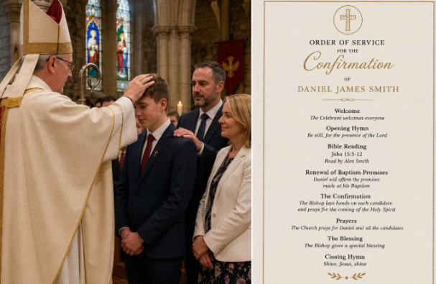
• Where is he?
• Who is with him?
• What is everyone wearing?
• Why might they be dressed like that?
• Does this look ordinary or special?
• What clues suggest this is a religious ceremony?
Use the resource here to learn more:
Resources - RE:quest
Resources - RE:quest
Respond:
Ceremony Investigation on a page in books (similar format to before)
Ceremony:
Religion:
What happens:
Special clothing and symbols:
Who makes the promises?
How does the community help?
What is sacred?
What does this ceremony show about Daniel's identity?
Reflect
Daniel says “Today I chose to make these promises because I believe them."
How might Daniel feel?
Then Sophie asks
Should important promises always be your own choice?
Lesson 9: Why is a Bar or Bat Mitzvah an important milestone for Jewish young people?
Explore:
Give the children some statements said by Hana/Mia or Daniel. Children match the statement to the correct person e.g.:
💬 "My parents made promises for me."
💬 "I chose to make these promises myself."
💬 "My family celebrated with me afterwards."
💬 "I was welcomed into a community."
💬 "My ceremony happened in church."
Today we're meeting another young person who is becoming responsible for their own faith. Discuss the difference between a Bar and Bat Mitzvah.
Reveal...
Mimi (12)
Watch: KS2 Religious Studies: What is a Bat Mitzvah? - BBC Teach
Learn:
Show children 5 pictures/artefacts:
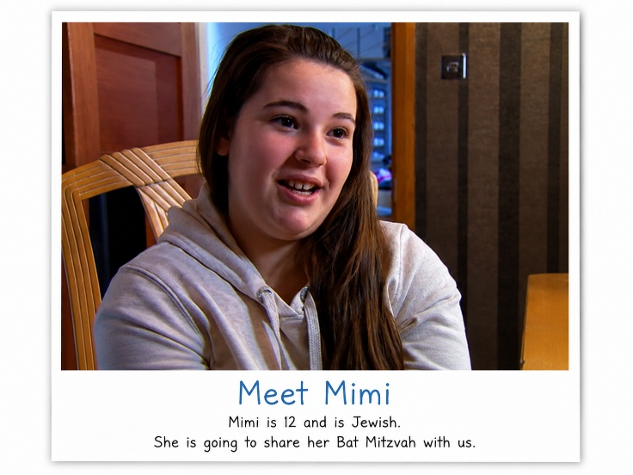
Torah Scroll, Tallit (prayer shawl), Star of David Necklace, Invitation to Mimi’s Bat Mitzvah celebration, Mimi reading from the Torah in the Synagogue.
What might each object tell us about Mimi's special day?
Then look at each object in more detail, teaching its purpose.
Torah
Explain
This is the Jewish holy book.
At a Bar or Bat Mitzvah, the young person reads from the Torah for the first time as someone taking responsibility within the Jewish community.
- It rolls rather than having pages.
- It is treated with great respect.
- It is read aloud during the ceremony.
Tallit
Some Jewish people wear a prayer shawl called a tallit. It reminds them of God's commandments.
Star of David
Symbol. Identity. Belonging.
Again, another objective.
Invitation
Community. Family. Celebration.
Key vocabulary: Bar Mitzvah Bat Mitzvah Torah Synagogue Rabbi Tallit
Then show the children a photo of Mimi at her Bat Mitzvah,
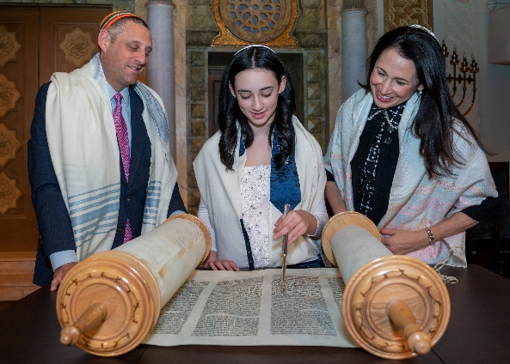
Respond
Complete a Bat Mitzvah Ceremony Investigation sheet in a similar format to the others building up in their books.
Reflect:
Sophie asks
Should everyone celebrate growing up in the same way?
Can a celebration change the way someone thinks about themselves?
Add the picture of Mimi at her Bat Mitzvah to the washing line display.
Lesson 10: Why do some Sikhs choose the Amrit Sanskar ceremony?
Explore
Ceremony Sort
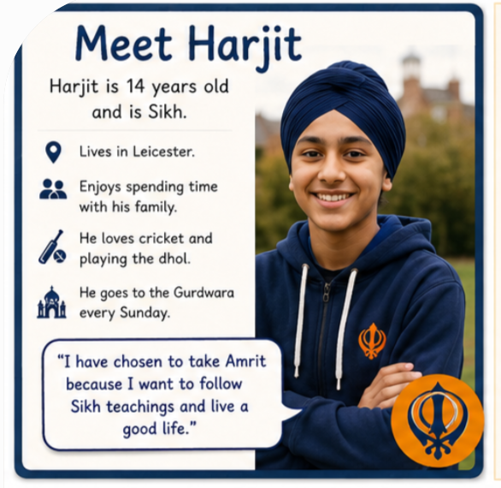
On the board are four images. Sort them into 2 groups – Parents make promises and Young person makes promises.
Baptism
Confirmation
Bat Mitzvah
Naming Ceremony
Today we're meeting someone who is making another important choice.
Learn
Meet Harjit
Age: 14
Lives in Leicester
Enjoys cricket and playing the dhol
Attends the Gurdwara every Sunday with family.

Watch:KS2 Religious Studies: Taking Amrit - BBC Teach
Rather than an Order of Service this time...
I'd make this:
The Five Clues
Show children the 5 K’s represented with an image: Why do you think these could be important?
Then explain.
Each object reminds Sikhs how to live.
Introduce the ceremony.
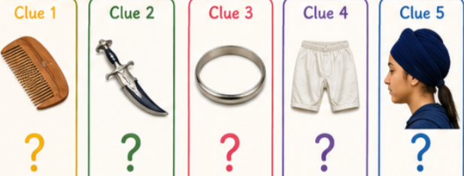
Harjit has chosen to take Amrit.
They promise to:
- follow Sikh teachings
- remember God
- help others
- live honestly
- join the Khalsa
Scripture - Guru Granth Sahib
During Amrit Sanskar, prayers from the Guru Granth Sahib are read because Sikhs believe it is their living Guru.
Compare this with: Bible/Torah
For more info on Amrit see the Oak lesson: Lesson: Perspectives on taking Amrit | Oak National Academy
Respond
Continue your Ceremony Investigation.
What does this ceremony show about Harjit's identity?
Harjit has chosen to commit to Sikh beliefs and become part of the Khalsa.
Reflect:
Can symbols help people remember who they want to be?
Children immediately think beyond religion e.g.
Football shirts.
Wedding rings.
School uniform.
Friendship bracelets.
Theo
Why do Sikhs believe the Guru Granth Sahib is important during Amrit Sanskar?
Livvy
How do the Sikh community support Harjit during this ceremony?

Lesson 11: How do clothing and symbols help people show who they are?
Explore:
Without looking at your books, what special clothing or symbols can you remember linked to Birth ceremonies?
As they call them out, build a class mind map.
Could include:
- White baptism gown
- Water
- Candle
- Cross
- Bishop
- Bible
- Torah
- Tallit
- Star of David
- Five Ks
- Guru Granth Sahib
- Turban
- Khanda
Now ask: Why don't people just wear ordinary clothes?
Learn:
Welcome to the Identity Museum. Around the room are Museum Stations, each containing a photograph.
Station 1
White baptism gown
Station 2
Cross necklace
Station 3
Bible
Station 4
Torah scroll
Station 5
Tallit
Station 6
Star of David
Station 7
Kara
Station 8
Khanda
Station 9
Turban
Children walk around the stations and discuss the following three questions (they could make notes on Seesaw)
What is it?
Which ceremony or religion might it belong to?
What might it tell us about the person's identity
Once they’ve had time to look at everything. Reveal each one.
What have we discovered?
Children should begin noticing patterns.
For example
The objects...
✔ remind people what they believe
✔ help people belong
✔ show commitment
✔ connect them to their community
✔ are treated with respect.

Now introduce one sentence.
Identity is made up of the things that are important to us and the communities we belong to.
Can clothing tell us something about someone's identity?

Respond:
Identity Comparison Grid
Object | Religion | What does it show?
White gown | Christianity | New life
Cross | Christianity | Following Jesus
Torah | Judaism | Following God's teachings
Tallit | Judaism | Remembering God's commandments
Kara | Sikhism | Commitment
Turban | Sikhism | Identity and respect
Khanda | Sikhism | Sikh beliefs
Then ask children to colour code🟦 Belonging 🟩 Commitment 🟨 Identity
Some objects fit all three.
Reflect
Show four pictures. Football shirt. Wedding ring. School uniform. Scout scarf
Can clothes tell us something about who we are?
How are these similar to religious clothing and symbols?
Theo
Why do believers think these symbols are important?
Livvy
How do clothing and symbols help people feel part of a community?
Sophie
Can someone belong to a religion even if they don't wear special symbols?
Lesson 12: What do promises tell us about what people believe?
Explore:
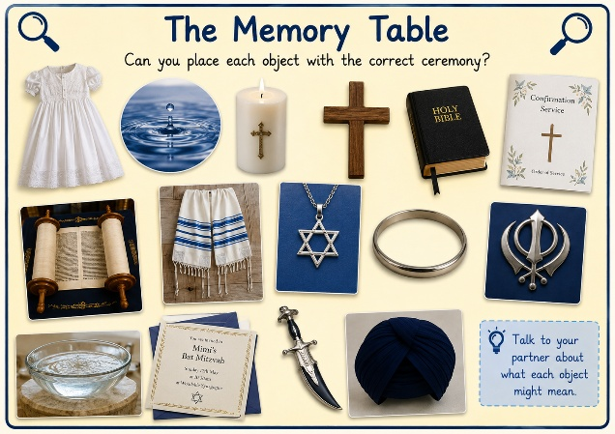
Show the children an A4 image including lots of the objects we have looked at. Talk with partner. What is the object? Which religion does it belong to? Which ceremony?
Learn:
Split the children into groups of 3/4. Give every group a large A3 comparison grid.
Across the top:
| Baptism | Naming Ceremony | Confirmation | Bat Mitzvah | Amrit Sanskar |
Down the side:
- Who makes the promises?
- What promises are made?
- What happens?
- What is sacred?
- Which scripture is used?
- Which symbols are used?
- How does the community help?
- What does this ceremony say about identity?
Now...
Instead of giving them answers...
Give them all of the evidence they've built up:
- Ceremony Investigation sheets
- Museum cards
- Daniel's Order of Service
- Mimi video notes
- Harjit's Five Clues
- Previous displays
Once the grids are complete, bring everyone together.
Rather than going ceremony by ceremony... Go question by question.
Who makes the promises?
Children notice:
- Baptism → parents
- Naming → parents
- Confirmation → individual
- Bat Mitzvah → young person
- Amrit Sanskar → individual
What pattern have we discovered?
Scripture
Children notice:
Bible
Torah
Guru Granth Sahib
Why might holy books be used?
Community
Again
Every ceremony...Family Friends Faith community Celebration
What does this tell us?
Respond
Big Question
What do promises tell us about what people believe?
Children answer using evidence.
Sentence starters:
One similarity between...
One difference is...
I noticed that...
This shows...
I think...
Reflect
Show the statement:
"Promises matter more when other people hear them."
Agree?
Disagree?
Sometimes?
Theo
What do promises in different religions tell us about what people believe?
Livvy
Why are family and community important during commitment ceremonies?
Feedback:

