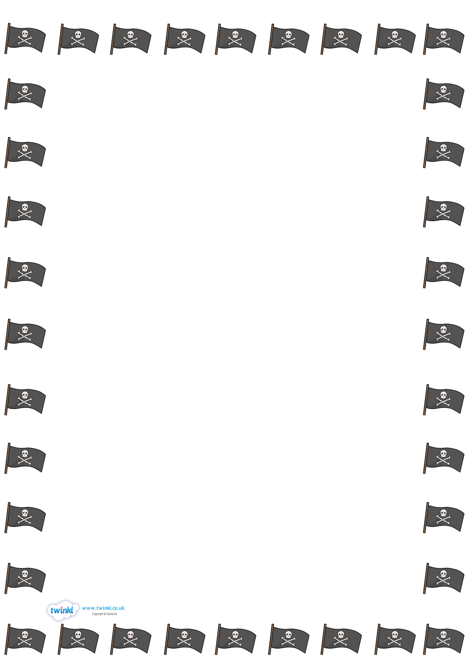
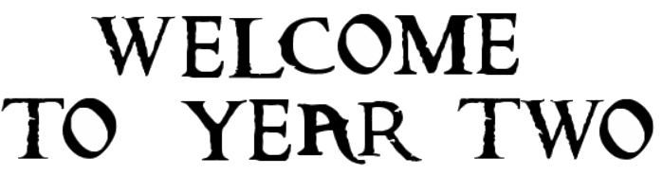

Ah-Harr Me Hearties!
We wish you a warm welcome to Year Two! We are really looking forward to working with you all. Year Two is such an exciting year, filled with fun, lots of learning and new experiences. Below is some information to get you started.
See you soon and have a wonderful summer break!
Mrs West & Miss Bradley

General Information
- Miss Bradley will teach Year 2a. and Mrs West will teach Year 2b. Mrs Ford and Mrs Chisholm will be our Teaching Assistants.
- Mrs Chisholm will be teaching Year 2a on a Thursday afternoon.
- Mrs Ford will be teaching Year 2b on a Thursday afternoon.
- Please ensure that all items of clothes are clearly named.
- P.E lessons will take place over one afternoon. We will let you know which afternoon this falls on, in September.
- Please provide a water bottle (named) every day for your child. The children will be given regular drink breaks.
- We will be looking for children that try hard in Year Two. We will have lots of certificates to give out and ‘Dojos’ to award. One child will be chosen per week to do ‘Show and Tell’.
- Please regularly check our Class Dojo page for updates or alternatively, the School Website class page.
- If you need to contact us, please do so on Class Dojo. We will read your message and get back to you as soon as we are able.
- Reading books will be changed on a regular basis. Information will be provided in the Reading Diaries along with all the login information for Seesaw etc.
Learning Opportunities:
We are hoping to give our children lots of new experiences and learning opportunities in Year Two. We will aim to give you plenty of notice before the event takes place. So far, we have these events lined up:
Term 1/2 - Visit to Lincoln Castle
Term 2 - Christmas Pantomime
Term 3 - D&T Project with ‘Grace’s Amazing Machines’
Term 4 – A Walk along the River Slea
Term 6 - Visit to ‘Jurassic Falls’ in Skegness
Assessment in Year Two:
SATs are no longer a statutory requirement in Year Two. However, we will be assessing the children in Writing, Reading and Maths once a term for our own teacher judgements. These judgements will be shared during parent’s evenings.
Homework:
Homework in Year Two consists of:
- Reading at least 3 times per week
- Numbots/ TTRS
- Spelling practice
- Activities may be set on Seesaw over half term breaks.
Our Writing Themes:
Each term, our English lessons are based on themes to inspire and get the creative juices flowing:
Term 1: Pirate Adventures
Term 2: Magic and Mayhem
Term 3: Invent and Achieve
Term 4: Fire! Fire!
Term 5: Tales from Africa
Term 6: Dinosaurs

