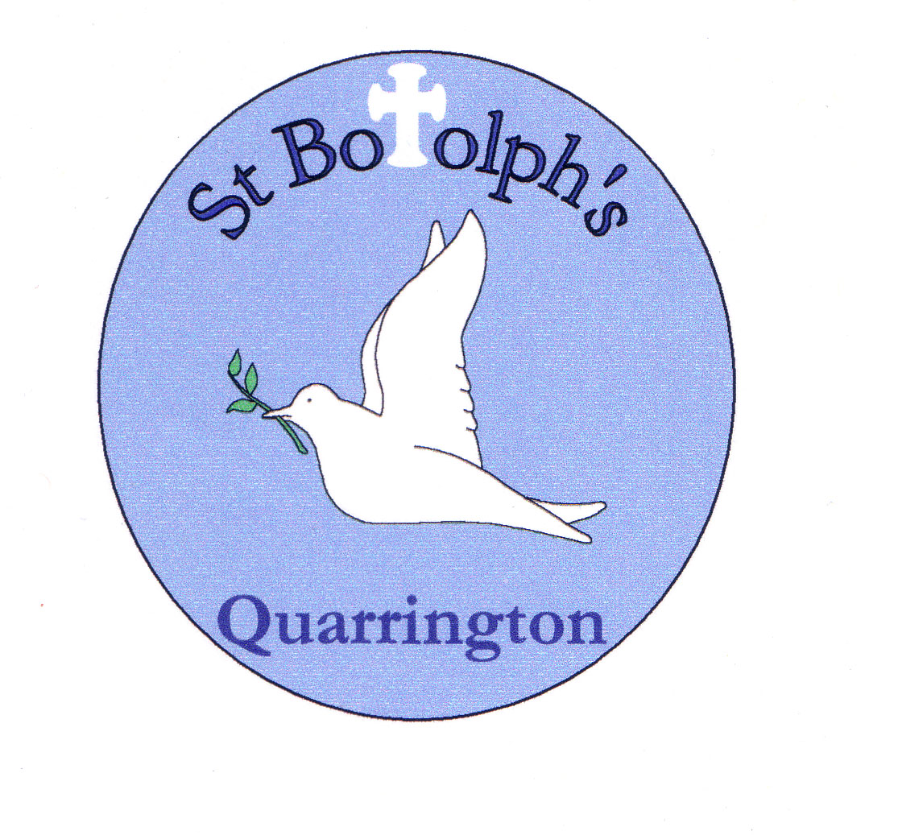
St Botolph’s Church of England Primary School
Acceptable Use Policy – KS2 pupils

All pupils use computer facilities including Internet access as an essential part of learning, as required by the National Curriculum.
Both pupils and their parents/carers are asked to sign to show that the policy has been understood and agreed.

Pupil name ____________________________________ Class __________________
I use the school’s internet and devices for schoolwork, homework and other activities to learn and have fun. School internet and devices are monitored.
I will use the computer, network, mobile phones, internet access and other new technologies in a responsible way at all times
Whether at home or school, I only use the devices, apps, sites and games I am allowed to, at the times I am allowed to.
I won’t share anything that I know another person wouldn’t want shared, or which might upset them. If I know a friend is worried or needs help, I will remind them to talk to an adult, or even do it for them.
I keep my passwords to myself and reset them if anyone finds them out. Friends don’t share passwords!
I won’t click on unexpected links or popups.
I will talk to a trusted adult if anything upsets me or worries me on an app, site or game – it often helps. If I get a funny feeling, I talk about it.
I know it’s not my fault if I see or someone sends me something bad. I won’t get in trouble, but I mustn’t share it. Instead, I will tell a trusted adult. If I make a mistake, I don’t try to hide it but ask for help.
I communicate and collaborate online with people I already know and have met in real life or that a trusted adult knows about.
I know new online friends might not be who they say they are – I am careful when someone wants to be my friend. Unless I have met them face to face, I can’t be sure who they are.
I don’t do live videos (livestreams) on my own and always check if it is allowed. I check with a trusted adult before I video chat with anybody for the first time.
I only give out private information if a trusted adult says it’s okay. This might be my address, phone number, location or anything else that could identify me or my family and friends; if I turn on my location, I will remember to turn it off again.
I know anything I do can be shared and might stay online forever.
I know that apps, sites and games have rules on how to behave, and some have age restrictions. I follow the rules, block bullies and report bad behaviour.
I do not post, make or share unkind, hurtful or rude messages/comments and if I see it happening, I will tell my trusted adults.
I do not make fun of anyone or exclude them because they are different to me. If I see anyone doing this, I tell a trusted adult.
I only edit or delete my own digital work and only use words, pictures or videos from other people if I have their permission or if it is copyright free.
I know I can’t believe everything I see online, know which sites to trust.
Signed: | Date:
Parent/Carer

Please can you encourage your daughter/son to make careful choices online, both at home and at school.
To find out more about our full E-safety Policy please visit our website.
You can also find support and online safety resources for parents here too.

Signed: | Date:
Please print name:
Please complete, sign and return to the school office

