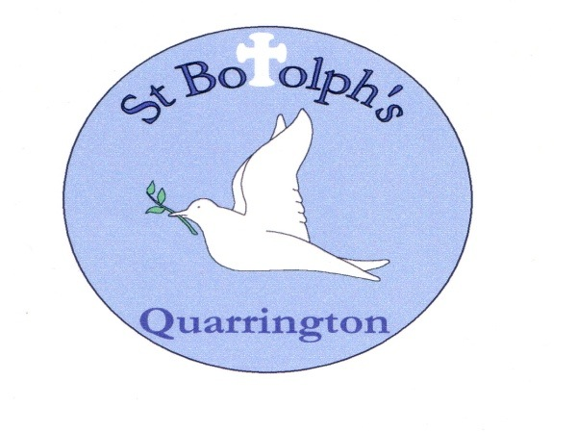

St Botolph’s Church of England School
Governor Meeting Attendance 2023/24

FULL GOVERNING BODY |  |  | FGB Meetings |  |  |  |  |  |  | FINANCE COMMITTEE | Finance Committee Meetings |  |  |  |  |  |  | CURRICULUM  COMMITTEE | Curriculum Committee Meetings
Governor Name | Governor Type |  |  |  |  |  |  |  |  | Governor Name |  |  |  |  |  |  |  | Governor Name
Governor Name | Governor Type |  | 03.10.23 | 23.11.23 | 06.02.24 | 14.05.24 | 25.06.24 |  |  | Governor Name | 02.10.23 | 21.11.23 | 30.01.24 | 19.03.24 | 30.04.24 | 25.06.24 |  | Governor Name | 22.11.23 | 01.02.24 | 05.03.24 | 11.06.24
Ruth Fox | Parent | Aps |  | Aps |  |  |  |  |  |  |  |  |  |  |  |  |  | Ruth Fox | DNA
Ian Freeman | Co-opted |  |  |  |  |  |  |  |  | Ian Freeman |  |  |  |  | Aps |  |  | Ian Freeman | Aps
Mark Graves | Local Authority |  | Aps |  |  |  |  |  |  | Mark Graves
Gareth Hughes | Parent |  | Aps | Aps |  |  |  |  |  | Gareth Hughes | Aps
Marissa Jones | Parent |  |  |  |  |  |  |  |  | Marissa Jones |  |  | Aps
Joe Lee | Co-opted |  | Aps |  |  |  |  |  |  | Joe Lee
Will Newham | Parent | Aps |  |  |  |  | Aps |  |  |  |  |  |  |  |  |  |  | Will Newham
Rebecca Rock | Foundation | Aps |  |  |  | D  N  A | Aps |  |  |  |  |  |  |  |  |  |  | Rebecca Rock |  | Aps
Denzil Shepheard | Foundation | Aps |  | Aps |  |  |  |  |  | Denzil Shepheard |  | Aps |  |  |  |  |  | Denzil Shepheard | Aps
Vacancy | Ex Officio Foundation
Katie West | Staff |  |  |  |  |  |  |  |  |  |  |  |  |  |  |  |  | Katie West
Debbie Wilson | Headteacher - Ex Officio |  |  |  |  |  |  |  |  | Debbie Wilson |  |  |  |  |  |  |  | Debbie Wilson
Mandy Wright | Deputy Head - Co-opted |  |  |  | Aps | Aps |  |  |  |  |  |  |  |  |  |  |  | Mandy Wright
Vacancy | Co-opted
Aps = apologies DNA = no apology received, did not attend

