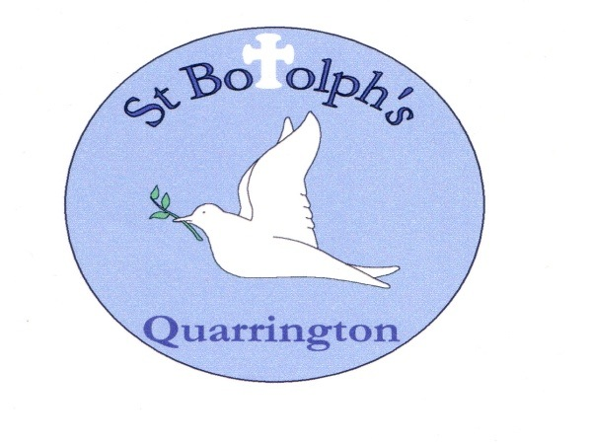

St Botolph’s Church of England School
Governor Meeting Attendance 2024/25

FULL GOVERNING BODY |  | FGB Meetings |  |  |  |  |  |  | FINANCE COMMITTEE | Finance Committee Meetings
Governor Name | Governor Type |  |  |  |  |  |  |  | Governor Name
Governor Name | Governor Type | 26.09.24 | 28.11.24 | 06.02.25 |  |  |  |  | Governor Name | 23.09.24 | 26.11.24 | 4.2.25
Ian Freeman | Fouundation |  |  |  |  |  |  |  | Ian Freeman
Mark Graves | Local Authority |  |  |  |  |  |  |  | Mark Graves
Gareth Hughes | Parent |  |  |  |  |  |  |  | Gareth Hughes |  |  | Apols
Marissa Jones | Parent |  |  |  |  |  |  |  | Marissa Jones
Joe Lee | Co-opted |  |  |  |  |  |  |  | Joe Lee
Will Newham | Parent | Apologies  Deployed In Brazil | Apologies  Deployed
Rebecca Rock | Foundation | Apologies  Work commitments
Matthew Downing | Parent
Vacancy | Ex Officio Foundation
Katie West | Staff
Debbie Wilson | Headteacher - Ex Officio |  |  |  |  |  |  |  | Debbie Wilson
Mandy Wright | Deputy Head - Co-opted
Rita Owen | Co-opted |  |  | Observing
Vacancy | Co-opted
Aps = apologies DNA = no apology received, did not attend

