Year Five

Term Two

**Britain’s Battle**

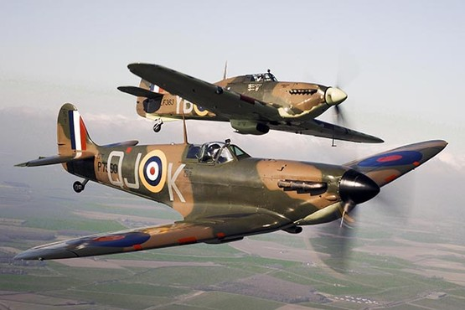

|  |  |
| --- | --- |
| **History** | A British Theme beyond 1066- *World War II* |
| **Science** | Forces, Air Resistance- *Airplanes in The Battle of Britain* |
| **D&T** | Textiles- *‘Make do and Mend’*  Growing Ingredients- *‘Dig for Victory’* |
| **Computing** | Coding- *Binary Code* |
| **Music** | Songs from the War- *Vera Lynn, Glenn Millar* |
| **PSHE** | Democracy- *What was fought for?* |
| **RE** | What is advent? |
| **MFL** | School- *A l’ecole (Unit 2, Rigolo 2)* |
| **PE** | Dance, Netball, Swimming |

|  |  |  |  |  |
| --- | --- | --- | --- | --- |
| **Essential Skills**  In this topic, the children will have the opportunity to… | | | | |
| HISTORY | |  | SCIENCE | |
|  | I use a timeline to place events. |  | I can explain that unsupported objects fall towards the earth because of the force of gravity. |
|  | I use a timeline to demonstrate changes and developments in society. |  | I can identify the effects of air resistance, water resistance and friction. |
|  | I can describe the main changes in a period of history. |  | I recognise that some mechanisms allow a smaller force to have a greater affect. |
|  | I choose reliable sources of factual evidence to describe the way of life of people in the past. |  |  |
|  | I choose reliable sources of factual evidence to describe what was important to people in the past. | DESIGN & TECHNOLOGY | |
|  | I understand seasonality. |
|  | I evaluate evidence which helps me to choose the most reliable forms. |  | I know where and how a variety of ingredients are grown, reared, caught and processed. |
|  | I know that both people in the past and now, have their own point of view. |  | I can store and prepare food properly. |
|  | I give clear reasons why there may be different accounts of history, linking this to factual understanding of the past. |  | I use proportions and ratio to produce recipes of my food product. |
|  | I use a variety of sources to find out about events, people and changes. |  |  |
| MUSIC | |
|  | I ask “What was it like for a … during …” |  | I sing from memory with confidence. |
| DESIGN & TECHNOLOGY | |  | I perform alone and in a group, displaying a variety of techniques. |
|  | I draw on various sources of information. |  | I take turns to lead a group. |
|  | I work from my own detailed plans, modifying them where appropriate. |  | I sing expressively and in tune. |
|  | I clarify my ideas through discussion, drawing and modelling. |  | I hold my part in a round. |
|  | I communicate my ideas. |  | I am confident in singing solo. |
|  | I have the basics of cross-stitch and backstitch. |  | I sing in harmony with confidence and accuracy. |
|  | I can make weavings such as ‘God’s eyes’. |  | I understand that lyrics reflect the cultural context and have social meaning. |
|  | I have the basics of quilting, padding and gathering fabric. | PSHE | |
|  | I know what democracy is. |
|  | I mark out using my own patterns and templates. |  | I know about the basic institutions that support democracy |
|  | I can make a durable and desirable product. |  | I have learned about local democratic institutions. |
|  |  |  | I have experienced a democratic decision. |
| COMPUTING | | RELIGIOUS EDUCATION | |
|  | I develop an understanding of how technology works, with a focus on developing computational thinking. |  | I know the symbolism of the Advent ring. |
|  | I understand that software relies on codes to run. |  | I understand the prophecy of the birth of Jesus Christ. |
|  | I know that a range of different coding languages exist. |  | I know what the season of advent means for Christians today. |
|  |  |  |  | I know the meaning of advent candles. |
|  |  |  |  | I know why we have advent calendars at Christmas. |
|  |  |  |  | I know the importance of advent in other countries. |
|  |  |  |  | I know how other countries celebrate advent. |

|  |  |
| --- | --- |
| **Promoting our Values**  Our Values will be promoted through the topic by… | |
| Social | Considering the life of an evacuee child, how did the local community work together? |
| Moral | Democracy- what did the country fight for? Conscription- right or wrong, debate |
| Spiritual | Reflecting on life today, our rights, beliefs and values |
| Cultural | Parliament, Churchill’s role during WWII |
| British Values | *Democracy-* Democracy vs Dictatorship  *Rule of Law-* What age legally can you join the army?  *Respect for Faiths & Beliefs-* Christmas celebrations  *Individual Liberty-* How was this different during the war? – link to Holocaust? |
| Christian Value | Perseverance |

|  |  |
| --- | --- |
| **Convention Right of the Child**  These are the rights that could be embedded into the topic… | |
| Article 1 | Everyone under 18 has these rights. |
| Article 2 | The Convention applies to everyone, whatever their race, religion, abilities; whatever they think or say, whatever type of family they come from. |
| Article 3 | All organisations concerned with children should work towards what is best for each child. |
| Article 4 | Governments should make these rights available to children. |
| Article 6 | All children have the right to life. Governments should ensure that children survive and develop healthily. |
| Article 9 | Children should not be separated from their parents unless it is for their own good. For example, if a parent is mistreating or neglecting a child. Children whose parents have separated have the right to stay in contact with both parents, unless this might hurt the child. |
| Article 10 | Families who live in different countries should be allowed to move between those countries so that parents and children can stay in contact, or get back together as a family. |
| Article 14 | Children have the right to think and believe what they want, and to practise their religion, as long as they are not stopping other people from enjoying their rights. Parents should guide their children on these matters. |
| Article 36 | Children should be protected from any activities that could harm their development. |
| Article 38 | Governments should not allow children under 16 to join the army. |