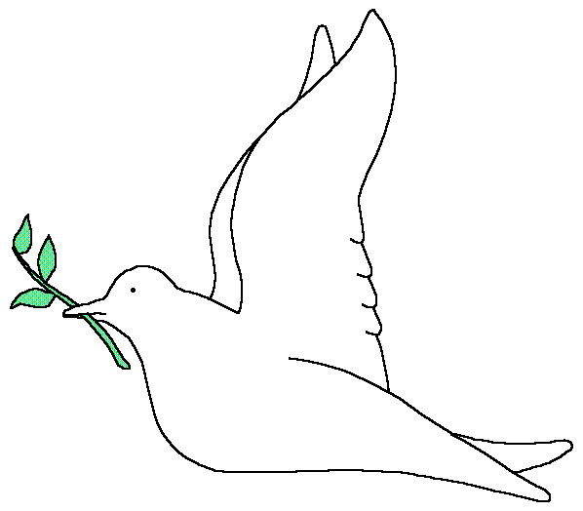
St. Botolph’s Church of England Primary School
St Bo olph's
†
Quarrington
Code of Conduct for all staff in School

We value the contribution you can make to our children’s learning. We all work hard to create and maintain a loving, caring, challenging and supportive school environment. We ask that you take the time to read and follow these simple guidelines.

Remember that you have been placed in a position of trust. All information you may see and hear about a child is of a confidential nature. Please do not talk about any child outside of the school or to any parents. Any breach of confidentiality will be dealt with seriously.

When in school building or grounds:

- Always encourage the children to do their best and give them a lot of praise.
- Never tell a child off for not being able to complete a task. Encourage them to do as much as they can. If you are unsure as to what to do ask for advice from another member of staff or seek advice from the Headteacher.
- You are in school to support the needs of the children, never discipline them by smacking or shouting.
- If you are in any way concerned about a child in your care always inform the Safeguarding Officers asap. (Mrs Wilson, Mrs Bellaby, Mrs Valentine)
- Inform any helpers of any medical conditions relating to a child they are working with. If however, a child in your care has an accident or needs medical attention, inform a member of staff immediately.
- When writing in a home/school record book always be positive and give an objective account of what you have done with the child.
- Please dress in a smart yet practical way. Casual jeans, shorts, leggings, cropped or low tops are not regarded as suitable clothing for working in the school environment.
- Never swear in front of the children.
- Never shout or use force to reprimand a child – inform the class teacher or Headteacher if they are unwilling to follow your instructions.
- Be aware of the school and playground rules
- Refer to these simple rules and always encourage the children to follow them.
- Wear names badges or visitor lanyards in school.
- At break times and lunch times if you are in the staffroom, please remember that anything you see or hear about individual children of families is of a confidential nature and must not be discussed outside of school.

When out of school on a visit please follow all the above guidelines for supporting children in school. In addition:

- Ensure that you know the names of all the children in your class.
- Have a list of children who have special needs and make sure you know what to do if that child needs support.
- All information given about children on the visit risk assessment form is not for disclosure to anyone.
- If a child in your care needs medication i.e. an asthma inhaler or travel sickness tablets, you must carry their medication with you at all times and discuss the administration arrangements with the teacher before the visit commences.
- Always know where the nearest toilet is.
- Ensure that the children in your care wash their hands after touching animals or plants and always before eating.
- Never let the children in your group out of your sight.
- Please do not buy the children in your group any sweets, food, drink or souvenirs unless this has already been discussed.
- Do not allow your group to be photographed or videoed, even by an official press photographer, unless it has been approved. If a photograph has been approved, only give the Christian names of the children, not their full names.

Thank you following these basic guidelines. We appreciate your support and hope you will enjoy helping in our school.

Mrs D Wilson
Headteacher

…………………………………………………………………………………………

I have read and understood the code of conduct for helpers in school. I agree to follow this code.

Signed……………………………………………………………..

Please print name………………………………………………….

Date………………………….

