St Botolph’s CE Primary School

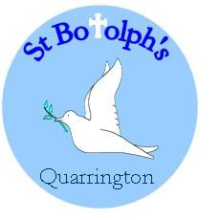

Marking and Feedback Policy

Amended
6.3.18 | 23.2.20 | 30.9.20
Emma Bellaby | Emma Bellaby | Emma Bellaby
Renata Bland







Rationale

Feedback is a vital part of the school’s wider assessment processes, which aims to provide an appropriate level of challenge to pupils in lessons, allowing them to make good progress. Feedback should empower children to take responsibility for improving their own work; it should not take away from this responsibility by adults doing the hard thinking work for the pupil. All children should have their work discussed and marked in such a way that feedback will improve their learning, develop their self-confidence, raise self-esteem and provide opportunities for self-assessment.

Aims

‘Memory is the residue of thought…’ Daniel Willingham

- To ensure children progress, knowing their achievements and what they need to do next.
- To ensure planning is amended in order that the teaching and learning meet the needs of all children.
- To ensure that core literacy and numeracy skills are promoted and reinforced across the curriculum.
- To teach pupils to think deeply about the work that they have completed.
- To ensure that marking and feedback practices are manageable and purposeful for all stakeholders.

General Principles

- Live oral feedback is the most powerful form of feedback. Teachers create as many opportunities for this as possible.
- Children’s work should be marked as soon as possible after completion, and, if possible and appropriate, in the presence of the child (live marking).
- Feedback should relate to the lesson objective and the desired outcomes of the learning experience, or to the development of key literacy and numeracy skills.
- Comments should be written language that is appropriate to the individual child’s age and ability.
- Focused marking comments should point out successes and, where appropriate, points for improvement.
- Children should be given specific time to read, reflect upon and respond to marking and feedback.

Types of marking

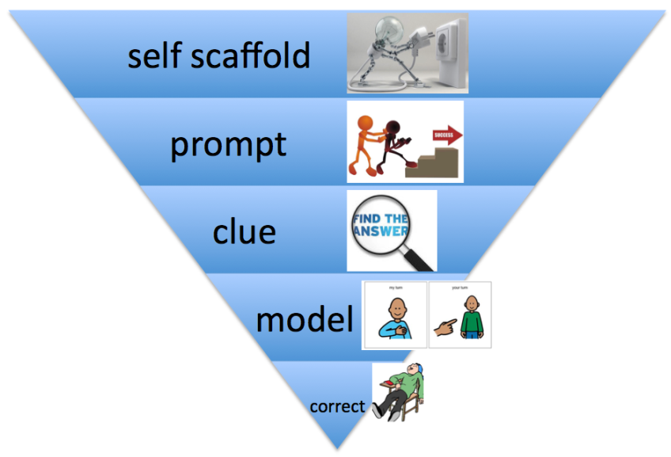
Work in all subjects is marked using the symbols found in the appendices, no matter who marks the work. Work is marked by teachers, teaching assistants and pupils.

Marking is carried out by teachers using green ink for positive comments.

Purple ink is used in all subjects to show next steps, challenges and developmental/supportive comments.

Pupils mark using blue pen.

Teacher / TA marking - At St. Botolph’s, good work that shows evidence of meeting the agreed success criteria is acknowledged by a green tick next to the learning objective.

So that pupils know that they have completed their work to a good standard and have an awareness of what they have done well, the following strategies are used in addition to a tick next to the learning objective:

- Green highlighter
- Green ticks
- Smiley faces
- Stickers
- Dojos
- Green comments where appropriate and where the impact of writing one is clear.
- Visits to the Headteacher, or an appropriate member of the SLT to show their work.

Self-marking – Children mark their own work where appropriate. Mathematics and comprehension activities are obvious examples but teachers find opportunities in other contexts. The emphasis is on children assessing their own learning and using this to move their learning forward.

Peer-marking – When appropriate (and after considerable modelling), children mark a partner’s work. Initially the focus is on children identifying the strengths and an area for development.
Whole class feedback – Whole class feedback gathers key themes from the work of all the children in the class and is used to address common errors in core literacy skills, for example capital letter use and spellings. It is used either at the beginning or end of a session in response to formative assessment which takes place during or following a lesson.

Marking of writing – A re-drafting approach is used for the marking of writing in all curriculum subjects. Whole class feedback is used to improve technical accuracy, transcription errors and content improvement.

Monitoring and Evaluation

Work sampling is carried out on a regular basis. It can be used to highlight good practice and to evaluate the extent to which consistent, high quality marking enables the aims of this policy to be achieved. Findings are shared with staff and governors.

Performance indicators are:
- Improvement in children’s achievement and attainment;
- Consistency in teachers’ marking across phases;
- Participation of children in the process.

Signed: Headteacher ………………………………..

Chair ……………………………………………………..

Date:

Review date:

Appendices

How to address the marking of spelling

- Common spelling errors should be addressed during whole class feedback sessions. Pupils should self-correct, or should be supported by guided editing if they are not yet able to access editing independently.
- Word mats for words from statutory word lists should be used periodically to allow children to remedy errors in all written work.
- Spelling errors in edited pieces of writing should be indicated using the appropriate symbol and pupils should be given time to correct their spellings using one of the following strategies:
- Spelling of words that can be spelt phonetically or which follow a recognised spelling pattern should be corrected using an appropriate strategy that relates to the RWI programme e.g. adding dots and dashes to the correct spelling of the word, using dots and dashes/Fred Fingers to indicate where sounds have been missed or where pupils have made an incorrect phoneme choice, using a phoneme frame to reinforce the different sounds within the words.
- Spelling of common exception words and Year 3&4 / Years 5&6 word lists. Where these words do not follow a recognised spelling pattern or cannot be spelt using phonics strategies, they should be corrected using one of the following strategies:
  - The word is written correctly for them to copy.
  - The word is indicated and the child corrects it independently using an appropriate word mat/word list from home school diary.
  - The line in which the word is misspelt is indicated and the child must find and correct the word independently.
  - The child is instructed to find and correct x number of words from the appropriate word list independently.

- Teachers use their professional judgement to decide which of these strategies is most appropriate. In Y2 and Y6, word list spellings cannot be counted as correct if the error has been indicated to them specifically, due to this not being independent.

Maths Marking Symbols

 | Well done, you got this right
 | Make a correction
I | Intervention
S | Support required
E | Equipment used
→ | Challenge
SM | Self Marked
PM | Peer Marked

Writing marking symbols
Key Stage FS/KS1
✓ | Correct
________ | Good idea  ‘Green is Good’
Something missing/error/
punctuation
 | Spelling
 | Make a correction
→ | Next step or challenge
S  PM  SM | Supported  Peer-marked  Self-marked

Writing marking symbols
Key Stage 2
✓ | Correct
________ | Good idea  ‘Green is Good’
/ / | Start a new line or paragraph
Something missing/error/
punctuation
 | Spelling
 | Make a correction
→ | Next step or challenge
S  PM  SM | Supported  Peer-marked  Self-marked

