St. Botolph’s CE Primary School

25 May 2012

Dear Parent / Carer

It has been brought to my attention that at least one child in the school has symptoms of Ringworm, which is mildly contagious. However, Department for Health guidelines state that it is not necessary to keep children away from school, but it is important to seek medical advice and ensure that treatment is given.

According to the BBC, ‘Ringworm is caused by fungal infection, mostly by a group of fungi called dermatophytes. Spores of the fungus may be picked up from another person, the soil, a domestic animal or household objects. Anyone can develop ringworm but it's more likely to happen when there's a local breakdown of the immune defences, such as a scratch in the skin, which allows the fungal spores to invade. Ringworm usually causes reddened and scaly patches on the skin, which form in an irregular ring shape with a slightly raised edge. The patches may be very itchy. Ringworm is usually easily treated with antifungal creams and lotions.’ http://www.bbc.co.uk/health/conditions/ringworm2.shtml
All children in school are encouraged to wash their hands regularly and we would ask for your help in re-enforcing this message with the children at home.
Yours sincerely
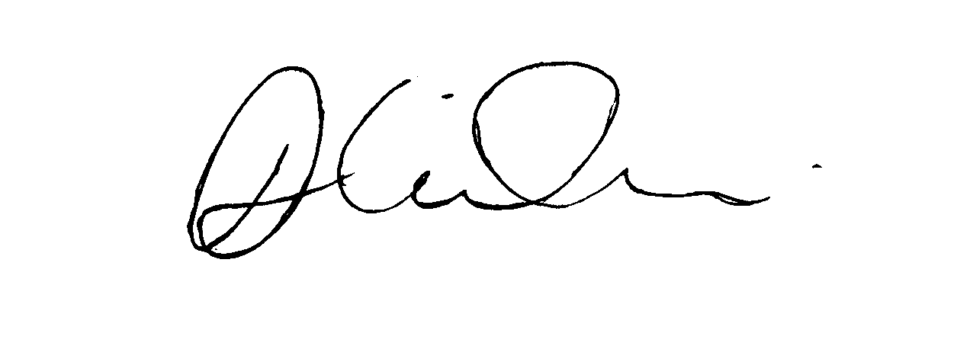
Mrs. D Wilson
Headteacher

