Governor Report – September 2024
Whole School Data
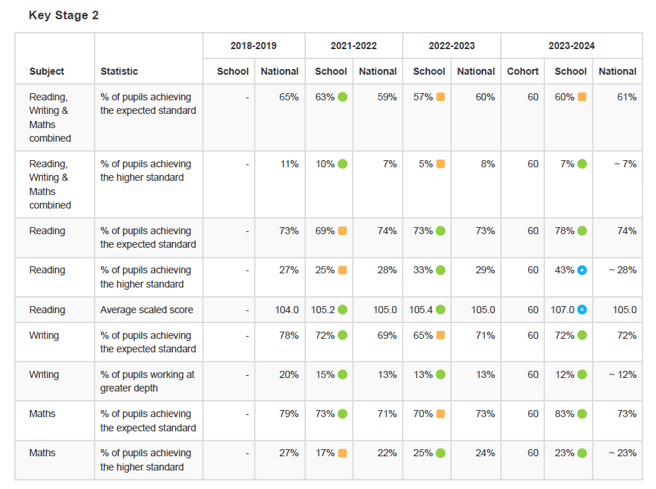
Our statutory KS2 data showed that the percentage of children achieving the expected standard in Maths, Writing and Reading improved on the 2022/2023 data. The data was in line with national data, with children achieving Greater Depth standard above national
