School Uniform

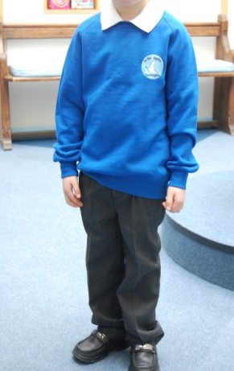

**School uniform:**

* **A white polo shirt**
* **A royal blue jumper**
* **Dark grey trousers or dark grey shorts in the summer**
* **Grey, black or white socks**
* **Black shoes**

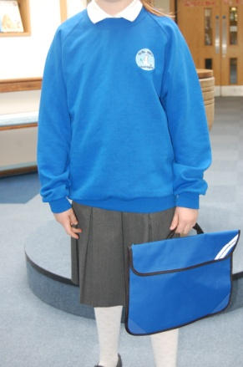

**School uniform with a jumper:**

* **A white polo shirt**
* **A royal blue jumper**
* **Dark grey skirt/ trousers**
* **White or grey socks (knee high or ankle)/ grey tights (see picture below)**
* **Black shoes**

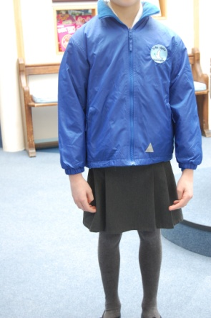

**Coats (optional)**

**You can buy a reversible royal blue coat.**

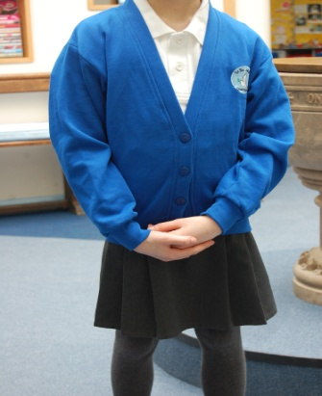

**School uniform with option of a cardigan:**

* **A white polo shirt**
* **A royal blue cardigan**
* **Dark grey skirt**
* **White or grey socks (knee high or ankle)/ grey tights**
* **Black shoes**

**PE Kit:**

* **White T-Shirt with or without school logo**
* **Royal blue shadow striped shorts**
* **Black plimsolls**
* **Royal blue PE bag**
* **Sun hat in the warm weather (optional)**

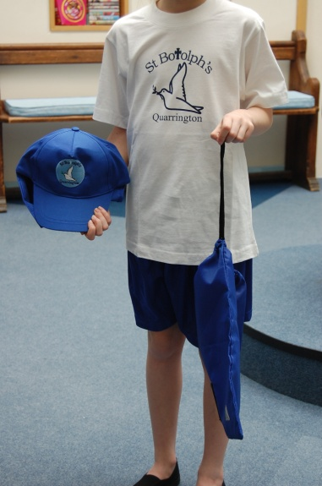

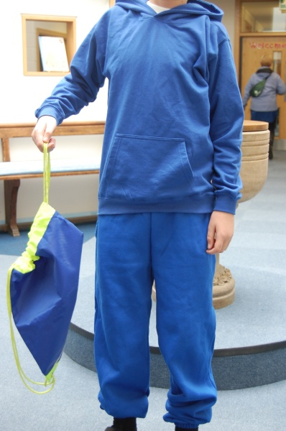

**Key Stage Two outdoor tracksuit (OPTIONAL)**

**As you can imagine the children get really cold outside when doing PE in the winter months. We have introduced a tracksuit to keep them warm and to make sure the children don’t get their school jumpers/cardigans muddy and sweaty, as some children like to wear them outside. This is a suggestion that we hope will help.**

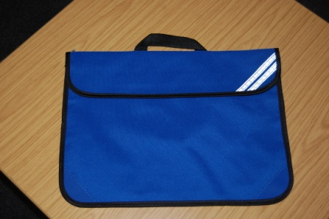

**Book bags will be bought for the children in Foundation and Key Stage 1.**

**PE bags cost £3.50**

**Legionnaires cap for the summer months cost £3.50**

**High Vis PE/Swimming bag costs £5.10**

**Fleece hat costs £4.50**

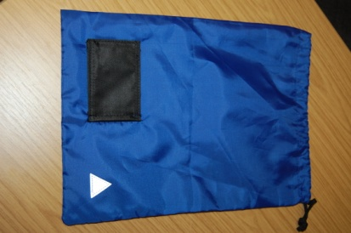

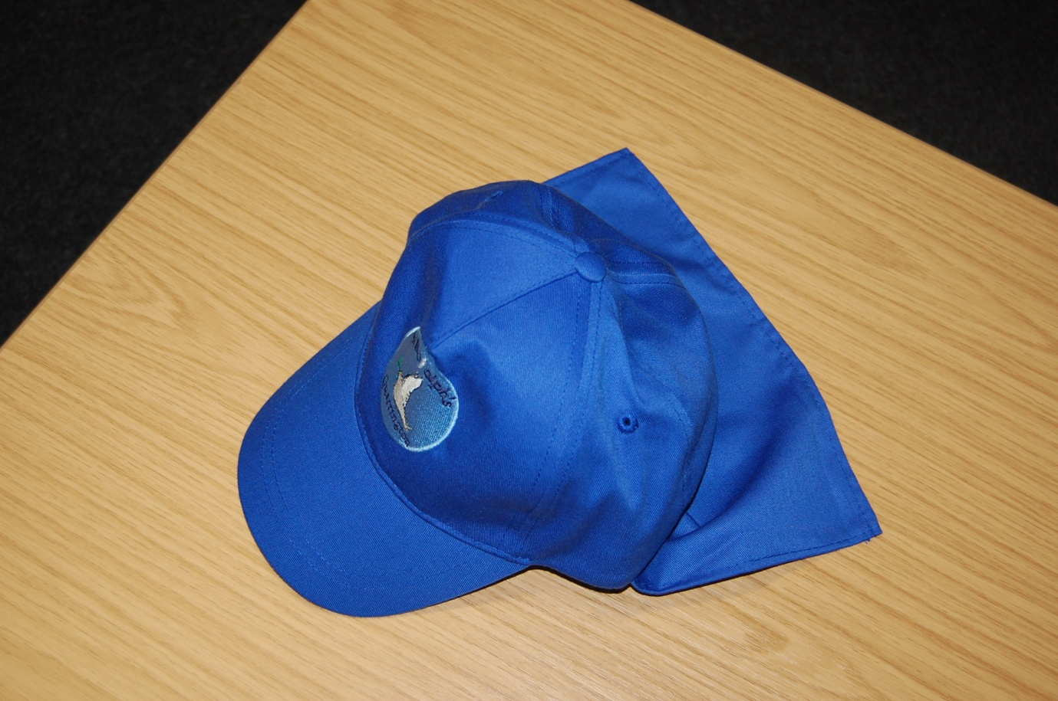

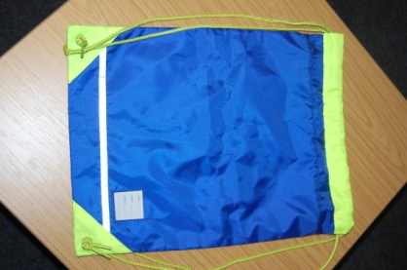

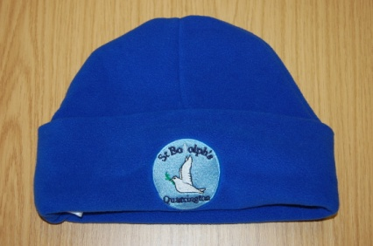

[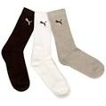](http://www.google.co.uk/imgres?imgurl=http://csimg.pricesavvy.co.uk/srv/GB/29022868700385399/T/340x340/C/FFFFFF/url/puma-3-pack-crew-socks.jpg&imgrefurl=http://www.pricesavvy.co.uk/a/productlist/idx/6050000/mot/Puma/productlist.htm&usg=__RqOs8RIXkZZKcUq9UvbpDdncJ94=&h=340&w=340&sz=34&hl=en&start=256&zoom=1&tbnid=ZwUL4FvvtmSAbM:&tbnh=119&tbnw=119&ei=LchKUZjRCpSChQftgYGYBg&prev=/search?q=socks+black+grey+and+white&start=240&hl=en&safe=active&sa=N&gbv=2&tbm=isch&itbs=1&sa=X&ved=0CEoQrQMwDzjwAQ)

Footwear options:

Plain black, grey or white socks with no patterns or comic features on them. Tights, knee white or grey socks or ankle white socks (depending on the weather).

It is really important that the children wear plain blue, white black or grey headbands, bobbles and clips in their hair.

[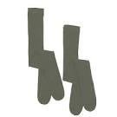](http://www.google.co.uk/imgres?imgurl=http://cdn1.bigcommerce.com/server3000/2d3c7/products/507/images/1002/grey_tights__99663.1361965643.1280.1280.jpg&imgrefurl=http://www.guildfordschoolsandsport.co.uk/products/grey-tights-2-in-a-pack.html&usg=__ocXMIW2_LdpVuYXmZ_QZOOYsqMQ=&h=600&w=600&sz=24&hl=en&start=16&zoom=1&tbnid=ym5qa_5MOkVlDM:&tbnh=135&tbnw=135&ei=XMhKUaWEOoXDhAfH5YHgBQ&prev=/search?q=grey+tights&hl=en&safe=active&gbv=2&tbm=isch&itbs=1&sa=X&ved=0CEoQrQMwDw)

[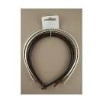](http://www.google.co.uk/imgres?imgurl=http://www.mias-accessories.co.uk/658-2495-thickbox/1-cm-plastic-alice-band4-packblack-tort-gold-silver.jpg&imgrefurl=http://www.mias-accessories.co.uk/en/hair-accessories/658-1-cm-plastic-alice-band4-packblack-tort-gold-silver-5023769860130.html&usg=__7PiRu_hiqaU9Rd6lQWYfn-LjkZA=&h=600&w=600&sz=50&hl=en&start=20&zoom=1&tbnid=cdUnPHLVN-sS1M:&tbnh=135&tbnw=135&ei=GclKUf28FsiDhQeos4DIAQ&prev=/search?q=grey,+navy,+black,+alice+bands+for+girls&hl=en&safe=active&sa=N&gbv=2&tbm=isch&itbs=1&sa=X&ved=0CFIQrQMwEw)

[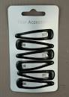](http://www.google.co.uk/imgres?imgurl=http://img.auctiva.com/imgdata/1/7/0/1/6/2/1/webimg/588856661_o.jpg&imgrefurl=http://www.ebay.co.uk/itm/6-Sleepies-Bendies-Hair-Snap-Clips-Slides-Black-Navy-Tort-Blue-Burgundy-5cm-/160842039687&usg=__TO2YELx6LS4rnKhdGsDzOmtuSZU=&h=500&w=355&sz=36&hl=en&start=378&zoom=1&tbnid=2ujDaIf1pJE75M:&tbnh=130&tbnw=92&ei=s9RKUa_oBKnA7AaH6oHQAg&prev=/search?q=hair+clips+for+girls+in+black,+navy+and+grey&start=360&hl=en&safe=active&sa=N&gbv=2&tbm=isch&itbs=1&sa=X&ved=0CE4QrQMwETjoAg)

[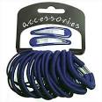](http://www.google.co.uk/imgres?imgurl=http://ecx.images-amazon.com/images/I/414boH94TBL.jpg&imgrefurl=http://www.womensaccessories.co.uk/category/womens-hair-clips/&usg=__enB1Ss7UyyV41xkbvrVvVNtOUoQ=&h=300&w=300&sz=23&hl=en&start=31&zoom=1&tbnid=BEmg_wWx5t5G2M:&tbnh=116&tbnw=116&ei=ntVKUd-tG8qu7Aa8qoGoBQ&prev=/search?q=hair+bobbles+for+girls+in+black,+navy+and+grey&start=20&hl=en&safe=active&sa=N&gbv=2&tbm=isch&itbs=1&sa=X&ved=0CEAQrQMwCjgU)

[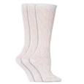](http://www.google.co.uk/imgres?imgurl=http://ecx.images-amazon.com/images/I/41w6uegCIpL._SS290_.jpg&imgrefurl=http://www.universal-textiles.com/Girls-White-Pelerine-School-Socks/dp/B007IT0TFC&usg=__buOUgl6Ip991vG6zoZPQpqyL0G0=&h=290&w=290&sz=9&hl=en&start=184&zoom=1&tbnid=SXs6sOlzlkoN8M:&tbnh=115&tbnw=115&ei=m9ZKUdvXLo-ShgeXh4GgDw&prev=/search?q=girls+white+socks+for+school&start=180&um=1&hl=en&safe=active&sa=N&gbv=2&tbm=isch&um=1&itbs=1&sa=X&ved=0CDIQrQMwAzi0AQ)

**These items are a reminder for you.**

**Please remember children should wear black shoes during school, not boots or trainers. However, in the bad weather I would encourage the children to wear boots when walking to school and change into shoes when they reach their classrooms. During the summer months please refrain from sending your children in open toe sandals. In the interest of health and safety we have been advised that these are not appropriate school footwear.**

**Children in Reception work outside during all weathers, so boots are acceptable in this year group for this reason.**

[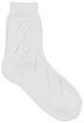](http://www.google.co.uk/imgres?imgurl=http://www.countyschoolwear.co.uk/sites/default/files/imagecache/product_full/sap_-_cotton_pelerine_ankle_socks.jpg&imgrefurl=http://www.countyschoolwear.co.uk/buy-online/non-badged/school-wear-uniform-accessories/school-footwear/school-socks-and-tights/scho-1&usg=__ukQ6h15DXQ5O1hOX5zwXlm5AEQI=&h=476&w=325&sz=38&hl=en&start=1&zoom=1&tbnid=3TyJgz6Zqi3BCM:&tbnh=129&tbnw=88&ei=9NdKUZzCOZC5hAe-tYGABw&prev=/search?q=girls+short+white+ankle+socks+for+school&um=1&hl=en&safe=active&sa=N&gbv=2&tbm=isch&um=1&itbs=1&sa=X&ved=0CCwQrQMwAA)

[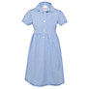](http://www.johnlewis.com/john-lewis-school-belted-gingham-checked-summer-dress-blue/p14473?imageCount=1)

[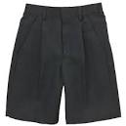](http://www.google.co.uk/imgres?imgurl=http://johnlewis.scene7.com/is/image/JohnLewis/000205333?$prod_main$&imgrefurl=http://www.johnlewis.com/school-boys'-bermuda-shorts/p206715&usg=__LQahteEuZEloOG90hW73l483XS4=&h=475&w=475&sz=26&hl=en&start=1&zoom=1&tbnid=gCNmeR_Bxzs_oM:&tbnh=129&tbnw=129&ei=NOtKUcToMJS4hAeQ6YH4DA&prev=/search?q=boys+light+grey+school+shorts&um=1&hl=en&safe=active&gbv=2&tbm=isch&um=1&itbs=1&sa=X&ved=0CCwQrQMwAA)

[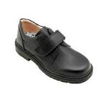](http://www.google.co.uk/imgres?imgurl=http://www.mylittleshoebox.co/images/00000157.JPG&imgrefurl=http://www.mylittleshoebox.co/index.php?page_id=dept&deptid=56&id=13&desc=BOYS%20SCHOOL%20SHOES-BOYS&usg=__hlvs_DzP9ctCdW1ALhXoFR2tY7o=&h=2624&w=2624&sz=483&hl=en&start=9&zoom=1&tbnid=x43IXxBrqIy2NM:&tbnh=150&tbnw=150&ei=gfJKUczPDcrQhAfshIGgCA&prev=/search?q=black+school+shoes&um=1&hl=en&safe=active&gbv=2&tbm=isch&um=1&itbs=1&sa=X&ved=0CDwQrQMwCA)