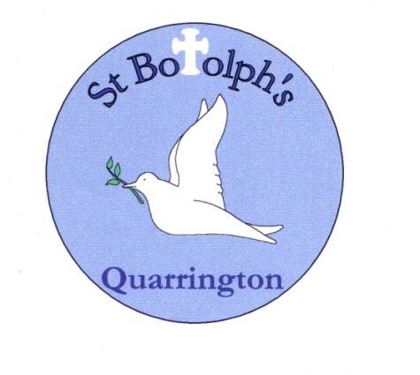

**Science at St Botolph’s CofE Primary School**

**The Intent**

At St Botolph’s Primary School, we offer the children high quality first-hand experiences which develop children’s natural curiosity. Scientific enquiry is at the heart of exciting and enriching Science lessons of biology, chemistry and physics and through this, children master both investigative and practical skills that underpin the development of scientific knowledge.

Our intent is that all of our pupils, irrelevant of their background or starting point, will be given the opportunity to ask their own questions about the world around them. Through a new carefully planned spiral curriculum, we will give the children the opportunity to develop their own interests, which will help to develop a sense of excitement and curiosity about natural phenomena.

**Science Policy**

**2023-2024**

**The Vision**

Our vision at St Botolph’s is to ignite pupils' curiosity and encourage them to confidently explore and discover the world around them, so that they develop a deeper understanding of the world we live in. Through our practical and spiral curriculum, we aim to inspire and excite our children and foster a thirst for knowledge. The teaching of Science will promote and develop transferable skills such as observation, communication and teamwork and allow mathematical skills to be applied. We also ensure that the Working Scientifically skills are built-on and developed throughout children’s time at the school so that they can apply their knowledge of science when using equipment, conducting experiments, building arguments and explaining concepts confidently and continue to ask questions and be curious about their surroundings

**An Introduction**

This policy describes our teaching of Science and outlines our aims, approaches and the progression across year groups. Our school offers a spiral curriculum for Science. The advantages of this is that learning is reinforced and solidified each time a child revisits the subject matter. It allows a logical progression from simplistic ideas to complicated ideas and children can identify that new learning has a relationship with old learning and can apply this earlier knowledge to later learning objectives.

The Spiral Curriculum is predicated on cognitive theory advanced by Jerome Bruner (1960), who wrote, "We begin with the hypothesis that any subject can be taught in some intellectually honest form to any child at any stage of development." In other words, even the most complex material, if properly structured and presented, can be understood by very young children.

**Our Aims:**

Science teaches an understanding of natural phenomena. It aims to stimulate a child’s curiosity in finding out why things happen in the way they do. It teaches methods of enquiry and investigation to stimulate creative thought. Children learn to ask scientific questions and begin to appreciate the way science will affect their future on a personal, national, and global level.

The intended outcomes of our curriculum are to enable children to:

* develop scientific knowledge and conceptual understanding through the specific disciplines of biology, chemistry and physics
* develop understanding of the nature, processes and methods of science through different types of science enquiries that help them to answer scientific questions about the world around them
* be equipped with the scientific knowledge required to understand the uses and implications of science, today and for the future.

**Implementation**

**The Teaching of Science**

Science is taught every week in all year groups. Working Scientifically is embedded in every science lesson, either as; fair testing, research, observation over time, grouping and classifying, or seeking patterns. The strand being taught is also identified at the start of each lesson, biology, chemistry or physics. The table below shows the different topics and their corresponding strand taught in each year group at St Botolph’s.

|  |  |  |  |  |  |  |
| --- | --- | --- | --- | --- | --- | --- |
|  | Year 1 | Year 2 | Year 3 | Year 4 | Year 5 | Year 6 |
| Working scientifically | | | | | |
| Biology | Plants | Plants | Plants |  |  |  |
| Animals, including humans | Animals, including humans | Animals, including humans | Animals, including humans | Animals, including humans | Animals, including humans |
|  | Living things and their habitats |  | Living things and their habitats | Living things and their habitats | Living things and their habitats |
|  |  |  |  |  | Evolution and inheritance |
| Chemistry | Everyday materials | Uses of everyday materials |  |  | Properties and changes of materials |  |
|  |  | Rocks |  |  |  |
|  |  |  | States of matter |  |  |
| Physics | Seasonal changes |  |  |  | Earth and space |  |
|  |  | Light |  |  | Light |
|  |  | Forces and magnets |  | Forces |  |
|  |  |  | Sound |  |  |
|  |  |  | Electricity |  | Electricity |

**Progression of Skills**

To ensure progression in the skills of scientific enquiry, teachers use the CIEC document, working scientifically as support and guidance. This highlights the progression from EYFS to Key Stage 1 and then into Key Stage 2. The working scientifically posters are displayed in the different key stages and this allows the children to establish the questions they should be asking and they too will see the progression as they move up through the Key Stages.

**Progression of Vocabulary**

Teachers are provided with an Excel Spreadsheet, which contains the vocabulary that needs to be taught. The vocabulary for each topic is separated into year groups so that progression is ensured. (See separate Excel spreadsheet) It allows teachers to see the vocabulary taught in previous years, as well as the vocabulary they need to teach.

**Equipment and resources**

High quality resources have been purchased to support the teaching and learning of science. These resources and equipment ensure that children are able to work and conduct experiments independently and never in groups greater than three. This has had a massive impact on the learning of children, as it ensures that every child is an active learner. Books and video clips, iPad’s, laptops and data loggers are also used to support and promote understanding.

**Assessment**

To judge that a pupil is working at the expected standard in science, teachers need to have evidence which demonstrates that the pupil meets all of the 'working scientifically' statements and all of the 'science content' taught in the final year of the key stage. To ensure this, teachers should draw on assessments that have been made earlier in the key stage to make their judgement against this framework.

At St Botolph’s we do this by ensuring opportunities for assessment are built into both medium- and short-term planning. Teachers assess against the objectives in the science framework and will assess if a child has met or not met the required standard.

Parents are informed on attainment, progress and effort in annual reports. National curriculum Science scores are also reported to parents at the end of KS1 and KS2.

**Training:**

The science coordinator attends appropriate STEM courses and feedbacks to the other staff members. This provides teachers with up to date information and key resources available to enhance teaching and learning. For example, the introduction to Reachout Reporter, Explorify, experiment ideas, resources etc.

Reachout CPD (<https://www.reachoutcpd.com/courses/>) is a free resource that teachers can complete if they need to develop their subject knowledge of a specific area that they are due to teach. This ensures the high-quality teaching of science.

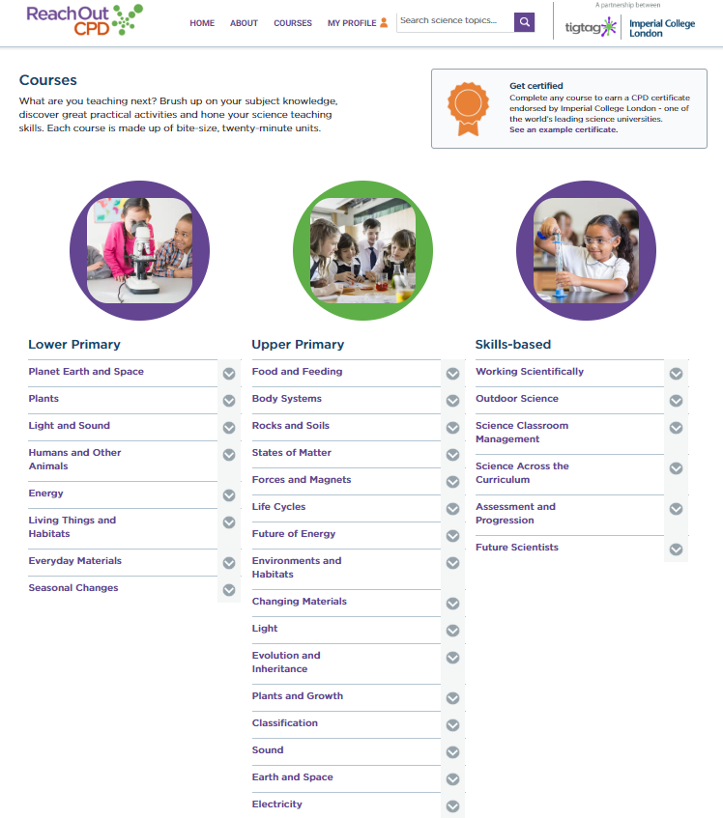

**Impact**

As a result of the knowledge and skills that we intend to and will implement within the school, our pupils will achieve well. This achievement will be reflected through application of Science in the broader curriculum and beyond. Using our assessment information, we will know when pupils are ready for the next stage in their learning and act accordingly. In doing this, the children will be successful, knowledgeable scientists who are curious about the world around them.