St Botolph’s Church of England Primary School

Snow Policy

1 Introduction

1.1 In the event of disruption caused by heavy snow, the prime concern of the school will always be the safety of the pupils and staff. The decision whether or not to send a pupil to school, however, must be at the discretion of the parents, taking into account factors such as local road conditions and the availability of childcare.

2 Aims and objectives

2.1 The school aims to remain open in the event of snow. We feel this is important for those parents who are relying on us to care for their children in term time. In the event of heavy snowfall, we cannot guarantee a normal school day.

2.2 However, there are certain factors which may lead to the school closing, such as whether:

there are enough members of staff to be able to provide satisfactory care;
the severity of the weather conditions is on such a major scale that it is unlikely that many people will be able to make it into school;
the school can provide lunch for the children;
the school grounds are sufficiently safe for children, parents and staff;
the school has sufficient heating;
the school has lighting and hot water across the site;
external agencies, e.g. police, local government, motoring organisations, etc, are advising against travel in our region.

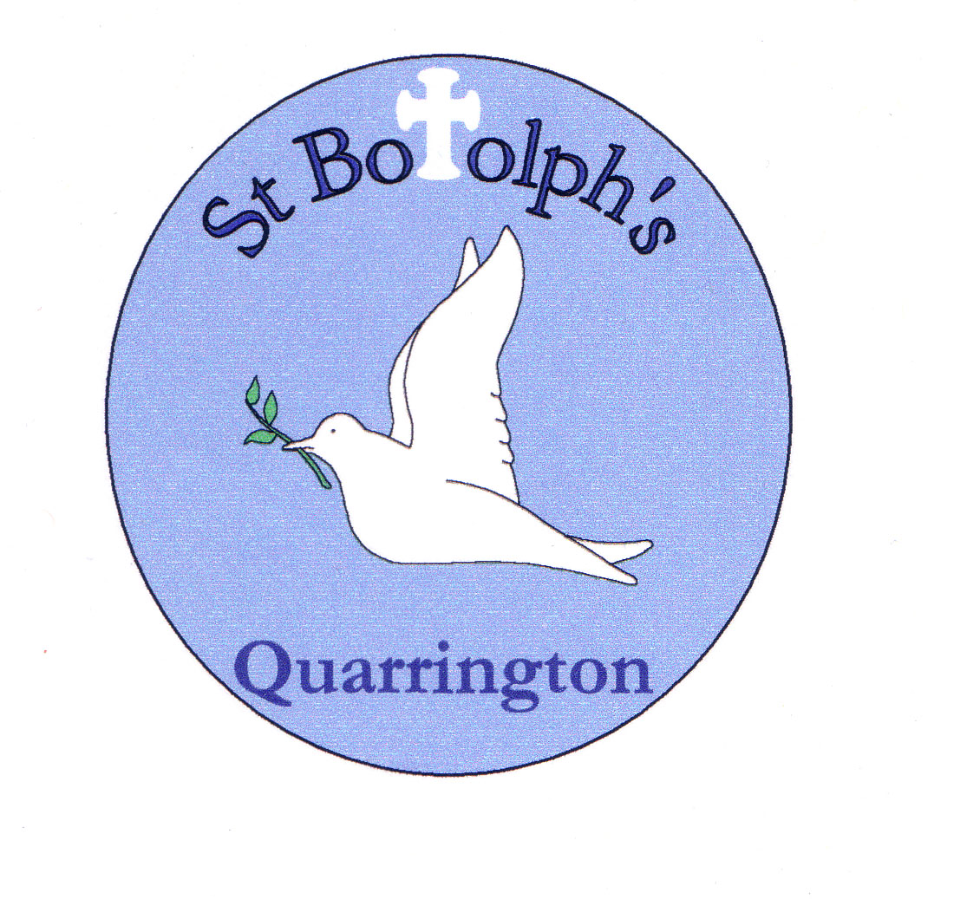
2.3 In the event of snow, if the school is to remain open, we will declare this a ‘Snow Day’ which means that the school will remain open with certain conditions and will post this on the website as soon as possible and normally by 7.00am on the day as well as notifying you of this by Parentmail. A Snow Day means that no after school activities will take place – including Badgers’ After School Club and all children must be collected by 3.10pm. Parents and carers should continue to check both the website and their mobile phones to check that the school is able to remain open until then.

If, for the reasons outlined above, the safest or most expedient judgement is to close the school a ‘Closure Day’ will be declared and we will post this on the website as soon as possible and normally before 7.00am on the day as well as notifying you of this by Parentmail.

When the school is open, we will remain open until the end of the normal school day at 3.10pm: weather permitting.

3 Frequently asked questions

3.1 Will parents be contacted in the event of snow?
Our website www.stbotolphs.co.uk should be consulted regularly. We will also endeavour to Parentmail everyone to ensure a clear message is sent.

This document (Snow Policy) can be found on the school website and gives clear instructions for snow days.

3.2 Do I need to contact the school?
There is no need to contact the school regarding your decision to travel or not; this will help to avoid blocked school lines. However, please tell us if your child will be absent and why to avoid an unauthorised absence mark. Children who live within walking distance of the school would be expected to do so even if they would normally travel by car.

3.3 Does it matter what time we arrive at school?
No. We will expect children to arrive throughout the morning. However, it is important that children sign in and register at the front office, or with a member of staff.

3.4 What will happen if heavy snow arrives during the school day?
We may declare a ‘Snow Day’ resulting in the school closing at 3.10pm. This would be communicated to you via the website and Parentmail. If you wish to collect your child(ren) from school before this time you are welcome to do so, but please make sure they are signed out.

3.5 When should I collect my child?
School will close at 3.10pm on Snow Days. Parents are welcome to collect at an earlier time if this suits them but they must sign their child out. Anyone struggling to collect their child by 3.10pm due to poor road conditions, transport arrangements etc, should contact the school to inform us of the likely collection time.

3.6 Will there be after school activities?
On ‘Snow Days’ there will be no after school activities, games or clubs – including Badgers’ After School Club. We will, however, endeavour to run our Early Birds before school club as normal. However, should you be delayed in collecting your child, please ring the school office to keep us informed. As always, we will look after the children until you are able to get here, but please remember that members of staff will also be anxious to get home if the weather and road conditions are poor.

Signed:

Date:

Review Date:

