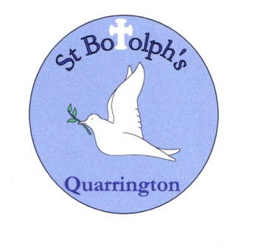

St Botolph’s Church of England Primary School. Quarrington, Sleaford.

Religious Education Policy

This policy has been adopted by the Governors in consultation with the R.E. subject coordinator and teaching staff.

Review

The Headteacher, Staff and Governors will review this policy in the Autumn Term 2018.

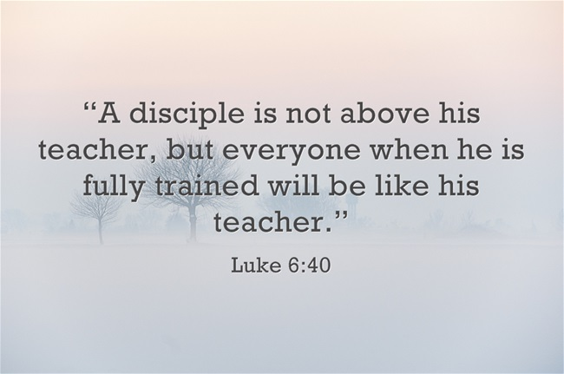**The Aims of R.E. at St. Botolph’s Church of England, Primary School.**

**R.E. at St. Botolph’s Church of England Primary School will be provided in line with the Legal Requirements. These are that:**

* the basic curriculum will include provision for Religious Education for all pupils on the school roll;
* the content of R.E. shall reflect the fact that religious traditions in Great Britain are in the main Christian, while taking account of the teaching and practices of the other principle religious traditions represented in Great Britain;
* the R.E. which is provided shall be in accordance with the locally agreed syllabus for Lincolnshire LEA (published in 2013).

**Within the framework of the law and the Agreed Syllabus, our aims in R. E. are:**

* to enable each child to explore our shared human experience and the questions of meaning and purpose which arise from our experiences;
* to enable pupils to know about and understand the beliefs and practices of some of the great religions of the world, particularly those represented in Lincolnshire and the U.K. Among these religions, Christianity has a particular place and is taught in each year of the Primary phase;
* to promote respect, sensitivity and cultural awareness by teaching about the religions represented in the region and the country;
* to affirm each child in his/her own family tradition, religious or secular;
* to provide children with opportunities for spiritual, moral, social and cultural development;
* to develop the ability of pupils to think about and develop for themselves, beliefs and values by which they can live, through studying concepts like celebration, the sacred, authority, religious belief and lifestyle, and exploring the fundamental questions of life.

**Context**

The context of R.E. at St Botolph’s Church of England Primary School is that of a two form entry Primary school serving children in the age range of 4-11 years old.

We work to the Lincolnshire Agreed Syllabus.

We recognise the variety of religious and nonreligious backgrounds from which our pupils come. We welcome the diversity and we intend to be sensitive to the home background of each child. We are glad to have the active support of members of local faith communities in R.E. and the support of our local clergy.

We recognise the relationship between pupils’ spiritual, moral, social and cultural development and the leading role which the R.E. curriculum plays in some of these areas.

**Time Allocation.**

The Dearing Review of the Curriculum (1996) recommended a minimum of 36 hours per year for R.E. at Key Stage 1, and 45 hours per year at Key Stage 2, a recommendation endorsed by the Lincolnshire Agreed Syllabus, 2013. The time allocated at St Botolph’s Church of England Primary School, will be 36 hours per year at Key Stage 1 and 45 hours per year at Key Stage 2. R.E. curriculum time does not include Collective Worship, even where the assembly provides a starting point for curricular work.

**Scheme of Work.**

A detailed scheme of work is available for teachers and other interested parties alongside this policy. It has been written in the light of the Agreed policy and is taken from the Lincolnshire Syllabus for R.E. It is based around termly themes in Foundation and Key Stage 1, where Christianity and Judaism will be the major religions studied. At Key Stage 2 pupils will learn about Christianity throughout the Key Stage, and will also have major learning opportunities with regard to two other religions, Hinduism and Islam in years 3 and 4, and Judaism and Sikhism in years 5 and 6.

No teacher can be an instant expert in the six world religions – Christianity, Judaism, Hinduism, Islam, Sikhism and Buddhism. Staff who feel the need to build up their own subject knowledge can take up some training opportunities. The R.E. Coordinator can supply some reading material for staff and the Agreed Syllabus gives Staff a basic knowledge of the World Religions.

**Teaching and Learning Styles.**

**OFSTED** reports suggest that the range of teaching and learning strategies in use in R.E. is often too narrow, in overusing stories and a limited range of drawing and written tasks. Our policy is to aim to increase the use of R.E. in Art, Drama talking activities, visits, posters, photos, videos, display work and other active learning strategies. Cross curricular work is encouraged, in line with whole school policy on teaching and learning. We recognise the importance of teaching to the Attainment Targets of the Agreed Syllabus in a balanced way.

**Resources.**

Resources are stored in the Resource Cupboard in the Atrium, and should be returned after use. The school has invested in new books, religious artefacts, video, picture packs and posters and staff may need to familiarise themselves with the new materials. We maintain an R.E. shelf in the Resource Cupboard in the Atrium and in the Library, which offer many stories from different traditions which teachers have used in R.E. There is a range of R.E. ‘big books’ which can be used across the age range as well. We realise that in Lincolnshire children do not have access to a huge variety of different places of Worship of the six Major Religions so Videos and photographs are also used to enhance learning. Staff are invited to suggest gaps in the resources for future spending.

**Visits to Places of Worship.**

We are able to visit different Christian churches in the immediate vicinity of the school, where clergy and other members of the community are willing to meet with children and be involved in R.E. We have strong links with Quarrington C.E Church and aim to use this valuable resource for all classes. Rev. Mark Thomson, Governor and Rector of St. Botolph’s Church, comes to Collective Worship on a regular basis and is most willing to contribute to any R.E. units of work in an active way.

**R.E. and I.C.T.**

R.E. can be enriched by the appropriate use of I.C.T. At the same time, R.E. teachers can use and develop the I.C.T. skills of the children. At St. Botolph’s the interactive whiteboards will be used to aid the teaching of R.E. Children will be encouraged to use and develop their I.C.T. skills to support the activities of finding information about beliefs, teachings and practices and their impact on individuals, communities and cultures. I.C.T. will be used to help our children in their understanding and to communicate and explore information about the concepts of Celebration in religion (K.S.1) and religions, beliefs and lifestyles

(K.S.2). I.C.T. will only be used in R.E. to enrich and improve the quality of teaching and learning.

**Matching work to pupils’ needs**

Whole school policy with regard to special needs and differentiation applies to R.E.: teachers should be alert to the fact that some children have special and deep experience of a religion through family practice.

**Assessment.**

We report on pupils’ progress and attainment as required by law. We use short and long term assessment (see attachments) to measure pupil’s attainment and progress in R.E. We will intend to make specific, individual, accurate comments on each child’s progress in R.E, based on regular monitoring of work.

**Moderating, Evaluation and Review.**

We intend that this policy should operate for the next five years and then be fully reviewed by all staff and Governors. To ensure that that the policy is in practice and to help teachers keep track of their own work and needs for support or training, all staff are asked to return a summary sheet of R.E. work done to the Coordinator each term. The Coordinator’s role includes monitoring and evaluation of this policy in practice.

**Withdrawal.**

We note the rights of parents to withdraw their children from R.E. and of teachers to withdraw from teaching the subject. We aim to provide an open curriculum which can be taught to all pupils, by all staff. Please refer to the Coordinator or Head teacher any questions from parents about withdrawals.

Link Governor: Rev Mark Thomson

Named Coordinator: Mrs Sarah Brunt

Date: June 2017

Author: Mrs S Brunt