

# Growth Mindset Policy

Our aspiration is that St Botolph’s CE Primary will be an outstanding school.

We value and respect everyone in our community and work as a team to:

* Provide learning experiences which support and inspire high achievement for all ;
* Ensure a caring, safe and welcoming environment;
* Promote co-operative and responsible attitudes to make a positive contribution;
* Actively encourage independence and confidence to thrive in a changing world.

“Happy, Healthy, High Achievers”

Rationale

The research of Carol Dweck, a Professor of Psychology at Stanford University, has shown that people who believe that their intelligence can be developed (thus demonstrating a growth mindset) outperform those who believe their intelligence is fixed (fixed mindset). When children learn that they can “grow their brains” and increase their intellectual abilities, they do better. This very much compliments St Botolph’s CE Primary Schools’ ‘I can’ and ‘I can’t do it …YET’ philosophy.

It has been found that by focusing on the process which leads to learning (such as concentrating, persevering and learning from mistakes), we can foster a growth mindset in our children. Approaches to learning which involve meta-cognition, consistently have shown high levels of impact. The evidence also indicates that teaching these strategies can be particularly effective for low achieving pupils.

Aims

This protocol aims to ensure a consistency of approach across the school, in order to promote a growth mindset culture by our use of language, by modelling and managing behaviour and by organising teaching and learning. This includes the teaching, learning and assessment of learning attitudes, which aim to help us all to think about our learning more explicitly.

Learning Environment

Each class creates an environment in which growth mindset messages are promoted and where the differences between a fixed and growth mindset are evident and can be easily referred to.

What is the difference between a Fixed and Growth Mindset?

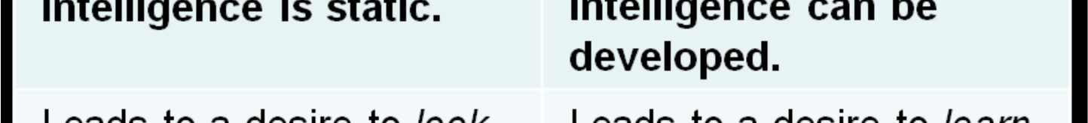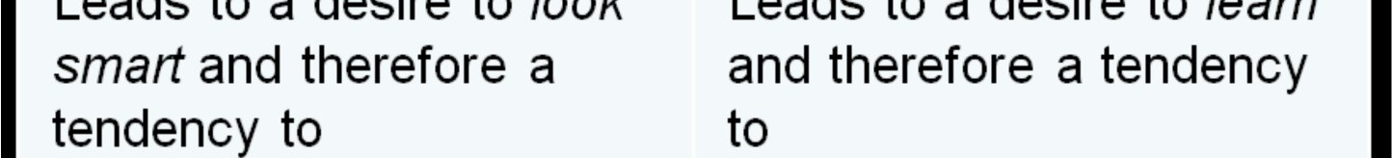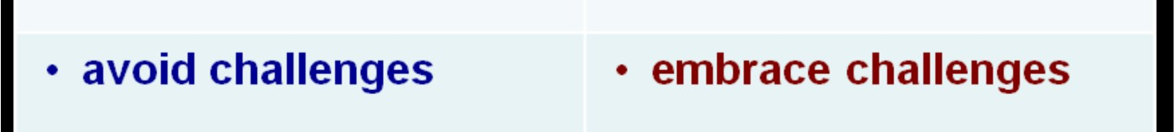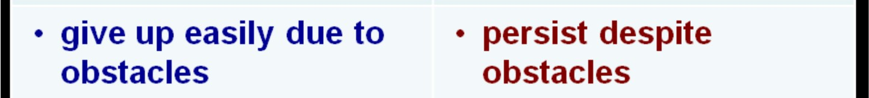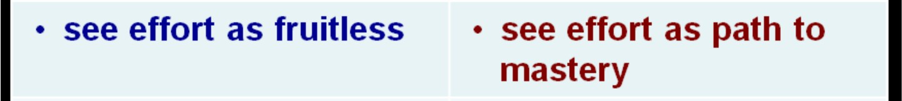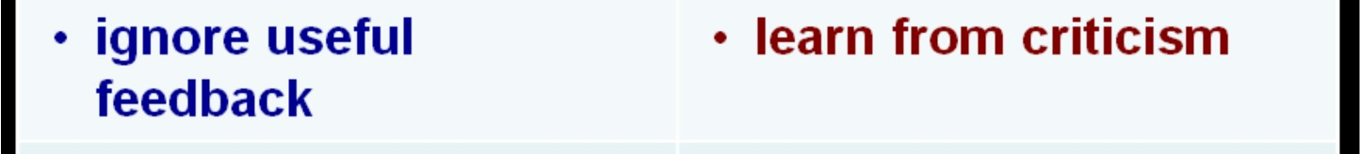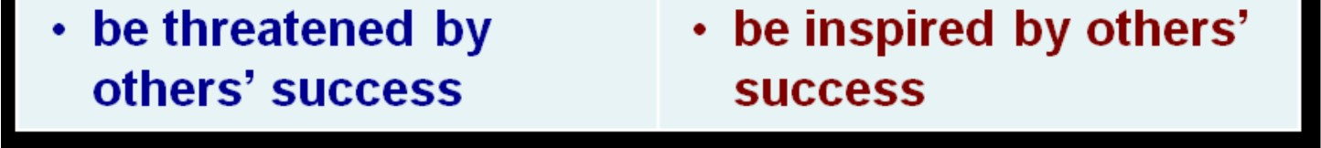

A quote from Carol Dweck:

"In a fixed mindset, students believe their basic abilities, their intelligence, their talents are just fixed traits. They have a certain amount and that's that, and then their goal becomes to look smart all the time and never look dumb. In a growth mindset, students understand that their talents and abilities can be developed through effort, good teaching and persistence. They don't necessarily think everyone's the same or anyone can be Einstein, but they believe everyone can get smarter if they work at it."

Language, marking and feedback

The word ‘work’ outside education is something we do for somebody else and contains no explicit connection to education and learning. At St Botolph’s, we believe ‘work’ means learning, discovery, exploration and play.

We give praise for persistence, effort and resilience, rather than for being ‘clever’. Wherever possible, praise highlights the effort, skill, process or attitude, rather than the person.

We are also aware that most of us have a mixture of fixed and growth mindsets, and that we are all on a journey towards a having growth mindset.

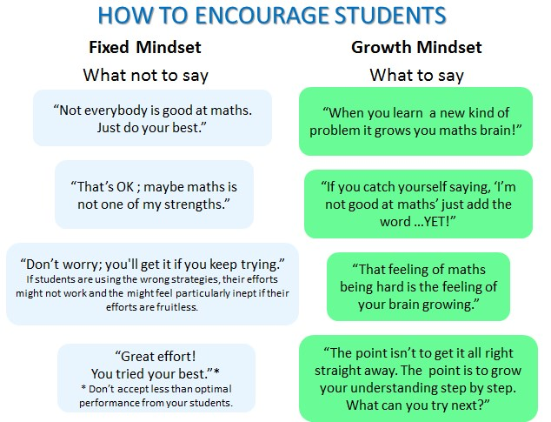

Organisation

When children are placed in a “lower ability” or middle ability” group, this can encourage the child to have lower expectations of him/herself. Children are often aware of where they are in relation to the rest of the class and therefore will vary their aspirations accordingly, thus undermining their growth mindset. Their access to higher order thinking, language and activities can potentially be limited by this approach.

At St Botolph’s, we keep groupings flexible. Children often work collaboratively in mixed attainment pairings and small groups. In this way, we have found that children learn from each other and challenge themselves more. They understand that being able to explain learning to a peer will, in fact, enhance their own learning. They place fewer limits on their learning and have higher expectations of what they can achieve. This, consequently, has improved the attainment of all our pupils.

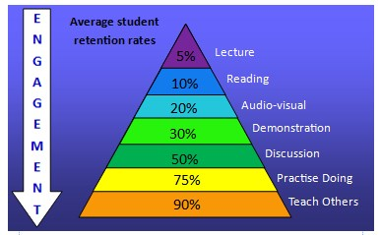

Teaching approaches

At St Botolph’s, contributions from all children are valued. We endeavour to foster a culture whereby children feel proud of their learning and understand that making mistakes is a crucial part of learning, as is the improvement of work. Errors are regularly planned to be used as learning points within lessons.

Children are encouraged to be active learners and take responsibility for their own progress. In order to learn, we need to be challenged and embrace struggle. We often use the analogy of the ‘learning pit’ to help children talk about where they are in their learning journey.



Teachers, and the children themselves, are able to identify when further input is needed and hold mini teaching sessions within lessons to support learning and help children out of the ‘pit’.

At St Botolph’s, we encourage a culture where mistakes are celebrated because mistakes are necessary for learning and improving intelligence. If children have fixed mindsets they find it hard to cope with failure; we teach our children to see mistakes as positive. People with a growth mindset see failure not as a negative, undermining judgement on them as people, but as something they can learn from so that they can succeed in the future.

Appropriate, targeted adult support can have a significant impact on learning. However, if not managed reflectively, it can also have a significant impact on attitudes towards oneself as a learner, and on independent learning, Children can become ‘TA dependent’. At St Botolph’s, support staff work with all children. Both teachers and support staff promote independence and resilience.

Rewards are used at St Botolph’s for a wide range of reasons, such as promoting good behaviour and to recognise achievement and effort. Friday celebration worships provide an opportunity for children to be rewarded for showing behaviours which represent growth mindset, running alongside our Christian Values. This can be seen in the reasons for which pupils receive a Headteacher awards too.

Parents need to be clear about what we mean by a growth mindset, how we promote it at school and how they can support it at home. More information can be found on the schools website.