St. Botolph’s CE Primary School

29 November 2012

Dear Parents / Carers

It has been brought to my attention that at least one child in school has symptoms of Threadworms.

According to the BBC, Threadworms - also known as pinworms - are the most common parasitic worms in the UK. They're tiny (about 1cm long), pale, thin worms that look like cotton threads and thrive in the intestines. Threadworms are particularly common among younger children who play closely together. Poor hygiene, particularly not washing hands after using the toilet, is a major factor in the spread of infection. http://www.bbc.co.uk/health/conditions/worms2.shtml
All children in school are encouraged to wash their hands after visiting the toilet and we would ask for your help in re-enforcing this message with the children at home.
Yours sincerely

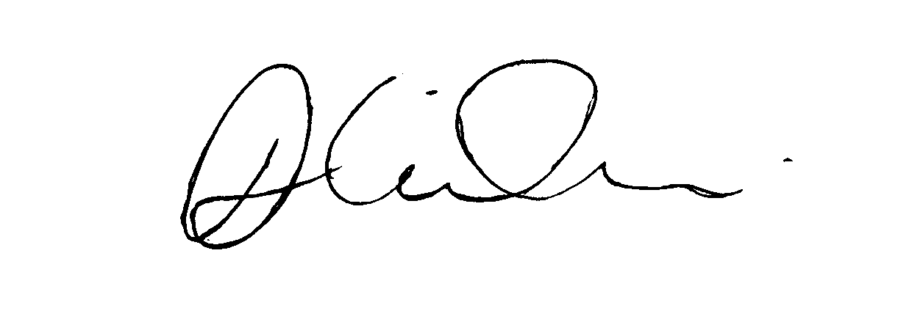

Mrs. D Wilson
Headteacher

