Year One

Term Four

Garden Detectives

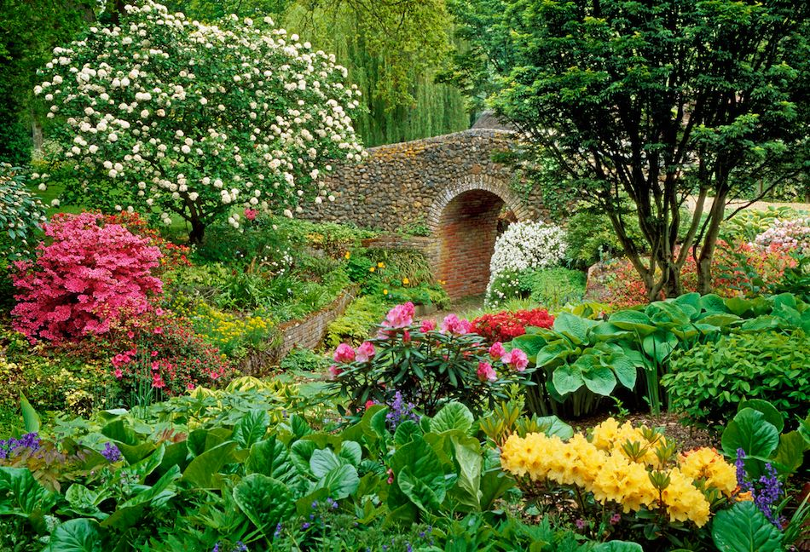

|  |  |
| --- | --- |
| **Maths** | Addition and Subtraction within 20, Shape and Patterns |
| **English** | Narrative  Explanations |
| **Geography** | Studying the school and it’s grounds- Planning a Garden |
| **Science** | Mini-beasts  Spring  Plants- Part One |
| **Art** | Still Life- Observational Drawings of Flowers |
| **Computing** | Sorting data |
| **Music** | Composer Study- Vivaldi, Spring |
| **PSHE** | Road Safety |

|  |  |  |  |  |
| --- | --- | --- | --- | --- |
| Essential Skills | | | | |
| GEOGRAPHY | |  | SCIENCE | |
|  | I tell others’ the things I like and dislike about a place. |  | I can identify and name common mini beasts and insects. |
|  | I describe places using geography words such as physical and human. |  | I can compare and describe the structure of mini beasts. |
|  | I can mark on a map of the local area, the location of the school. |  | I can identify habitats that mini beasts are most suited to. |
|  | I can map the outside area (garden?) |  |  |
|  | I can make drawings of a place I am finding out about. |  | I observe changes across the four seasons. |
|  | I can suggest ways I could improve somewhere near the school (garden). |  | I observe and describe weather associated with the seasons and how the day length varies. |
|  |  |  |  |
|  | ART & DESIGN |  | I can identify and name common garden plants. |
|  | I can describe what I can see and talk about what I like and don’t like about the work of an artist. |  |  |
|  | MUSIC |
|  | I can think about the techniques an artist has used. |  | I know how some sounds are made and changed. |
|  | I can ask questions about a piece of art. |  | With help, I can make sounds with a slight difference. |
|  | I can use pencils to create lines of different thicknesses in drawings. |  | I can use my voice in different ways to create different effects. |
|  | I can choose how to arrange my work. |  | I can listen for different types of sounds. |
|  | COMPUTING |  | PSHE |
|  | I can sort objects into groups according to a give criteria. |  |  | I know the rules of the road. |
|  | I begin to use technology to create graphs and pictograms. |  | I know how to keep safe. |
|  |  |  | I can tell you about basic road safety. |
|  |  |  | I know the people that can keep me safe. |
| RELIGIOUS EDUCATION | |  |  |  |
|  | I can discuss how I celebrate Easter. |  |  |  |
|  | I know what Lent is. |  |  |  |
|  | I know the Easter Story. |  |  |  |
|  | I know what Shrove Tuesday is. |  |  |  |
|  | I know why we eat Hot Cross Buns. |  |  |  |
|  | I know the meaning of a palm cross. |  |  |  |
|  | I know what happens at Church during Easter time. |  |  |  |
|  | I know why we eat eggs at Easter. |  |  |  |

|  |  |
| --- | --- |
| **Promoting our Values**  Our Values will be promoted through the topic by… | |
| Social | Enterprise work, developing a community garden, working with adults |
| Moral | How can we be safe on the roads? Caring for living things |
| Spiritual | Easter celebrations |
| Cultural | Fruit from other countries, spring celebrations in England |
| British Values | *Democracy-* Learning from adults  *Rule of Law-* Safety in the garden,  *Respect for Faiths & Beliefs-* Easter celebrations |
| Christian Value | Peace |

|  |  |
| --- | --- |
| **Convention Right of the Child**  These are the rights that could be embedded into the topic… | |
| Article 1 | Everyone under 18 has these rights. |
| Article 3 | All organisations concerned with children should work towards what is best for each child. |
| Article 14 | Children have the right to think and believe what they want, and to practise their religion, as long as they are not stopping other people from enjoying their rights. Parents should guide their children on these matters. |
| Article 24 | Children have the right to good quality health care, to clean water, nutritious food, and a clean environment, so that they will stay healthy. Rich countries should help poorer countries achieve this. |
| Article 31 | All children have a right to relax and play, and to join in a wide range of activities. |