St Botolph’s CofE Primary School
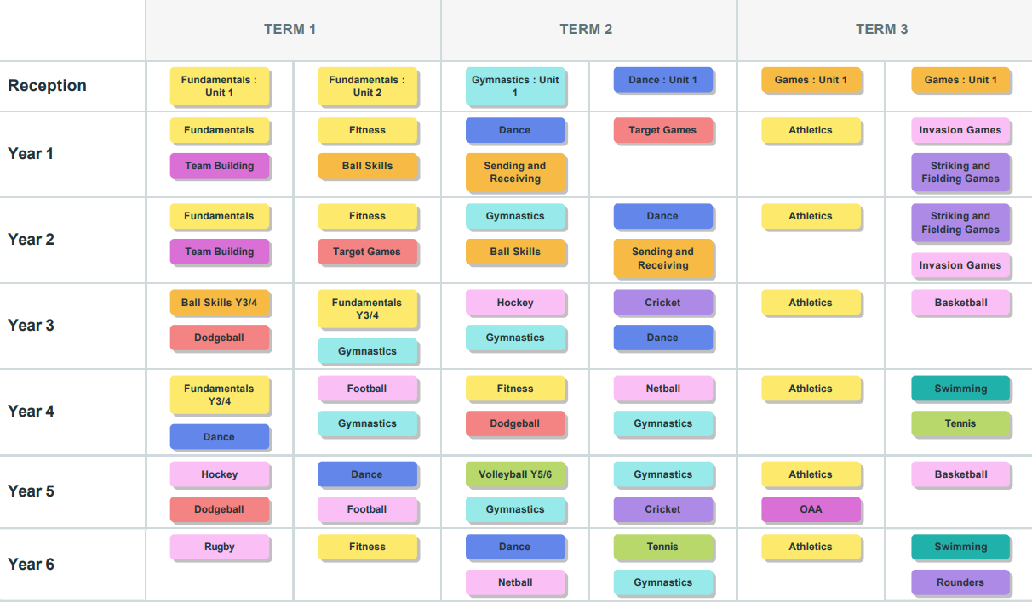
Physical Education Long term plan 2025-2026

