Governing Body at St Botolph’s CE Primary School

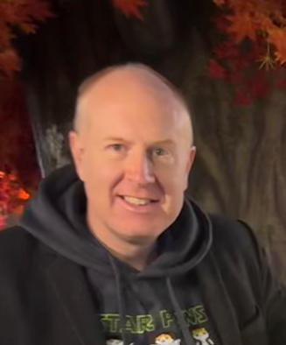 | Ian Freeman  Chair  Foundation Governor | Hi, I am Ian Freeman, both of my Children attended St Botolph’s C of E School and are now flourishing at the two grammar schools in Sleaford. I was always impressed with the quality of education that my children received and now that they are no longer at St Botolph’s I have remained involved to be able to give something back to the school.  Outside of the school, I am the church organist for St Botolph’s Church and am also the chair of Trustees for Second Chance Associations (the charity shop on Boston Road) as well as being involved in the charity that runs the annual beer festival in town that raises funds for SHOCK Sleaford which provides defibrillators in the NG34 postcode area.  When I have time to work, I am a part time NHS-funded carer, and I work part time running my own IT support company.
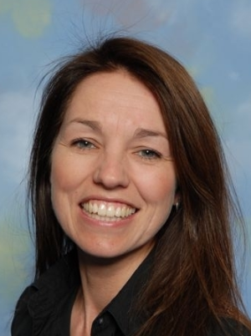 | Debbie Wilson  Headteacher | My Name is Mrs Wilson, I am the Headteacher at St Botolph’s CE School and I am very proud of all the staff and the children.  I feel very privileged to be able to help shape the lives of young children and give them opportunities to succeed.  I have worked here for over eighteen years and have loved every minute of it. The school has grown and developed so much over the years and I truly believe it is a great place to be.  When I do get some free time, I love to run, cycle, golf, swim, walk, read and travel. Being outside is really important to me.  I have an open-door policy, so please, if you would like to discuss any issues or concerns, please make an appointment, I would love to see you.  I know that I am lucky to have supportive parents and a great team around me. That’s what makes St Botolph’s a special place to be. I am one lucky Headteacher.
 | Mark Graves  LA Governor | I’m Mark,  I graduated in 1987 and returned to work in my family business here in the town, something I’m really proud of. Over the years, I’ve enjoyed being involved in the community, not just through the business, but also in supporting the many local organisations that help make this town special.  I first became a governor in 1991 when I was appointed as a local authority governor, just as I began my time with Sleaford Town Council. At that point, the school was still on Grantham Road, across from what is now the Spar convenience store. When plans were made to reorganise local primary schools, the decision was made to build a new school on its current site.  I’ve held various roles, including chairing the governing body, and now I serve as Chair of Finance. Although I’ve stepped back from some of my other community roles, I’m still very proud to be part of St Botolph’s School. Every visit to the school reminds me of what a privilege it is to be involved.
 | Katie West  Staff Governor | My name is Katie West and I have been a teacher at St Botolph’s for ten years- time flies when you’re having fun! I started out my career as a Teaching Assistant, working in all year groups, before making the leap to qualifying as a teacher. I love my job and have spent most of my teaching career in Key Stage One. I am so lucky to lead English in the school- my passion lies in teaching early reading and phonics. I have been staff governor at the school for a few years now and enjoy being involved in this aspect of school life.  When I’m not at school, I am a mummy to a wonderful little girl who keeps me incredibly busy. With my family, we love taking long walks with our beautiful dog and visiting the seaside, especially my favourite place on the planet- Scarborough!
 | Joe Lee  Co-opted Governor | I’m Joe, and I serve as a Co-opted Governor for St Botolph’s C of E Primary School in Sleaford. Having grown up in the local area and attended secondary school in Sleaford, I felt that becoming a governor at St Botolph’s was my way to give back to a community I feel close to. Throughout my career in the ICT and Education sectors, I have come to understand the challenges of working with tight budgets while still maintaining high standards.  Becoming a co-opted governor has been an incredibly rewarding experience for me. I was honoured when the governing body approved my application to contribute to the strategic direction and oversight of St Botolph’s. With my background in schools ICT, I feel that I bring valuable insights that help shape the policies and decisions that guide our future. I enjoy collaborating with my fellow governors, participating in meetings, and ensuring that we stay true to the school’s vision and values.  My commitment to making a difference drives me in my role as a co-opted governor. I take great pride in the progress and achievements of our school, knowing that my contributions play a part in its success. Whether I’m advocating for new initiatives, supporting the implementation of strategic plans, or providing guidance on complex issues, I feel that my dedication and expertise are making a real difference. It’s incredibly rewarding to know that I’m helping to shape the future of our school and ensuring it continues to thrive and serve our community effectively.
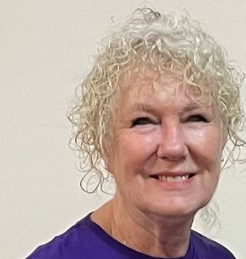 | Rita Owen  Co-opted Governor | Hello my name is Rita Owen, Safeguarding Officer for St Botolph’s Church and a member of the PCC. In an addition I am an External Verifier for VTCT Skills inspecting colleges and training providers for a host of qualifications mainly in Childcare and Health and Social Care.  I was first introduced to St Botolph’s School some years ago. My husband and I had guardianship of our granddaughter, who attended and excelled at the school. I have also been involved with messy church which has been held at the school.  I believe I can offer the school as a Governor a wealth of experiences. As a child I was classed as “thick and stupid”, terminology used in those days. I knew I wasn’t and when I started working for NHS, support was given and I was diagnosed with dyslexia. From that day on I strived to achieve as much as I could adjusting my method of learning. I completed my nurse training, leaving that to open a restaurant ( my favourite pastime is cooking) I then went on to work in children’s home and managed a residential home for the elderly before moving to Lincolnshire when I opened a training centre , retiring form that in 2001.
 | Mandy Wright  Co-opted Governor | With 22 years of experience in education, I am passionate about fostering a positive and enriching environment for both students and staff. As Deputy Head, I am dedicated to supporting the development of our school and ensuring we provide the best possible opportunities for all learners.  Outside of my professional life, I am a proud mother of three children and am happily married. I enjoy travelling to new destinations, diving into a good book, and spending time exploring forests. My love for nature and adventure continues to inspire both my personal and professional life, where I strive to instil a sense of curiosity and wonder in our school community.  As a Governor, I am committed to helping our school thrive, and I look forward to contributing to its continued success
 | Matthew Downing  Parent Governor | Hello - I'm Matt and my eldest daughter has just started foundation at St Botolph's  I've worked in the NHS for almost 20 years, primarily as a Paramedic for the ambulance service. I also attend church on a weekly basis and would consider myself a devout Christian, with Jesus being the central focus of my life.  My primary reason towards applying for the governor role is to offer something back to the community – St Botolphs appears to be an excellent school and it would be a privilege to work with it, to help continue its values and ethos.  I'm looking forward to being a voice on behalf of other parents and to help shape our wonderful school.
 | Gareth Hughes  Parent Governor | I have 3 Children who all attend or have attended St Botolph’s. Eldest was at St Botolph's for 2 years and left in 2022 for High School, my son is in Yr 5 and my youngest daughter started Reception /Foundation this School Year. I currently work for the Royal Air Force at RAF Waddington for the Royal Air Force Aerobatic Team the Red Arrows. The children have been in 3 schools in the past 8 years, their previous school in Lincoln was appalling and swore it would not happen again. To ensure this, I wanted to help the school maintain and improve its already exceptional standards.  I’ve been a Governor at St. Botolph’s for 2 years now, where I have, seen huge changes, from creating new teaching rooms and sports facilities to organising school trips myself. This ensures the students can see and experience new and exciting things, whilst having access to areas they feel comfortable in and that encourages them to learn.”
 | Marissa Jones  Parent Governor | My name is Marissa, and I joined the Governing body as a Parent Governor in 2022 when my son started in Reception at St Botolph’s.  My background is primarily in Accountancy, and so I was excited to see what I could bring to the Finance Committee whilst learning along the way. I quickly developed a passion for children’s education, and I have since been employed St Botolph’s, so I feel I have a strong connection with the school.  I am honoured to be a Governor and be part of a team where we work towards shaping the best possible future for the children.  In my spare time, my favourite thing to do is relax at home with my family.
 | Will Newham  Parent Governor | I’m Will Newham, a proud parent of 3 children at St Botolph’s.  I enjoy being a governor at St. Botolph’s and helping the school provide a nurturing, high-quality education for all students. I’m passionate about supporting the school’s growth, promoting strong governance, and creating a positive environment where every child can thrive.  As a parent, I believe my experiences can help shape the future of St. Botolph’s.
 | Julie James  Clerk to Governors | My name is Julie James and I have been at St Botolph’s for 23 years, working as Clerk to Governors and in the school office (until October 2023). I am a very proud mother of two grown up children, both whom attended St Botolph’s.  Outside school, I love to travel in our motorhome, read and spend time with my family and friends.

