
†

Quarrington

School Uniform Policy

St Botolph’s Church of England Primary School

Uniform:

A white polo shirt (can be with or without logo) | 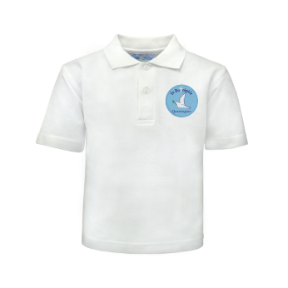
A royal blue sweatshirt or cardigan (can be with or without logo) | 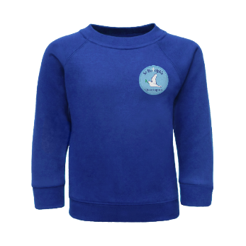 | 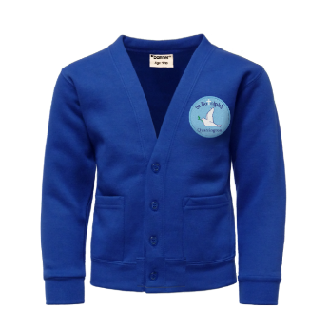
Dark grey trousers or dark grey shorts | 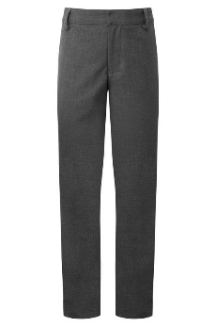 | 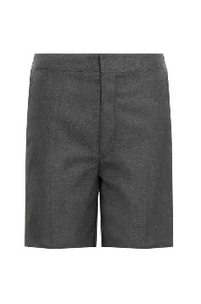
Dark grey skirt | 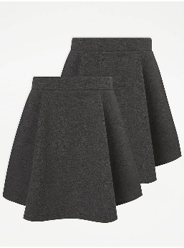
Plain grey, black or white socks or grey tights | 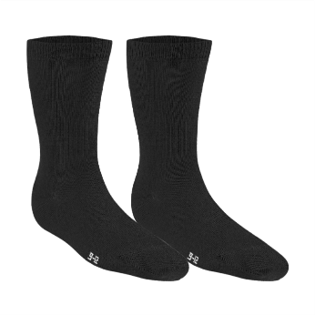 | 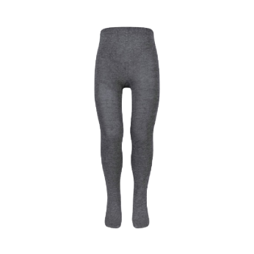
Blue gingham summer dress | 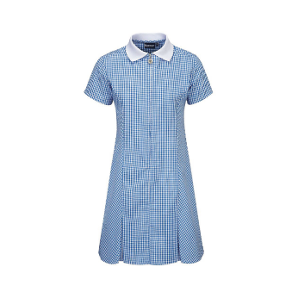

PE Kit:

A white T-shirt shirt (can be with or without logo) | 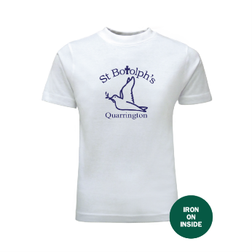
Royal blue shadow striped shorts | 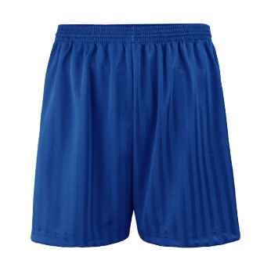
Royal blue hoodie (can be with or without logo) | 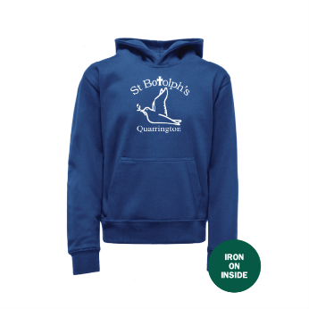
Plain royal blue jogging bottoms | 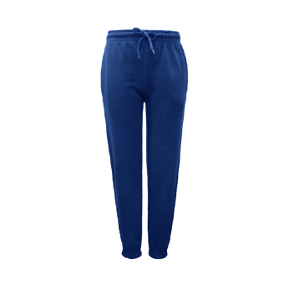
Black Plimsolls | 