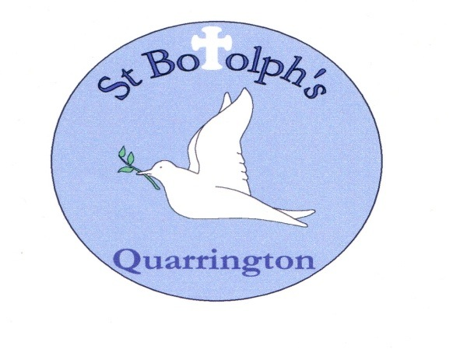

St Botolph’s Church of England School
Governor Meeting Attendance 2025/26

FULL GOVERNING BODY |  | FGB Meetings |  |  |  |  |  |  | FINANCE COMMITTEE | Finance Committee Meetings
Governor Name | Governor Type |  |  |  |  |  |  |  | Governor Name
Governor Name | Governor Type | 10.09.25 | 25.11.25 | 10.02.26 | 01.04.26 | 01.06.26 |  |  | Governor Name | 10.09.25 | 24.11.25 | 9.2.26 | 24.3.26 | 1.7.26
Matthew Downing | Parent |  |  |  | Aps
Mark Graves | Local Authority |  |  |  |  |  |  |  | Mark Graves
Gareth Hughes | Parent |  |  |  |  |  |  |  | Gareth Hughes |  | DNA
Revd Philip Johnson | Foundation
Marissa Jones | Parent |  |  |  |  |  |  |  | Marissa Jones
Joe Lee | Co-opted |  |  |  |  |  |  |  | Joe Lee
Will Newham | Parent |  |  |  | Aps
Katie West | Staff
Rita Owen | Ex Officio Foundation |  |  |  | Aps
Hilary Sykes | Foundation
Debbie Wilson | Headteacher - Ex Officio |  |  |  |  |  |  |  | Debbie Wilson
Mandy Wright | Deputy Head - Co-opted
Vacancy | Co-opted
Vacancy | Co-opted
Ian Freeman  Resigned 10.2.26 | Foundation |  | Apology |  |  |  |  |  | Ian Freeman
Aps = apologies DNA = no apology received, did not attend

