
Governors’ Report for September 2026
The report covers the period from September 2025 to September 2026
D.T
Mrs E Eames

Overview and main focus for the year:
Over the past year, I have been studying the development and delivery of Design and Technology across the school. My role has included ensuring that the curriculum is well sequenced and accessible to all pupils, while supporting staff in developing their subject knowledge and confidence.
My leadership priorities have included monitoring curriculum coverage and progression and ensuring pupil voice to check views and understanding of the subject.
Ongoing monitoring indicates that DT provision is developing positively, with a focus on maintaining consistency across year groups and ensuring that pupils build knowledge and practical skills progressively.
One of the key areas for development across the school has been establishing a rigorous method of assessing DT that linked with the milestones.

CPD within school.
With change in staffing, I checked that a particular teacher was confident in her DT knowledge of the different units. As Makey Makey was a new topic for her, we had a session where I showed her how to use the kits and we worked through some of the lessons together until she was confident to deliver the unit. As the sessions were being taught, I checked that the lessons were going as expected and we talked about how to move the children forwards with their learning.
As children are should have an awareness of innovators in the real world, I have created fact files that link with different units of work, such as textiles, architecture, cookery and computing. This gives staff key facts that they can then share with the children and support their learning.

Monitoring and Evaluation and Pupil Voice
The monitoring of DT books focused on the quality and consistency of pupils’ work and the progression of skills across the year groups.
Pupils’ books demonstrated progression in their DT learning, with increasing attention to detail with regards to the depth of planning and designing, through the year groups. Monitoring also considered whether planning, designing, making and evaluating were evident within pupils’ work. Often work was found on Seesaw, rather than in books, as this was more appropriate.
Pupil voice was used to gather pupils’ views about their DT learning and experiences. Pupils were able to discuss what they had learned and the skills that they had developed. Every child spoke enthusiastically about previous projects that they had enjoyed, even going back two or three years. They were generally able to explain the purpose of their projects and describe aspects of the design and making process. Many more children were able to state the different phases of the DT process – exploring, planning, designing, making and evaluating. Previously, lots of the children didn’t recognise the term evaluation or the significance of using this skill as part of their learning.
A couple of quotes-
What do you like about DT?”
“I like that I can make lots of exciting things.” (Y2)
How do you know that you’ve made a good product?
“The product fits the design criteria and you feel proud of it.” (Y6)
Overall, the monitoring provided evidence of positive progression in DT, with pupils engaging well in practical and creative learning.

Quality of teaching and learning.
The quality of teaching and learning in Design and Technology is characterised by a strong emphasis on creativity, practical skill development and purposeful problem-solving. Teachers provide well-structured, engaging lessons that balance hands-on making with clear modelling of techniques, enabling pupils to develop confidence with a wide range of materials, tools and processes. Learning is sequenced thoughtfully so that children build technical proficiency over time while also understanding the design cycle—from research and planning to evaluation and refinement. High expectations and effective scaffolding ensure that pupils take pride in producing high-quality outcomes. Across the curriculum, DT teaching nurtures resilience and critical thinking, helping pupils become capable, reflective designers who enjoy applying their skills in meaningful contexts.

No lesson observations have been undertaken, but book scrutinies, pupil voice and observations of final products reveal these insights.
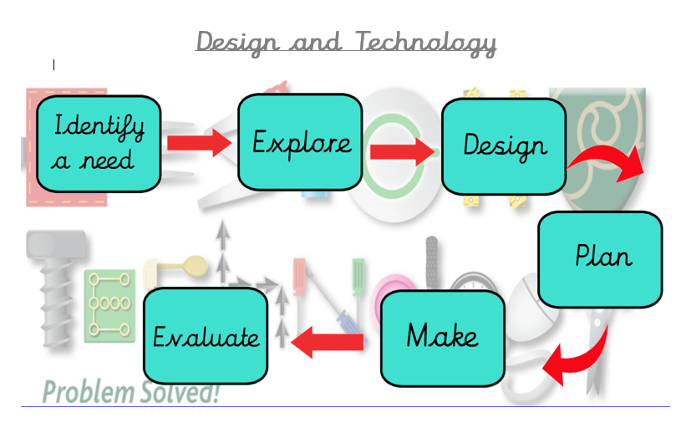
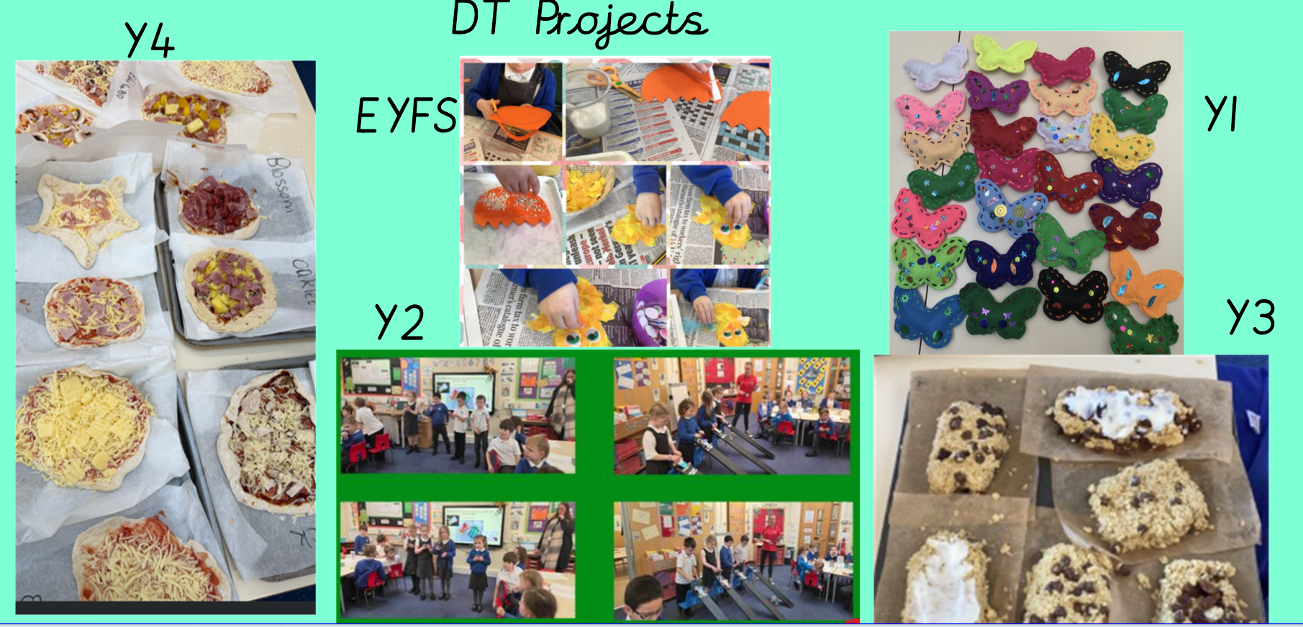
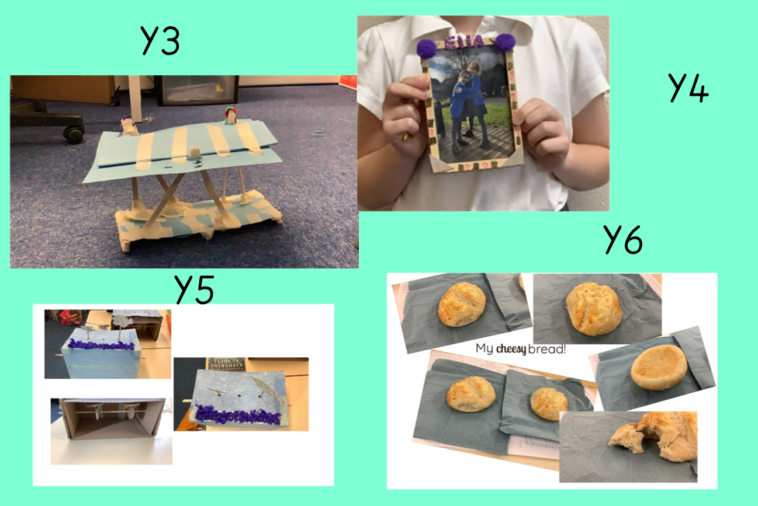

Data Analysis
Most children are achieving the required expectations in Design and Technology. The main area where children are currently struggling is remembering the innovators they have studied. At this stage, children are only required to have an awareness of these significant individuals and their contributions. To support children in retaining this knowledge and making meaningful links to their DT work, I will be encouraging the use of more frequent pop task quizzes. I will also recommend displaying examples of the innovators’ work and relevant images around the classroom to provide children with regular visual reminders and reinforce their learning.
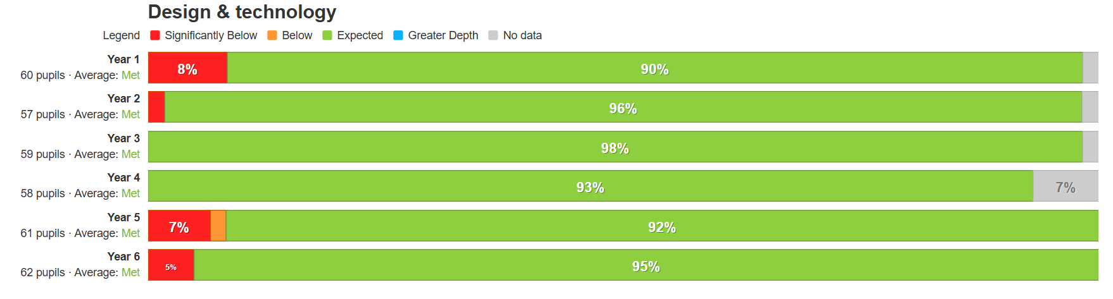

Enrichments
As part of their Design and Technology curriculum, Year 6 pupils visit Carre’s Grammar School to take part in a specialised woodwork unit. During these sessions, the children have the opportunity to use more advanced tools and equipment to design and construct their own wooden robots. These outreach experiences significantly broaden the diversity of their DT skills and give them valuable insight into what learning in a secondary school environment looks like. Both staff and pupils consistently enjoy these visits and the sessions continue to be a highly beneficial element of our DT provision.

Strengths
The strengths of DT are that nearly all children are meeting the expected standards. This includes developing skills in planning and designing, making and evaluating products. Assessment data indicates that the majority of children are making good progress and are able to apply the skills and knowledge they have developed across a range of DT projects. For those children who have barriers to their learning, there are widget cards to help with the different phases. For those with motor control issues, there are support scissors and adapted rulers. Adults would support with equipment more specialist to the unit.
Another strength is our link with the local Grammar School. As part of their construction unit, Year 6 visit Carres School to use more complex equipment and create a wooden robot. As well as learning new skills, the children are also working towards their transition into a secondary education. It’s always a huge success and the children love it!
The assessment system has been successful this year, providing valuable insights and effectively linking assessment information to key Design and Technology milestones. Staff are able to efficiently record pupils’ attainment against the expected standards, enabling data to be collated and analysed effectively. This has supported the identification of strengths and areas for development, informing future planning and provision.

Ways forward/Targets
Moving forwards, I would like to continue raising the profile of DT across the school. One way of achieving this could be through introducing more WOW Days, giving children opportunities to apply the knowledge and skills they have developed in DT to a range of separate, engaging projects.
This academic year, I will be planning a DT day and link it to Lincolnshire Day. The children will be in mixed year groups and work on different features of our county. We are very excited to see the amazing products that the children will be creating.
I would also like to establish a DT moderation folder containing a portfolio of exemplar work from each unit across the different year groups. By sharing and discussing examples of pupils’ work, we can develop a shared understanding of what age-related expectations should look like in DT. This will support consistency in assessment, help staff to identify appropriate standards and provide clear guidance when evaluating pupils’ work.

