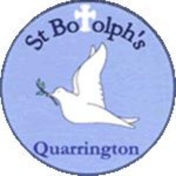
Governors’ Report for September 2026
The report covers the period from September 2025 to September 2026
Subject - English

Overview and main focus for the year:
During 2025–26, English continued to be a key focus across the school, with work centred on maintaining strong outcomes and a positive culture of reading, while further developing the consistency and quality of writing provision.
Reading remained a strength. Early reading continued to be taught systematically through Read Write Inc., with targeted support for pupils requiring further intervention. Across the school, the Reading Framework and whole-class reading approach supported progression in fluency, vocabulary and comprehension. Reading for pleasure remained a high priority, with a range of initiatives providing pupils with opportunities to encounter and discuss a broad range of high-quality texts and authors. The school's Reading Framework reflects this emphasis, progressively developing pupils from listening and responding to a wide range of texts into increasingly independent readers who can articulate their preferences, recommend books and read for a range of purposes.
Writing was a significant area of development during the year. Work focused particularly on strengthening the foundations for writing in EYFS and KS1 through effective transcription, oral composition and sentence-level teaching, alongside developing modelling and scaffolding across the school. The established writing curriculum provides progressive expectations for writing and GPS and supports pupils through the writing process of reading as a reader, reading as a writer, planning, drafting, editing, revising and publishing. Whole-school monitoring during the year provided opportunities to evaluate the implementation of these approaches and identify areas for further refinement.
CPD
During 2025/26, professional development in English focused on strengthening staff subject knowledge and ensuring greater consistency in the teaching of early reading and writing.
In Reading, staff training supported the continued implementation of Read Write Inc., with teachers and teaching assistants receiving ongoing training and support from RWI trainers and the school's Lead Phonics Teachers. This supported a consistent approach to phonics teaching and the identification and support of pupils at risk of falling behind.
In Writing, professional development focused particularly on strengthening sentence-level instruction and the teaching of transcription. Staff development supported teachers to consider the importance of oral composition, explicit modelling and scaffolding, and the development of fluent handwriting, spelling and punctuation in reducing cognitive load as pupils move towards increasingly independent composition. Lesson observations later in the year provided opportunities to see these approaches in practice and identify areas for continued development.
Monitoring and Evaluation
Monitoring and evaluation during 2025–26 included a programme of writing learning visits across EYFS, KS1 and KS2, alongside consideration of pupils' work, curriculum implementation and assessment information. The visits enabled leaders to evaluate how the school's developing approaches to writing were being implemented across different phases.
Monitoring identified a number of strengths, including positive and purposeful learning environments, effective teacher modelling, opportunities for oral rehearsal and discussion, explicit vocabulary development and appropriate support and scaffolding for pupils with additional needs. In EYFS and KS1, there was clear evidence of a focus on transcription, phonics and oral composition, while across KS2 pupils were increasingly encouraged to consider vocabulary, grammatical choices and their impact on the reader.
Monitoring also identified areas for continued refinement, including ensuring that teacher modelling consistently makes the writing process and authorial choices explicit, maintaining high expectations for handwriting and transcription, and ensuring an appropriate balance between discussion, modelling and sufficient time for pupils to write independently.
Findings from monitoring have helped to inform priorities for the continued development of writing provision.

Quality of teaching and Learning
The quality of English teaching observed during 2025/26 was positive, with clear evidence that agreed approaches were becoming embedded across the school. Teachers demonstrated secure subject knowledge and made effective use of modelling, questioning, discussion and scaffolding to support pupils in developing their reading and writing.
In Writing, teaching was strongest where teachers explicitly modelled the writing process, verbalised their thinking and supported pupils to rehearse ideas orally before writing. Vocabulary was given a high profile, with pupils encouraged to select increasingly precise and ambitious language and explain their choices. Monitoring also demonstrated effective links between phonics, spelling, handwriting and sentence construction in EYFS and KS1.
In Reading, the whole-school approach provides a consistent structure through which pupils develop fluency, vocabulary and comprehension. Teaching includes opportunities for explicit vocabulary instruction, modelling of comprehension strategies, discussion and personal response to texts, alongside increasingly close analysis as pupils progress through the school.
Monitoring indicates that the next stage is to further strengthen consistency, particularly in the precision of writing modelling, transcription expectations and ensuring pupils have sufficient opportunities to apply taught skills independently.

Staff/pupil voice
Reading continues to have a high profile across the school and pupils are provided with a range of opportunities to engage with books, authors and reading-related activities. Initiatives such as Reading Ambassadors, monthly focus texts, author events and shared reading opportunities have helped to promote reading for pleasure and encourage discussion about books across the school.
Informal feedback from pupils indicates that reading is valued and enjoyed by many children, with opportunities to share recommendations and discuss texts with their peers. The active role of Reading Ambassadors in leading worship and developing reading opportunities has further strengthened pupil involvement in promoting reading across the school.
As the new English Subject Leader, a more structured programme of staff and pupil voice will be undertaken during 2026/27 to further evaluate strengths, identify areas for development and inform future priorities.

Data Analysis
Analysis of end-of-year data for 2025–26 indicates a positive picture in English overall, while also identifying clear priorities for continued development.
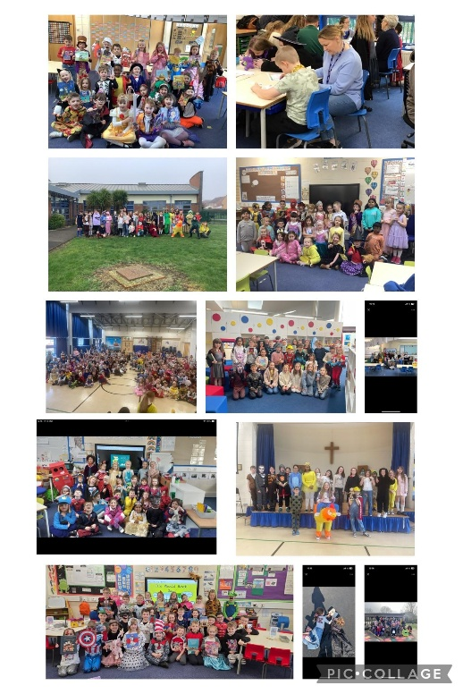
In Reading, 74% of pupils across the school achieved the expected standard or above, with 18% working at Greater Depth. Outcomes at the end of KS2 were particularly strong, with 79% of Year 6 pupils achieving the expected standard or above and 45% achieving Greater Depth. The cohort achieved an average scaled score of 107. These outcomes reflect the strong emphasis placed on reading across the school, including the progressive Reading Framework, structured whole-class reading provision and wider reading culture.
In Writing, 72% of pupils across the school achieved the expected standard or above, with 8% working at Greater Depth. While the proportion achieving the expected standard was broadly in line with Reading, the lower proportion achieving Greater Depth in Writing indicates an area for further consideration. Continued focus will therefore be placed on developing pupils' independence, sentence construction, vocabulary choices and control of transcription, alongside ensuring that pupils who are secure at the expected standard are appropriately challenged to develop greater sophistication in their writing.
Analysis of outcomes across year groups also highlights the importance of monitoring cohort and group variation, rather than relying solely on whole-school percentages. Assessment information will continue to be used alongside monitoring of teaching, pupils' work and pupil progress to identify where additional support or challenge is required.
Phonics outcomes were positive overall. In 2025–26, 80% of Year 1 pupils met the expected standard in the Phonics Screening Check, in line with the latest available national figure. By the end of Year 2, 95% of pupils had met the expected standard, demonstrating strong catch-up for pupils requiring additional phonics support.
Read Write Inc. is taught systematically from Reception, with pupils who require further support continuing to receive targeted provision in Year 2 and beyond where necessary. While outcomes by the end of KS1 are strong, ensuring that as many pupils as possible secure the expected standard at the end of Year 1 remains an appropriate area for continued focus.

Enrichment
A wide range of enrichment opportunities supported the school's strong emphasis on reading for pleasure during 2025–26. World Book Day was celebrated across the school, alongside monthly Friday Reading events which provided opportunities for pupils to read with parents, staff and children from other classes.
The school's Reading Ambassadors continued to play an active role in promoting reading, including leading collective worship and establishing a Book Nook on the playground. A Monthly Focus text provided further opportunities to introduce pupils to high-quality books, authors and genres beyond those encountered within their usual curriculum.
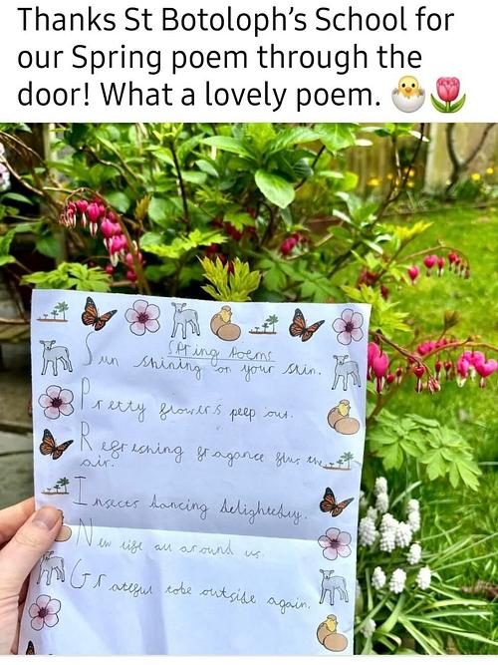
Pupils also benefited from wider literary experiences, including online author events, such as a session with Katherine Rundell, and a Year 6 visit to the Waterstones Children's Book Festival. Investment in new class sets of books for KS2 further broadened the range of high-quality texts available to pupils. Pupils also had opportunities to write for authentic audiences, including delivering their writing to members of the local community, which generated positive feedback for the school.
Together, these opportunities increased pupils' exposure to a broad range of books and authors and supported the school's continued commitment to developing a positive culture of reading.

Strengths
- Strong reading outcomes and reading culture. Reading remains a strength across the school, with particularly strong outcomes at the end of KS2. A well-established culture of reading for pleasure is supported through high-quality texts, Reading Ambassadors, regular reading events and enrichment opportunities.
- Clear and progressive reading provision. The whole-school Reading Framework provides clear progression from early decoding through to increasingly fluent, independent and critical reading, while the whole-class reading approach supports consistent development of vocabulary, fluency, comprehension and response to texts.
- Positive development in the teaching of writing. Monitoring demonstrates effective practice across the school, particularly in teacher modelling, oral rehearsal, vocabulary development and scaffolding. Strong links between phonics, transcription and sentence construction are evident within early writing provision.
- Effective early reading intervention. Phonics is taught systematically through Read Write Inc., with targeted support for pupils who require additional practice. The strong proportion of pupils securing the phonics standard by the end of Year 2 demonstrates successful catch-up for many pupils who require longer to secure early reading skills.

Ways forward/Targets
1. Further strengthen the consistency and quality of writing teaching across the school.
Continue to develop explicit sentence-level instruction, high-quality teacher modelling and purposeful teaching of grammar within composition. Monitoring will focus particularly on ensuring that pupils understand the choices writers make and are given sufficient opportunities to apply taught skills independently.
2. Strengthen transcription and the foundations for fluent writing.
Develop a consistent whole-school approach to handwriting and spelling, building securely from EYFS and KS1 and ensuring that pupils who continue to experience difficulties further up the school receive appropriate support. The aim is to increase automaticity in transcription so that pupils can devote greater attention to composition.
3. Further develop explicit vocabulary and language instruction across English.
Build upon existing strong practice in oral rehearsal and vocabulary teaching to establish greater consistency from EYFS to Year 6. Pupils should increasingly understand, select and apply precise and ambitious vocabulary in both reading and writing.
4. Maintain strong reading provision while further strengthening early reading outcomes.
Continue to develop the school's positive reading culture and strong reading outcomes, while maintaining a particular focus on pupils at risk of falling behind. In phonics, use assessment and monitoring to identify barriers for pupils who do not initially meet the expected standard and seek to increase the proportion securing the standard by the end of Year 1.

Monitoring the impact
Alongside these priorities, the English Subject Leader will establish a systematic programme of learning visits, book looks, planning scrutiny, assessment analysis and staff and pupil voice. This will provide a clearer evidence base for evaluating the implementation and impact of developments in English and identifying future priorities.

