
Governors’ Report for September 2026
The report covers the period from September 2025 to September 2026
Science
Katie Eastwood

Overview and main focus for the year:
Science at St Botolph’s is delivered through a carefully structured spiral curriculum, whereby key scientific concepts and knowledge are revisited and developed progressively throughout the academic year rather than being taught as discrete termly units. This approach enables pupils to build upon prior learning, deepen their understanding over time, and maximise retention of key content. Consequently, a strong understanding of the science curriculum is essential to ensure that learning is sequenced effectively and that progression is coherent across year groups. Careful curriculum planning and timetabling support the development of knowledge and skills in a logical and systematic manner, ensuring continuity and high-quality learning experiences for all pupils. In addition, leadership has been demonstrated through the implementation of new curriculum roadmaps, which have enhanced both curriculum provision and assessment processes within the subject area.

CPD
No personal CPD has been undertaken during this academic year. However, CPD opportunities and training have been provided for other members of staff within the school, when needed.

Monitoring and Evaluation
In July, a science book scrutiny was conducted across the school. The review demonstrated that teachers are implementing the science curriculum in accordance with the agreed curriculum documentation, ensuring consistency in curriculum delivery. Evidence within pupils’ books also indicated that learning activities were appropriately adapted to meet individual needs, enabling all pupils to access and engage successfully with the curriculum.
However, the scrutiny identified an area for development relating to scientific vocabulary. Evidence suggested that the vocabulary being used and recorded in Upper Key Stage 2 was often similar to that found in Lower Key Stage 2, indicating that expected progression in subject-specific terminology was not always evident. In response, the Progression in Vocabulary document was shared with all teaching staff to support the systematic development of scientific language across year groups. Furthermore, vocabulary progression has been explicitly highlighted within the long-term curriculum plan to ensure greater consistency and challenge.
In addition, a pupil voice survey was conducted during the summer term across the school. This provided valuable insight into pupils’ experiences of science, their attitudes towards the subject, and their understanding of the knowledge and skills being developed through the curriculum.

Quality of teaching and Learning
The quality of science education is strong, with pupils demonstrating positive attitudes towards learning and a secure understanding of key scientific concepts. Teaching is well planned and engaging, enabling pupils to develop their knowledge through practical investigations, enquiry-based learning, and opportunities to apply scientific vocabulary. The curriculum is broad and ambitious, providing pupils with opportunities to develop their scientific knowledge, investigative skills, and curiosity about the world around them. As a result, pupils make good progress and are well prepared for the next stage of their scientific learning.

Staff/pupil voice
When a staff voice was conducted in September 2025, in most year groups, staff were happy with the teaching of the science curriculum. One staff member asked for support with assessment. Assessment opportunities and resources were emailed out to all staff member to support their assessing in science. It was also highlighted that more time would be beneficial to conduct experiments and set up further comparative tests based on conclusions. As a result of this, more time was built into the yearly overview, to ensure this time was given.
A pupil voice was conducted with Key Stage 1 and Key Stage 2 pupils in July 2026. The pupils had very positive views of science. Children in all year groups, knew that there are three stands of science and were able to identify the five different areas of scientific enquiry.
One student said ‘Science gives us the opportunity to experiment, experience and learn new things. There is no limit what to you can do you.’ Another said ‘I love science. Experiments are fun. The build up and predictions builds up to the exciting bit. I love doing the experiment. At the end you know you did really well. It doesn’t matter if you go wrong, you will work it out in the end.’ The children also said they liked that the curriculum was spiralled because it allowed them to recap previous learning and build on it.

Data Analysis
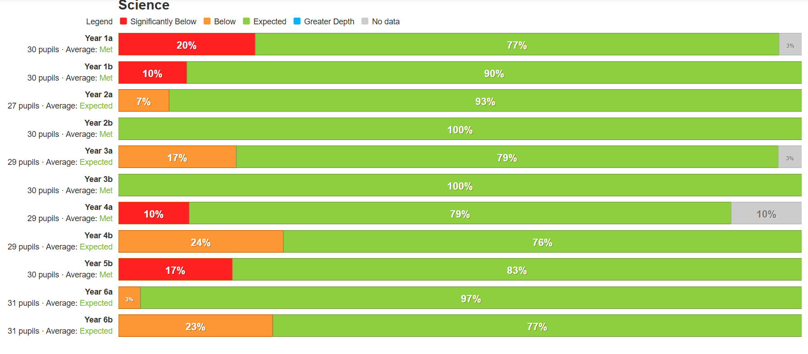

Enrichments
In March, a whole-school Science Day was held to promote engagement, collaboration, and enthusiasm for scientific learning. The event provided opportunities for teachers to work with classes beyond their own year groups and facilitated collaborative learning experiences across different phases of the school. The focus of the day was “Curiosity: What is the Question?”, inspired by the theme of British Science Week. Through a range of investigative and enquiry-based activities, pupils were encouraged to develop their questioning skills, think critically, and explore scientific concepts through curiosity-led learning. The day successfully reinforced the importance of scientific enquiry and fostered a positive culture of exploration and discovery across the school.
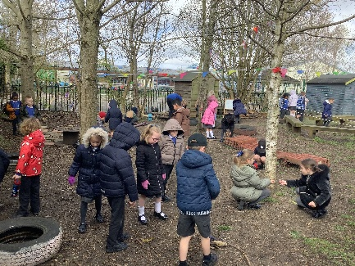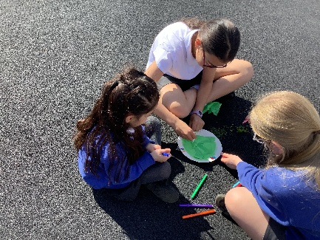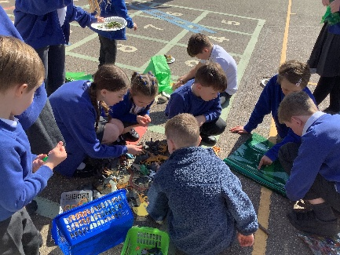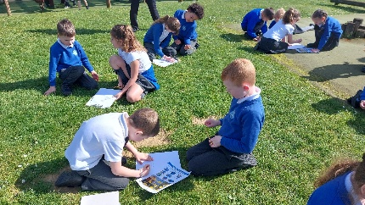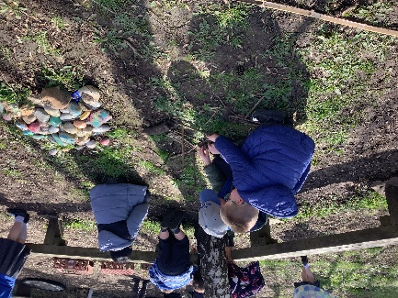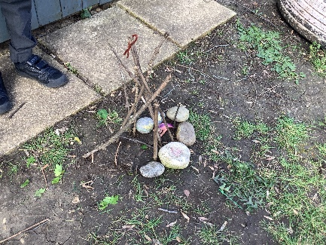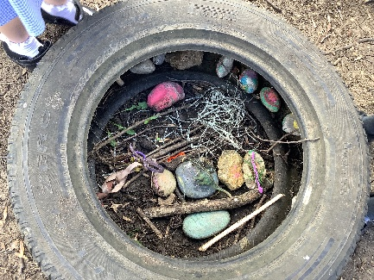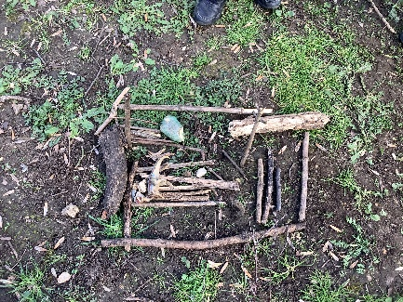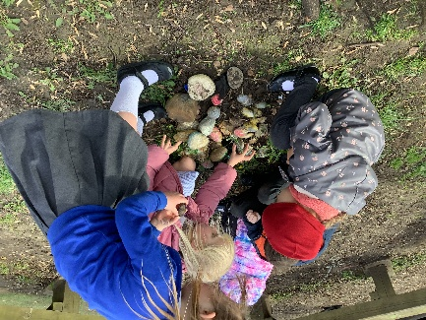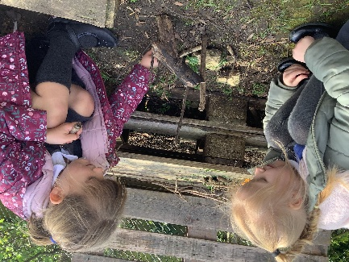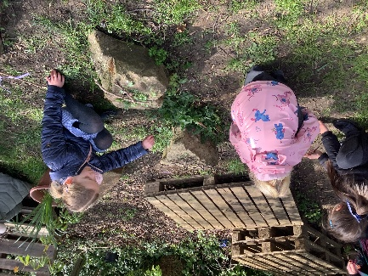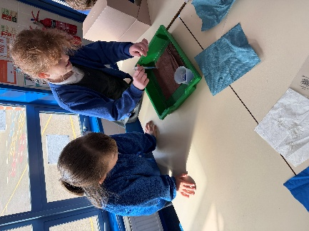
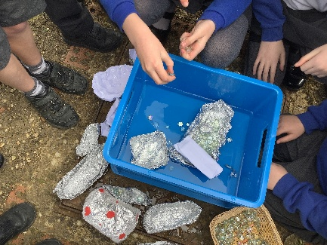 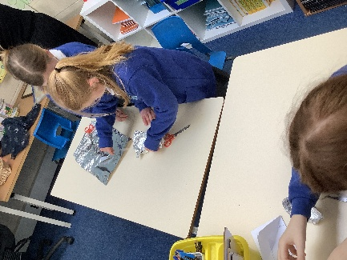 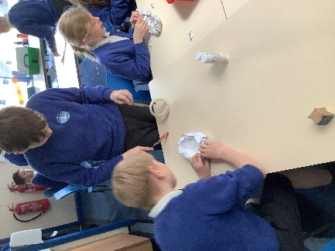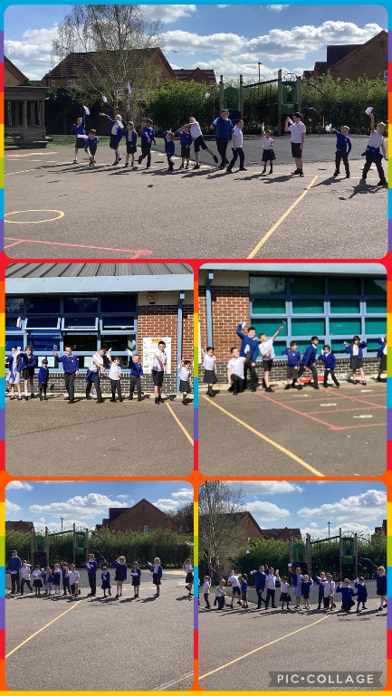5 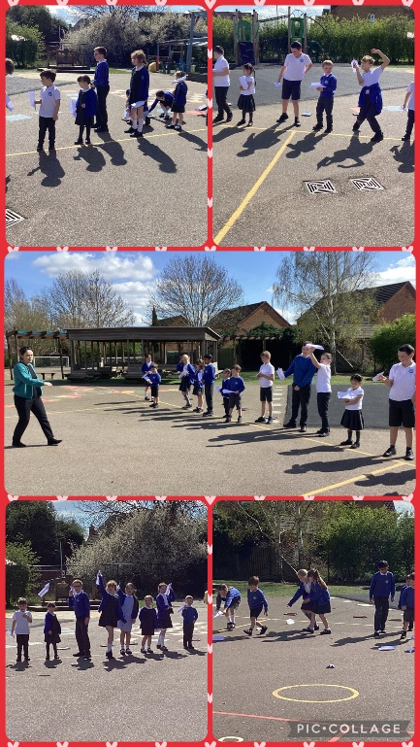 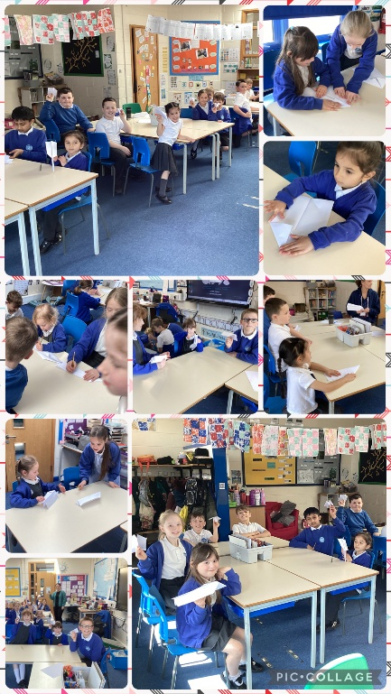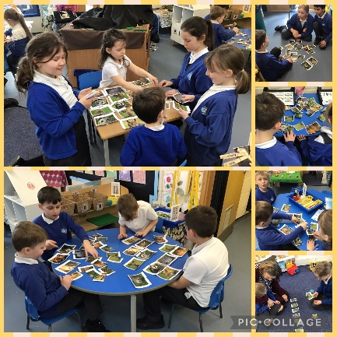 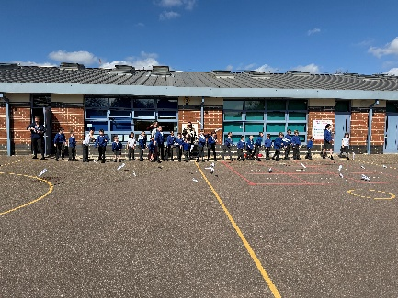 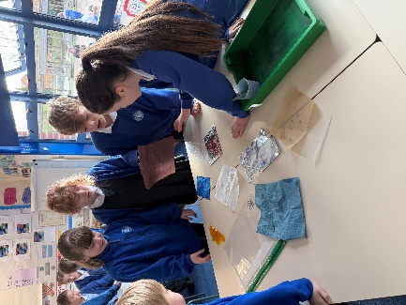

The Year 3 also went on a school trip to Magna in Rotherham, where the children did a workshop on magnets and explored zones on earth wind air and fire, linking to their science curriculum.

Strengths
- We have a robust curriculum that meets all the demands of the National Curriculum and beyond.
- All staff have a clear understanding of the value of science and are confident teaching science.
- We have a wide range of resources to support skill and knowledge development across the school. This ensures that all children have access to equipment when conducting experiments, rather than observing others.
- From the pupil voice, it was clear that all children regardless of their year group have a passion for science.
- All children were able to name at least one scientist.

Ways forward/Targets
- Subject leader to attend CPD next academic year.
- Ensure the progression of vocabulary throughout the school, when topics are built upon. For example, the vocabulary taught in year 6 on living things and their habitats, should be more advanced than year 4.
- Ensure that children are not writing a full experiment plan for every investigation and just to focus on the elements specific in the curriculum plan.

