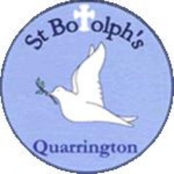
Governors’ Report for September 2026
The report covers the period from September 2025 to September 2026
Phonics
Mrs Katie West

Overview and main focus for the year:
This academic year, the priority of Phonics has been to ensure that the teaching of this crucial subject is consistent for all children. This has been achieved through regular practice sessions, training opportunities and through the use of online resources. Regular coaching sessions have contributed to the success of the teaching development.
With improved teaching, the priority then turned to ensuring that the number of children achieving the expected standard in reading was enhanced, paying close attention to the Phonics Screening. In addition to this, we worked to support the first 20% of our readers with appropriate and rigorous interventions, ensuring that every child, regardless of their age or stage, reached their full potential in this subject. We are proud of the progress that the children, and reading teachers, have made.
CPD
Read, Write Inc ‘Speed Sounds’ training for all staff was carried out by a member of the Ruth Miskin team in September 2025.
A RWI ‘Development Day’ was undertaken in March 2026 with a RWI consultant.
Regular contact is made with our RWI consultant, Mrs Tregunno, where advice and support is sought based on teaching and children’s progress.
Weekly practice sessions occur for half an hour, every Thursday. The objectives for these are based on observations made and the data. All reading teachers can access these sessions.
Weekly coaching sessions are carried out by Mrs West, and this is evidenced, thus a good picture of development is made. These sessions are based on individual needs or, the reading focus for the term.
All reading teachers have access to the online portal where videos and documents are accessible and easy to locate. These videos can also be sent by Mrs West as the form of a ‘pathway’.

Monitoring and Evaluation
The children are assessed at the end of every half term- six time per academic year. This begins for a child on week five of the Reception year. By doing this, we are making a strong start to the reading journey. These assessments are carried out via the online portal and gaps in learning can quickly be identified. Those children requiring intervention are given ‘one-to-one tuition’ by trained tutors.
Staff are coached on a regular basis which gives the Phonics lead the opportunity to watch teaching and more importantly, the learning in each group. Observations from this, perhaps weaker points in teaching, are then incorporated into the training programme, or sent via pathways. These learning walks are dated, with the aspects of teaching noted, therefore a detailed ‘practice map’ is available.

Quality of teaching and Learning
Monitoring happens on a weekly basis, from September through to July. This is through learning walks, coaching sessions and regular Practice Sessions. Our ‘Development Day’ with Mrs Tregunno confirmed our findings. She said that our teaching was strong and consistent, regardless of the group being observed. Our children demonstrate high levels of engagement and understand and appreciate the clear routines.
Data Analysis
Phonics data shows that the children are making good progress but not always at the expected level. These children have been identified and ‘Record of Concerns’ written, for those children making small steps of progress, and communicated with the SENCO. Regular assessment and monitoring identify the gaps in children’s learning and interventions put in place. The end of the year data is below, with a focus on phonological awareness and the ability to read those sounds in words (storybooks)
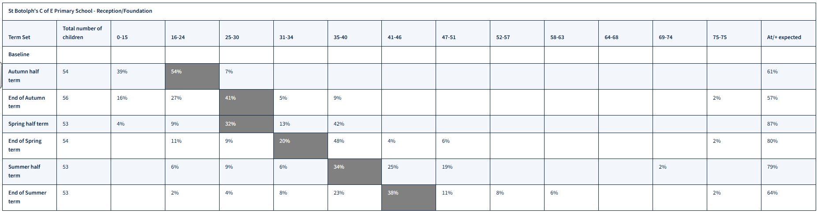

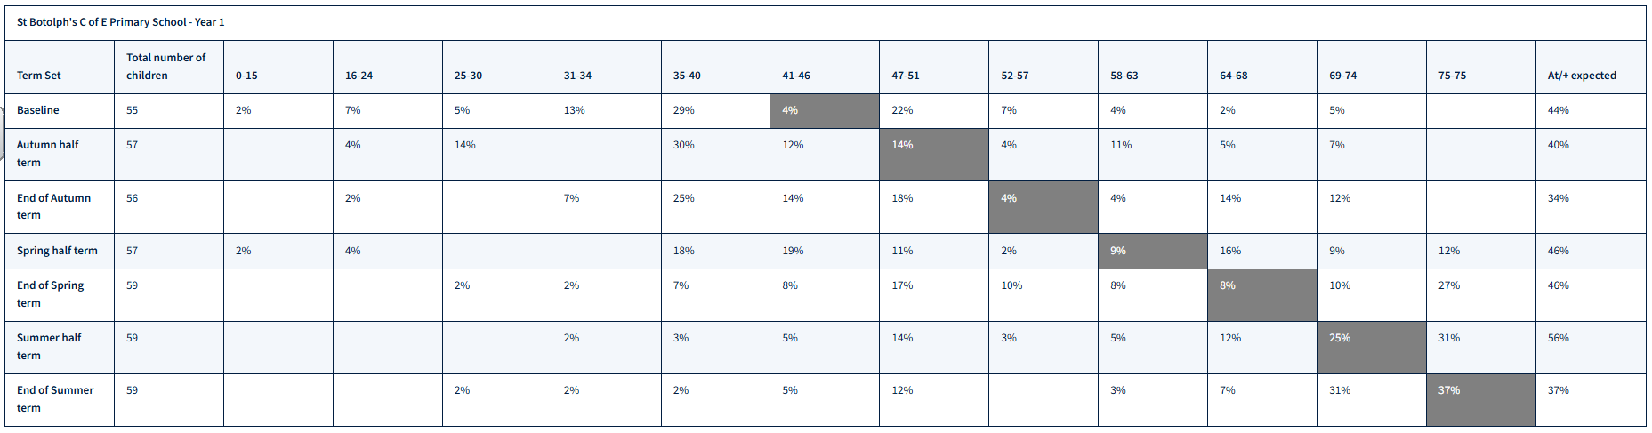

64% of Reception children are making expected progress in their phonological awareness with a further 23% one step below (this could be 1-5 sounds short of expected progress)
In Year One, only 37% of children are at the expected level but with a further 31% one step below (1-5 sounds short of expected). Despite this, 80% children passed the Phonics Screening in June 2026. The progress that the children have made since September 2024 is huge. This cohort began their school life with a large percentage of children that required Speech and Language and listening interventions.

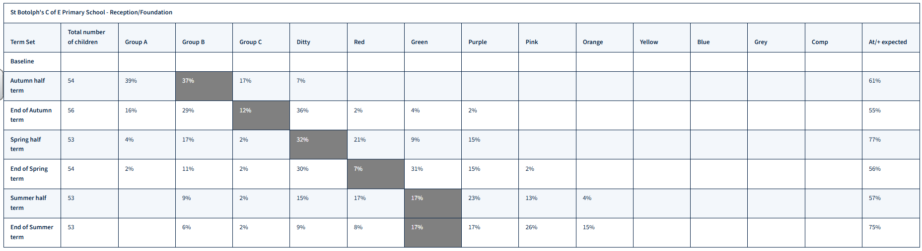

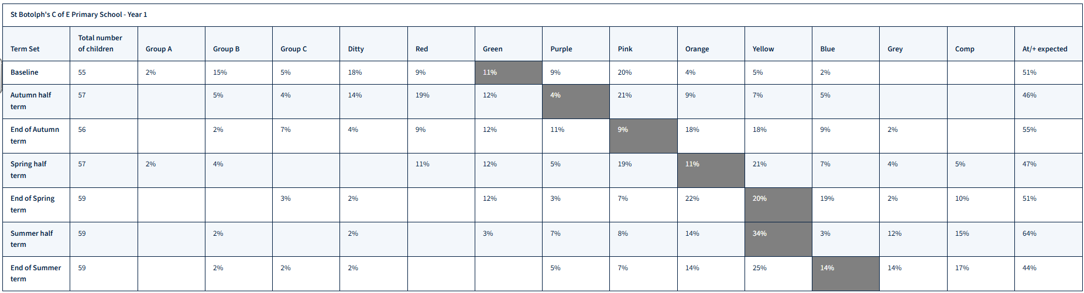

Strengths
The teaching of RWI is consistent is all Phonics groups. New members of staff in September 2026 will be trained accordingly.
All lessons are well resourced.
The online portal provides excellent CPD opportunities for staff, resources for parents and additional teaching opportunities for the children, at home and in school.
The progress of the children is good.
Ways forward/Targets
Phonics will be part of the school SDP in 2026-27.
All staff have the responsibility to improve phonics and with this mindset, the attainment of the children will be enhanced, and we will see this in our data.
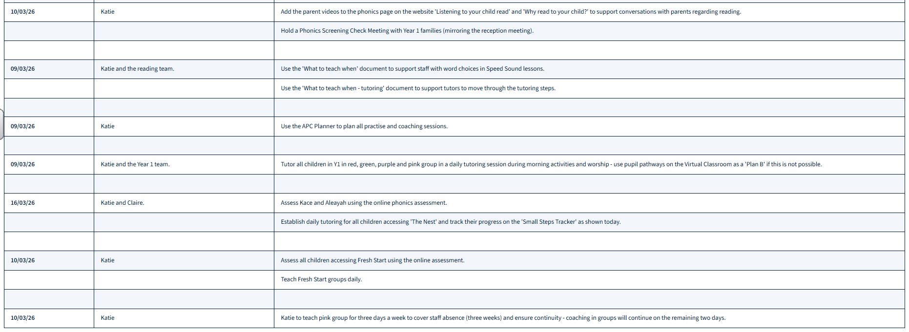
Developed Day Action Plan:

