St Botolph’s CofE Primary School
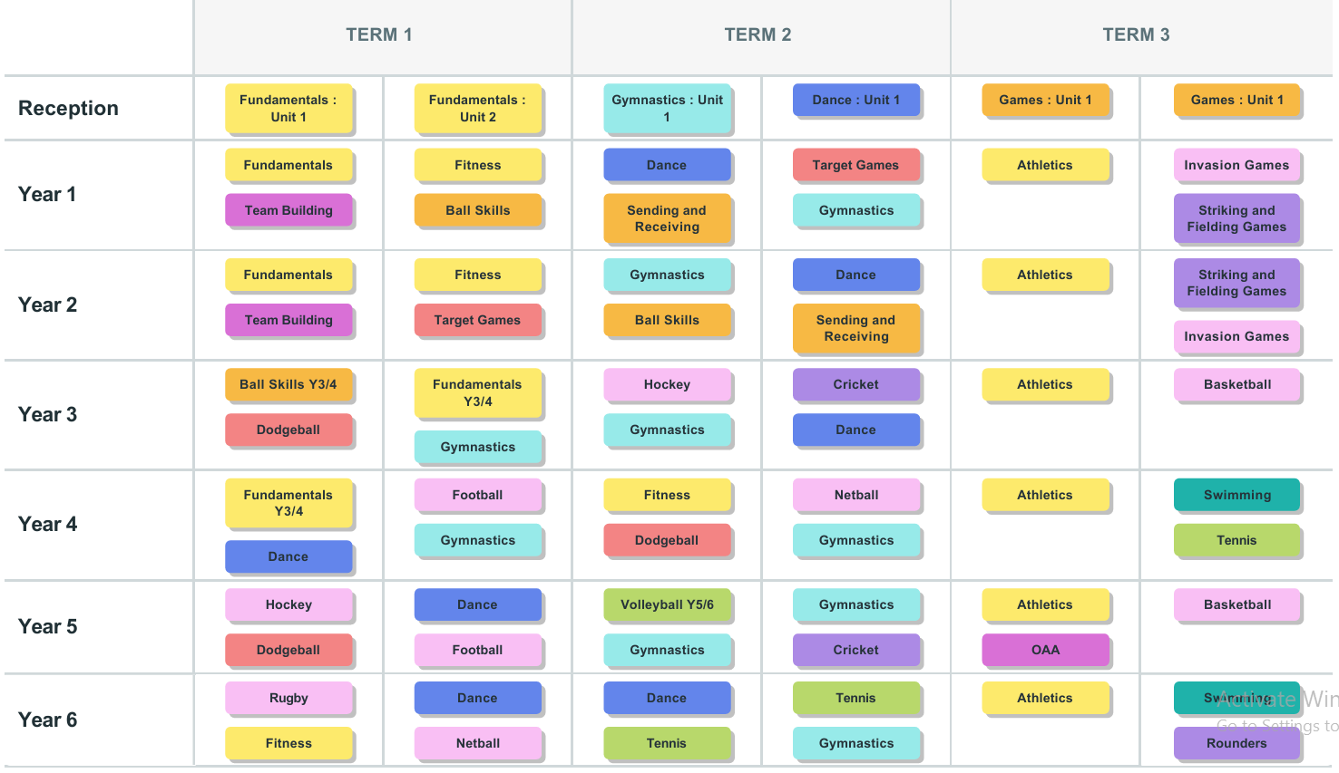
Physical Education Long term plan 2026-2027

